SIR SANDFORD FLEMING COLLGE
COMPREHENSIVE PROGRAM REVIEW

GIS APPLICATIONS SPECIALIST
GIS CARTOGRAPHIC SPECIALIST

2008-10-20

Prepared by: Noreen Goodliff
Coordinator, GISAS/GISCS Programs

Table of Contents

Introduction …………………………………………………………………… 1
1.0 Industry Trends
1.1 Sectoral Standards and Industry Trends …………………………… 1
1.2 Program Advisory Committee Feedback ………………………… 1
1.3 Industry Liaison …………………………….…………………… 2
2.0 Curriculum Development Framework
2.1 Curriculum Framework …………………………………………. 2
2.2 Outcomes for Curriculum Renewal ……………………………… 3
2.3 Previous Curriculum Mapping and Sequencing - 2004 …………….. 3
2.4 Recent Curriculum Mapping Procedures and Sequencing ………….. 5
2.5 Delivery Mode …………………………………………………. 6
2.6 Evaluation Methods …………………………………………….. 7
2.7 Curriculum and Diversity ………………………………………. 7
2.8 Credentials Framework: Ontario College Graduate Certificate ……. 8
2.9 Learning Pathways ……………………………………………... 9
3.0 Student and Graduate Satisfaction
3.1 Formal Measures of Student/Graduate Satisfaction ……………….. 10
3.2 Other Measures of Student/Graduate Satisfaction ………………… 11
4.0 Employment Trends
4.1 Employment .…………………………………………………… 11
4.2 Other Graduate Destinations ……………………………………. 12
5.0 Strategic Positioning
5.1 College Alignment ….…………………………………………… 12
5.2 Competitor Programs …………………………………………… 12
6.0 Enrolment Trends
6.1 Student Profile ………………………………………………….. 13
7.0 External Relations
7.1 Alumni ……………….…………………………………………. 15
7.2 Community Relations .…………………………………………… 15
7.3 External Endorsements ….……………………………………….. 16
7.4 Program Advisory Committee ……………………………………. 16
8.0 Program Resources
8.1 Human Resources ……………………………………………….. 17
8.2 Physical Resources ………………………………………………. 18
8.3 Program Costing ………………………………………………… 19
9.0 References ...………………………………………………………….... 21
10.0 Appendices ................................................................................... 22
Sir Sandford Fleming College 2008 Comprehensive Program Review
GIS Applications Specialist/Cartographic Specialist

INTRODUCTION
Sir Sandford Fleming College has been involved in geomatics education since 1973, beginning with the Cartographic Technician diploma program. Fleming was the first to offer college-level Geographic Information Systems (GIS) training, beginning in the early days of the discipline in 1981. Fleming now offers 2 post-graduate certificate training programs in GIS and one diploma program in Geomatics. Over the past 30+ years, Fleming has established an international reputation for excellence in the field, producing many award-winning graduates, and Fleming continues to be a leader in the field of GIS training and education.

The following report presents the results of a comprehensive program review of the post-graduate GIS Applications Specialist and the GIS Cartographic Specialist programs.

1.0 INDUSTRY TRENDS
1.1 Sectoral Standards and Industry Trends

The Canadian Geomatics industry is recognized as the world leader in this field, and its products and services are fully integrated into the business processes of all sectors of the economy and the decision- making processes of all areas of government.

The following is an excerpt from the Executive Summary of a submission, dated July 2002, “Exploiting the Innovation Potential of Geomatics – A Geomatics Sector Response to Canada’s Innovation Strategy”, Prepared by the Geomatics Industry Association of Canada and The Impact Group. (http://www.innovation.gc.ca/gol/innovation/site.nsf/en/in02326.html)
Geomatics is an enabling technology. The geomatics sector specializes in identifying the geographical locations of physical phenomena and human activities and presenting this information to decision-makers, on desktop computers and over the Internet, in the form of intelligent maps. There is a strong belief within the sector that the future of the geomatics industry depends on an ongoing partnership among industry, government and academe. Each has a vital and unique role to play, and each requires ongoing investment in its respective capacities.
The sector's future depends upon strong partnership between industry, government and academe, with each playing a vital role and requiring on-going investment
The geomatics sector is well positioned to play an important role in implementing Canada's Innovation Strategy. The sector provides critical knowledge and tools to improve productivity and decision-making in a wide range of government and business sectors, such as natural resources, disaster management, national security, municipal services, infrastructure, shipping, retail, finance, real estate, health, education and environment. The majority of planning and operational decisions have a location component, and geomatics has a fundamental role to play in the "where and when" of decisions.
1.2 Program Advisory Committee Feedback
The following is a summary of feedback provided from the last Advisory Committee meeting, held June 23, 2008.
- Major industry trends were identified as Municipal GIS applications, the integration of data from various sources, the emergence of Web based GIS applications, and the application of remotely sensed imagery and aerial photography.
- Another trend is the push for environmental assessment and management of natural resources.
- The big three schools which supply industry with graduates continue to be COGS, Fleming and BCIT
- The Ontario Ministry of Natural Resources still hires 75 – 80% Fleming graduates.
- Fleming has the strongest general purpose GIS/Geomatics programs, with other institutions offering specializations.
- Fleming GIS programs should maintain focus on Natural Resource Sciences.
- Overall, huge growth area and looking for employees is a challenge
In addition, the committee provided feedback on a new proposed modified curriculum. This modification involves condensing the 12 month programs into 10 month programs. The feedback was positive, and the committee will continue to provide additional feedback as more information is provided.

1.3 Industry Liaison
The GIS programs at Fleming continue to respond to the immediate needs of the GIS industry through student cooperative projects, completed over the second and third semesters of the programs. In many cases the students are developing customized applications that specifically suit the needs of the client, when standard commercial software is deficient. Frequently, projects are done for community based groups and non-profit organizations who are able to take advantage of the excellent research and innovation offered by our faculty and students, at no cost. The Cooperative GIS Projects often exhibit such a degree of innovation that the students involved are coached to seek patent rights on their developments. Examples of participants are: Friends of the Osprey, The Land Between, Kawartha Rail Trail, The Canadian Great Ape Alliance, and Ken Reid Conservation Authority.

In the final week of each program, students demonstrate the results of their Cooperative GIS Projects at an Open House event. The GIS Open House event is well known and established with industry, with as many as 60 – 70 guests attending each year It is common for some companies to attend annually, conducting interviews on site, and hiring students before they have actually graduated.

The Cooperative GIS project is an example of the integration of industry, students and faculty, and continues to be he cornerstone of the programs.

2.0 CURRICULUM DEVELOPMENT FRAMEWORK
2.1 Curriculum Framework
GIS is a discipline that undergoes constant change, in software, methods and standards. As a result, curriculum is in a constant state of “flux”, with faculty renewing lectures, laboratory exercises, evaluations, data, etc. every semester to adapt to software and hardware upgrades and general industry trends. While Fleming’s Faculty Renewal initiatives (every 5 years) afford faculty 6 weeks to learn about general trends in the industry, because of the nature of the discipline, the rapid changes, and the profoundness of the changes that can occur in 5 years, these renewal leaves are inadequate in this field of study. Faculty in this program are extremely dedicated and commit a great deal of “personal” time in order to remain current.

In addition, faculty have adopted several initiatives in an attempt to satisfy the “student learning first” approach adopted at Fleming. These include:
- Weekly meetings to discuss student issues and concerns
- In recognition of the heavy workload, faculty have attempted to combine evaluations across courses with similar vocational and learning outcomes. Discussions are ongoing.
- The GISAS /CS program meets frequently with our advisory committee in order to keep curriculum current and relevant
- In addition to weekly meetings, we have established a GIS Discussion Forum through Groupwise to keep the flow of ideas and information current and moving

2.2 Outcomes for Curriculum Renewal
In 2004, The Geomatics Institute at Fleming underwent a major review of the two post-diploma certificate programs at SSFC. The 2004 Proposal to Modify an Ontario College Graduate Certificate, Geographic Information Systems submitted by the Geomatics Institute at Fleming (see Appendix) was approved by the Ministry of Education and Training in 2004.

The main factors contributing to the review and subsequent modification included (but were not limited to):
- The need for increased cost efficiencies in delivery methods
- Alignment of both programs with the with the new broader scoped Geomatics Technician Program, (GMT), which replaced the former more specialized Cartographic Technician Program
- Student Satisfaction concerns, mainly around the stress resulting from heavy curriculum load

The curriculum review process yielded:
- A major modification of the GISAS Ontario College Graduate Certificate program, extending its length from two to three semesters,
- The merging of the GISAS and GISCS curricula in order to reduce costs of delivery. Common courses are offered throughout the programs, with the entire first semester of both programs being common.
- The repositioning of both graduate certifications in order to ensure appropriate transition for students completing the new Geomatics Technician (GMT) program
- The merging of two academic departments at the SENRS campus (Cartography and GIS) with the subsequent joining of advisory committees.
- The merging of class laboratory sections from previous cap of 35 students to a section to 65 students to a section. To facilitate this, Geomatics Technologists assist faculty in the lab.
- The addition of several new strands of curriculum including: Remote Sensing, WebGIS and enhanced Project Planning and Management

In September 2005, the new curriculum was successfully launched. Currently, we are delivering to the 4th student group since the revised curriculum.

Key indicators of success include:
- The successful implementation of the above mentioned new curriculum strands
- Extension of the Cooperative GIS Projection across two semesters, recognizing the importance of independent research, high level project planning and student innovation
- MTCU Credentials. The new program modifications resulted in the GISAS and GISCS programs being designated as Ontario College Graduate Certificate programs, instead of the previous designation: post-diploma certificate programs
- Cost efficiencies in delivery methods, with the identification of common curriculum and the subsequent integration of two programs of study.
- Cost efficiencies in delivery methods, with increased section sizes of up to 65 students.

2.3 Previous Curriculum Mapping and Sequencing - 2004
The following graphic, illustrates the current curriculum map as developed in 2004 and implemented in September 2005.

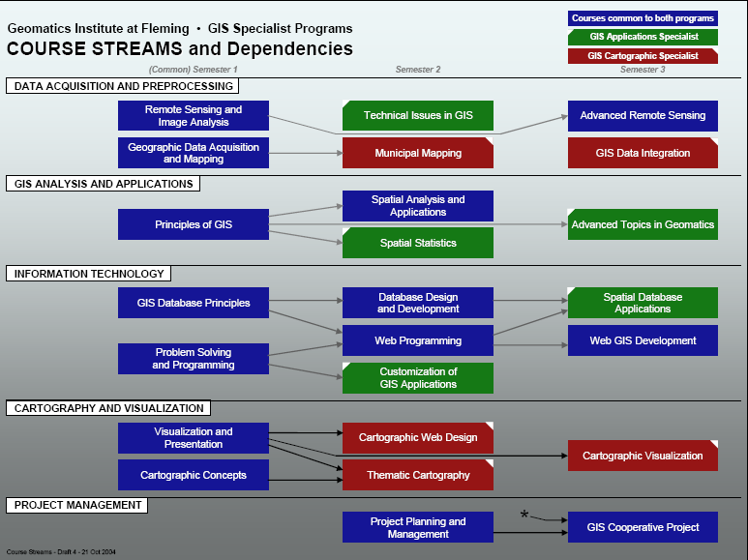

In order to monitor the success of this new curriculum, faculty have compiled information from a variety of sources including KPI scores, informal and formal student surveys, and course evaluations. (See Section 3.0) In addition, staff, faculty and managers have discussed the impact of the new curriculum on workloads, the increased role of technologists in the classroom due to section sizes of 65 students, and the overall health wellness of the staff and faculty.

The consensus from this information gathering is:
- the revised program has reduced the amount of time faculty have for revising curriculum and increased the level of stress
- August graduation is difficult for Trent students and may contribute to a decreased number of Trent students attending
- Repeat curriculum has been identified in some courses, mainly due to the merging of courses across two previous separate departments and programs
- A 12 month program of intense curriculum may be too long
- There are too many courses in first and second semester. (7 courses)
- Geomatics Technologists have insufficient time to re-install software upgrades and perform system maintenance
- While the third semester of the new (2004) program was intentionally assigned a lighter workload to allow students to spend more time on their cooperative project, students perceived this as an imbalance and an uneven distribution of work between semesters. Students felt the second semester was too heavy and the third semester too light.
- Students do not use their time wisely during the third semester. The perceived “imbalance” in workload has lead to a high degree of student absences during the designated work periods for the Cooperative GIS Project.

As a result, faculty began examining (and continue to examine) the possibility of reducing the program to 10 months and reducing the number of courses within first and second semester if possible. A series of meetings, including a two-day micro-scale review of curriculum March 2008 have taken place. The process continues, and the results to date are presented below.

2.4 Recent Curriculum Mapping – Procedure and Sequencing
Stage 1
A listing of all course material (skills, software, learning outcomes, deliverables, lecture and lab exercises and evaluations) called “skill sets” was produced by all faculty participating in the curriculum mapping process. This process was completed to facilitate review of curriculum at the micro level, and to identify overlapping curriculum which could be removed to accommodate moving to a 10 month program.

Canadian General Standards Board – Committee on Geomatics (CGSB-COG) is in the process of developing national standards, with the intention of aligning those standards to the ones already developed in the United States. It is hoped that a North American standard will eventually be developed. The U.S. University Consortium for Geographic Information Science – Geographic Information Science and Technology – Body of Knowledge 2006 has been reviewed by the group and it was decided that alignment with this document was a stepping stone to future accreditation of the program. Also, it was felt that cross referencing our curriculum to this standard would serve to validate our curriculum with the latest industry
standard. The document lists 10 knowledge areas or “Core Units” which are as follows:

a) Analysis Methods b) Conceptual Foundations
c) Cartography and Visualization d) Design Aspects
e) Data Modeling f) Data Manipulation
g) Geocomputation h) Geospatial Data
i) GI S&T and Society j) Organizational and Institutional Aspects

It was acknowledged by the group that the Body of Knowledge is intended to be a comprehensive list of the skills and learning outcomes for the Geomatics industry as a whole. The document states:

“…the BOK2006 is a top-down design intended to allow educational streams to follow different pathways through the curriculum to achieve a variety of outcomes, in recognition of the multiple pathways and diversity of geospatial technology.” (BOK2006)

The process revealed the following:
- Some core units are not covered in our curriculum, however, it was acknowledged that within the scope of our program (either 12 or 10 months) it was not possible to cover all core units. (i.e.: Geocomputation )
- Several skill sets and “groupings” of skill sets did not fall under any of the core units, such as Web-based Applications in GIS
- Our program successfully covers most of the core units, and some that were not identified
- Our curriculum is current and follows industry standards
- There were several areas of overlap identified, where the same core units or curriculum was delivered in two or more courses
- Certain courses could be “grouped” or categorized into core units and merged which may reduce the number of courses delivered.

Stage 2
As a result of this process, it was decided to regroup our delivery of skill sets into new courses which better follow the core units identified in the BOK2006, and which may result in a reduction in the number of courses delivered. Again, skill sets were cross referenced with these new “groupings” and again it was confirmed that there were several areas of overlap. These areas corresponded to areas identified through student surveys.

Stage 3
A Draft Revised Program Curriculum model, was developed with the new course groupings. Names were tentatively assigned to courses which were newly proposed. In some cases, no revision to the course name or content was necessary. The draft model was presented to the Advisory Committee in May 2008 for review and approval. (see appendix) Also in attendance at this meeting were three students, two from the AS program and one from the CS program. Students were invited to comment on the draft curriculum model. In summary, the Advisory Committee and the students responded very favorably to the proposed changes. As a result, we have set a target date for implementation of a revised program at September 2009. As stated previously, the process is ongoing and revised course names, descriptions, aims, and learning outcomes have yet to be developed. However, the following new curriculum map has been developed (subject to revision)
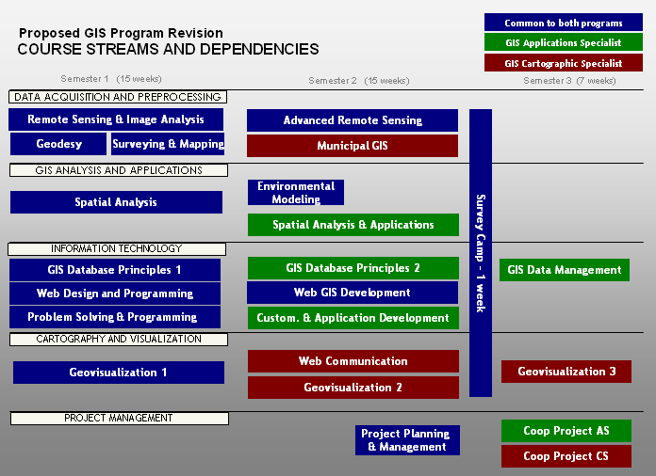

2.5 Delivery Mode
The 2004 revision saw the addition of the Guided Learning Hour, (GLH), in order to reduce costs of delivery. The GLH replaces one hour of faculty lead instruction. Normally, courses are delivered as follows:
- 1 hour lecture, consisting of an explanation of theoretical concepts, methods and processes.
- 2 to 3 hour laboratory time in dedicated computer labs. Students are exposed to and are instructed in the operation and customization of industry leading software and hardware
- Field exercises consisting of faculty and staff demonstrations of equipment with time allocated to each student to use equipment
- Off-campus field trips for the purposes of data collection and to experience the application of GIS is real world situations
- 1 hour Guided Learning Hour (GLH)

The proposed new curriculum model will follow much the same delivery modes, however it is felt that the GLH is not a significant cost savings and reduces valuable faculty led instruction with little benefit. The following table shows the current distribution of hours in the two programs.
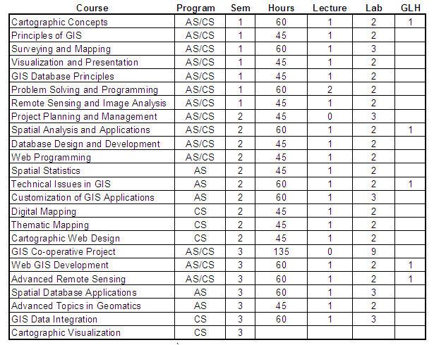

2.6 Evaluation Methods
Evaluation methods across both programs are varied and consist of the following:
    - Evaluations of short laboratory exercises
    - Short answer and multiple choice tests
    - Development and presentation of maps and other paper based visuals
    - Writing and submission of minor reports
    - Writing and submission of major reports
    - Results of independent research/project work
    - External accreditation by leading software manufacturers
    - Development of web-based applications and presentations
    - Delivery of oral presentations
    - Customization of standard GIS software
    - Creation of computer programs using industry standard development languages
    - Evaluation of the interaction with industry professionals

The revised curriculum model will continue to combine evaluations to reduce student workload.

2.7 Curriculum and Diversity
The GISAS and GISCS programs are demanding of the student’s time and energy. The faculty believe it is important for students to organize and develop a support structure to help each other in times of heavy workload and stress. Each year, during the 2nd or 3rd week of the program, we invite the students to elect a student representative from both programs. The role of the student representative is three fold.

- To organize events and activities, promoting emotional and physical health and well being. Examples are the establishment of teams, field trips and excursions, and pubs.
- To establish the Geomatics Students Club under the guidance of the Student Association in order to better integrate GIS students with the rest of the student population.
- To listen to student complaints or difficulties, which can then be discussed with the appropriate staff or faculty in an attempt to resolve them.

The election of student representatives supports student diversity and promotes program culture.

2.8 Credentials Framework: Ontario College Graduate Certificate
The following is a summary of the Ontario College Credentials Framework, as it applies to the GISAS and GISCS programs at Fleming. (see appendix for the entire framework)

Factor OCC Framework Standard Met?
1.0. SCOPE OF CURRICULUM OUTCOMES: BREADTH AND DEPTH  1.1 Complexity of knowledge and vocational outcomes | Breadth, depth, and complexity of knowledge would enhance the ability of graduates to perform a more specialized range of activities, most of which would be complex or non-routine. Leadership and guidance may be involved when organizing self or others as well as contributing to technical solutions of a non-routine or contingency nature.  Performance of a prescribed range of skilled operations that includes the requirement to evaluate and analyze current practices, develop new criteria, and may include the provision of some leadership and guidance to others in the application and planning of skills.  Applications may involve some complex or non-routine activities involving individual responsibility or autonomy and/or leadership and guidance for others as part of a team or group.  The qualification may involve broadening the skills of individuals already gained in a postsecondary program of instruction, or developing vocational knowledge and skills in a new professional area. | Standard met. GISAS and CS programs offer a specialization which enhances post-secondary educational credentials which are often general in nature and lacking practical skills.  The breadth, depth and complexity of knowledge enables graduates to perform a more specialized range of activities, most of which are complex or non-routine. The curriculum focuses on the development of technical excellence, the ability to trouble shoot and solve problems, evaluate and improve on practice, provide leadership and guidance in the search for solutions and organize the work of self and others.
1.2 Generic Employability Skills | Locally Determined | Standard met. The curriculum incorporates recognized employability skills implemented at a higher level, specifically communication, advanced project management and interpersonal skills
1.3 General Education | Locally Determined | The program has no general education requirement and conforms to the college’s general education policy.
2. TYPICAL DURATION FOR COMPLETION | Typically the duration to achieve this credential is 2 academic semesters or approximately 600 - 700 instructional hours or equivalent. | Exceeded. Currently 1008 hours, 3 semesters. Currently exploring the option of reducing this to 2-1/2 semesters.
3. ADMISSION REQUIREMENTS | Ontario College Diploma, Ontario College Advanced Diploma, Degree, Or Equivalent | Admission requirements adjusted to allow for a broader range of applications. Know-ledge of computers stressed.
4. NAME OF CREDENTIAL | Ontario College Graduate Certificate | Standard Met.

2.9 Learning Pathways
The following summarizes the various learning pathways available to the students when entering the GISAS and GISCS programs. It is intended to maintain these pathways in the revised curriculum model.

- Degree or diploma from a recognized post-secondary institution.
- Entry of Fleming’s GMT graduates into second semester of program.
- Entry of graduates from Military Mapping School into second semester.
- Agreements with Trent University for their third year students to take our GIS programs as an optional pathway to their degree. The GIS program counts as their third year of a geography degree. Currently Trent exchange students are required to achieve a minimum 60% in all GIS courses for them to be considered equivalent. Students must also return to Trent for their 4th year of Geography.
- Students are free to switch between specializations (AS or CS) after completion of first semester, regardless of the program applied to.

3.0 STUDENT AND GRADUATE SATISFACTION
3.1 Formal measures of Student and/or Graduate Satisfaction - KPI Results
The following table is a comparison of KPI summary results 2003 – 2007. Summaries of 2008 KPI results had not been received, at the writing of this report. Values are shown in percentages.

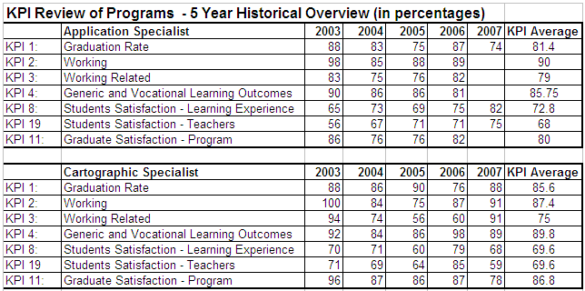

KPI summaries also indicate that graduates of Fleming GIS programs rank higher in Graduate Satisfaction with Generic and Vocational Learning Outcomes and overall with the program when compared with the college system average as shown below.

KPI 11: Graduate Satisfaction with Program 2005/06
College KPI score
Algonquin 83.95
Niagara 83.05
Sault 84.65
Fleming CS 84.73
Fleming AS 84.73
SYSTEM 83.84

KPI4: Graduate Satisfaction with Generic and Vocational Learning Outcomes 2005/06
College KPI score
Algonquin 85.74
Niagara 85.32
Sault 87.38
Fleming CS 87.36
Fleming AS 87.36
SYSTEM 85.48

3.2 Other measures of student and graduate satisfaction
Informal student surveys have been conducted in 2006 and again in 2007 in order to gauge the success of the 2004 revision. The results of these surveys identify the following emerging themes:
- Class sizes of 65 are too large to allow faculty and staff to circulate and spend time with students during a lab period. (100% agreement, survey of 2006, 60 out of 68 students)
- Support staff do not always possess the knowledge required to provide assistance in the labs and in some cases are learning the material at the same time as the students.
- More, smaller independent projects with less group work
- 90% agreement that database stream needs to be modified to cover more material in first semester, and less material in second semester
- Remote Sensing curriculum should be delivered in consecutive courses, without a break
- Identify and remove overlapping curriculum
- Spatial Statistics should be embedded in other curriculum and should be delivered to CS students
- CS students need more cartographic concepts, techniques and theory.
- CS students should be doing Independent Mapping project instead of Coop Project
- Some curriculum still uses old software and should be updated
- Eliminate repetitive tasks

Faculty have reviewed and discussed these comments at length during our micro-scale curriculum review and at subsequent meetings. All issues of an academic nature (i.e.: curriculum) have been discussed and addressed in the new curriculum model. Unfortunately, reducing class sizes, and eliminating the need for technologists support in the classroom is beyond the control of faculty to change, as these were cost savings measures. An appropriate student teacher ratio should not exceed 35:1, and this ratio is adhered to in every other program which delivers GIS curriculum at Frost.

4.0 EMPLOYMENT TRENDS
4.1 Employment
The Geomatics Sector Human Resources Student (2001) described a current market for Canadian geomatics companies of just under $2 billion, with an employment base of about 27,000 of which 22,000 is in the private sector and about 5,000 in the public sector.

A more recent study shows the worldwide market for geomatics technologies in 2002 was estimated at US$5 billion (Geomatics Sector - Human Resources Study (GSHRS). The same industry study projected that it would have annual revenues of US$30 billion by 2005. Another study, (Survey of the Alberta Geomatics Industry prepared for the Alberta Geomatics Group. March 1, 2000) in the year 2000 found that industry members anticipate the geomatics industry will grow 9% to 14% per year for at least the next 10 years. Clearly, there is an enormous and growing need for GIS professionals in the field, and Fleming is strategically positioned to take advantage of this need.

Typical job titles in geomatics include: geographer, cartographer, physical scientist, computer scientist,
Surveyor, GIS (geospatial or geographic information systems) analyst, project manager, remote sensing
scientist, surveyor, civil engineering technician, surveying and mapping technician, photogrammetrist and
image analyst.

Most geomatics companies are smaller firms (less than 10 employees) providing specific services,
equipment, or data. Larger companies provide a wide range of services, data or equipment or a
combination of these. Most geomatics companies in Canada serve the local and national markets,
however they also undertake a considerable number of International projects. A great deal of geomatics
employment is also found within the larger resource, engineering and land-management companies, as
well as in municipal, provincial or federal governments.

In 2000 the private sector employed 81% of workers in the geomatics industry and government employed 19%. Jobs in geomatics include many working environments. Most jobs have a high level of technology and computer use and are indoors. Other jobs require a great deal of fieldwork and being outdoors. One can also combine geomatics with work in other fields including archeology, medicine, forestry, geology, geography and astronomy to name only a few.

Recently, it was reported to us from an advisory committee member that at their institution, Ontario Ministry of Natural Resources, 75 – 80 % of the new students being hired are graduates from Fleming’s GIS programs. In addition, another member stressed that Fleming should maintain their focus in the field of Natural Resources.

The latest employment statistics, acquired from Student Services, Job Connect, would indicate that graduates of the programs enjoy a 94% employment rate.

4.2 Other Graduate Destinations
As stated earlier, students involved in the Trent/Fleming exchange program, must return to Trent for an additional year to complete their Honours degree. Additionally, a small percentage of students continue their education pursuing graduate degrees. Examples of destinations include: Ryerson: Master’s degree, in GIS, and Queen’s University, Master’s Degree in GIS.

5.0 STRATEGIC POSITIONING
5.1 College Alignment
The GIS program aligns well with the College’s vision and strategic priorities. (2005 – 2010) There is a strong emphasis in the program on innovation, individual challenges, growth and independent thinking. Graduates of the GIS programs are well prepared for positions in the workplace, with emphasis on project management and the use of interpersonal skills embedded across the curriculum, culminating in the Cooperative GIS project. One of Fleming’s strategic priorities for 2005-2010 is focused on applied learning, and the Cooperative GIS project is an excellent example of this type of learning. Fleming’s GIS program is housed in a $13 million award-winning, energy efficient, academic wing of the college. This facility provides leading edge laboratory and project facilities for all geomatics programming.
Fleming College is well known throughout the industry as the leader in Geomatics education. The GIS programs have high expectations requiring high student commitment to the learning process.
Learning Support Services, Counseling, Career Services, and other services are available to support student learning. Learning Support services offers alternate testing, note-takers, peer tutors and personal support technologies as they may be required by individual students.
5.2 Competitor Programs
Across Canada there are over 40 universities and 25 colleges and technical institutions providing various component parts of the recognized geomatics education/training . (Proposal to Modify an Ontario College Graduate Certificate, 2008) Whereas other institutions in Ontario provide select training options in the geomatics field, Fleming has been a leader in the employment market in terms of the number of graduates produced and their broad range of skills. The key competitors at the graduate certificate level in GIS are shown in the following table.

College | Program Title | Characteristics | Eligibility
Algonquin | Geographic  Information  Systems | The three semester graduate certificate is modeled after the Fleming program, but lacks advanced Web-based applications, and advanced Project Planning and Management skills.  The GIS department offers an articulation agreement with Carleton – a three-year technologist program with one additional year at Carleton University to receive a BA in Geography | Two- or three-year Ontario College Diploma or university degree in a related field, or equivalent with department approval.  Programming experience is not a requirement, however, applicants are encouraged to acquire basic programming experience prior to the start of the program of study.
Niagara | Geographic Information Systems -  Geospatial Management  Niagara on the Lake | Again, modeled after the Fleming Program. Three semesters, but semester two and three are 10 weeks only, graduating in July. Designated GIS lab open 24/7. Three courses on GIS Thesis development. Strong ESRI bias and promotion with little to no exposure to other industry leading software. Deficient in Web-based applications.  Niagara College boasts the Fourth consecutive #1 ranking in KPI ranking in Ontario. | College Diploma or University Degree, preferably in a related discipline (as determined by the College), OR an acceptable combination of related work experience and post-secondary education (as determined by the College), AND Proof of English proficiency.  A background with some computer programming, mathematics, and statistics is recommended.

Fleming has a competitive advantage with its advanced, web-based curriculum, ratio of full time faculty to students, expert technical support, industry reputation and partnerships, and tradition of student success in the workplace. In addition, with the critical mass of the three program areas, staff, equipment and other costs associated with the program can be offset by tuition from a larger number of students. As a result, Fleming has the lowest tuition rate of any other competitor program in Ontario.

6.0 ENROLMENT TRENDS
6.1 Student Profile
The educational background of the typical GIS applicant has largely remained the same, with a large majority of students being university graduates. A smaller percentage of students have college diplomas, some from other programs at Fleming College, such as Ecosystems Management, Fish and Wildlife and Parks and Recreation. Fleming has a high retention rate for students, which contributes to students transferring from other programs to seek a second diploma.

We continue to have two or three students from Trent University attending the Fleming GIS program through the Trent/Fleming GIS articulation agreement, but more and more students are opting to complete their degree at Trent before coming to Fleming for advanced GIS training.

In addition, the last two years have seen a number of students taking advantage of the bridging agreement between the GISAS and GISCS programs and the GMT programs.
The demographic profile of applicants has expanded. Traditionally, GIS was a seen as a complement to geographic and environmental studies. However, with tremendous growth in the industry, and a wider range of applications, we are now seeing students with degrees in art, music, business and in the health care field. This has presented some challenges as basic geographic principles and fundamentals of map making, skills that were often possessed by the applicant, must now be introduced in first semester. Conversely, we are also seeing an increasing number of student applicants who possess a solid foundation in GIS, due to the integration of GIS with geography curriculum at the elementary and secondary level, and with many universities now having basic to advanced GIS facilities. This presents an additional challenge to faculty, as the first semester often requires adaptation of curriculum to meet the wide and varied backgrounds of the students.

Conversion rates for applications in the GIS programs is higher than the collage average, with a 31.4% conversion rate in 2007 the GISAS program and a 23.6% conversion rate in 2007 for the GISCS program. College average in 2007 was 23.3%

Applications to the GIS programs has decreased from 2004 – 2008. However, as can be seen in the charts below, the decrease in enrollment experienced at Fleming is seen throughout the system. Fleming has experienced an average of 32% decrease in applications over five years, while the system average is 35.94%, with one college experiencing a 58% decrease in applications.

In overall applications to post-graduate GIS programs, Fleming by far exceeds other colleges, garnering almost 50% of the total applications, as shown below.

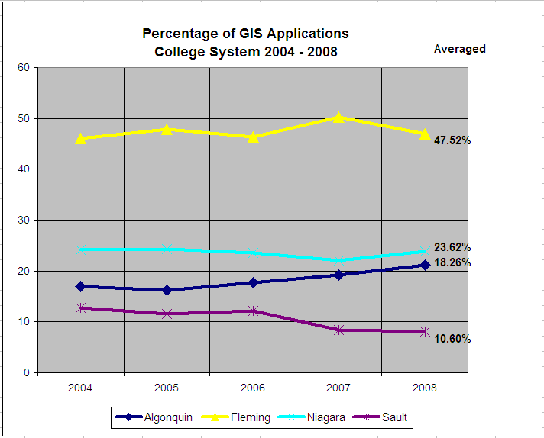

Fleming accounts for almost ½ of all applications to post-diploma GIS programs in Ontario
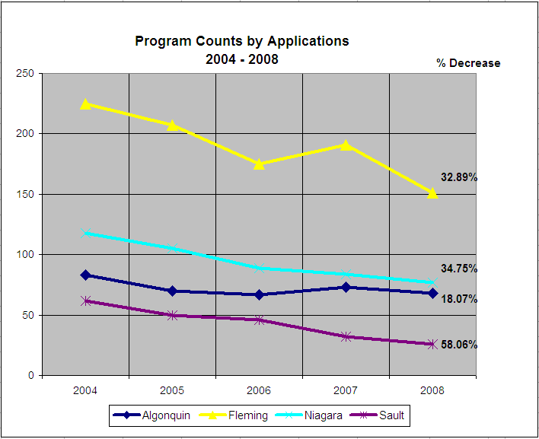
Decrease in applications to post-diploma GIS programs at all colleges, with Fleming below the average
7.0 EXTERNAL RELATIONS
7.1 Alumni
Student alumni have been and continue to be a valuable resource for faculty and staff in the program. In many cases, graduates of the program serve as a pool of highly qualified and trusted part-time faculty. In addition, many members of our advisory committee, including the current Chair, are past graduates, and faculty of the program. Alumni are loyal to their program and to the college and often serve as clients for current students in their Cooperative GIS projects. It is also typical for them to hire new graduates of the program in their organizations. We will continue to engage alumni in the program in this way.

7.2 Community Relations
The GIS program continues to establish partnerships with government, industry and the private sector through the Cooperative GIS Projects and the annual Open House event which takes place in August. In many cases, organizations utilize the significant intellectual resources of the college to complete projects that otherwise would not get completed, due to insufficient funds. As stated previously, some of the clients include:
Ontario Ministry of Natural Resources Trent University
Friends of the Osprey The Land Between
Kawartha Rail Trail The Canadian Great Ape Alliance
Otonabee Region Conservation Authority Ken Reid Conservation Authority
Region of Durham Waterloo Hydro

In recognition of their contribution to the Geomatics community, students are eligible to receive a number of awards. These include:
    - Bell Institute for Learning Design
    - Association of Ontario Land Surveyors Education Foundation GIS Award.
    - Gary Clements Memorial Award
    - Canadian Institute of Geomatics Award
In addition, our students have continually been recognized throughout the industry for their excellence in academics and have been the recipient of awards from:
- American Congress on Surveying and Mapping
- Canadian Cartographic Association
- National Geographic
- MapQuest
- British Cartographic Society
- Bentley Education Network
- Rand McNally
- Intergraph International

Formal agreements have been established with a number of prominent GIS and/or mapping software/hardware/data suppliers by means of the Strategic Skills Initiative program. Included in these agreements are: Telus, Autodesk, FirstBase Solutions, ESRI, CARIS, DMTI Spatial, PCI and GeoMedia. In addition we have a very desirable data sharing agreement with the federal and provincial governments (Ontario GeoSpatial Data Exchange).

Professor Raoul Ponce Hernandez of Trent University is presently exploring the possibility of Trent University offering a one or two year’s Masters in Spatial Analysis, in cooperation with Fleming College GIS programs. Professor Hernandez states that this program possibility would be dependent upon the GIS/Geomatics expertise that is at the Frost campus of Fleming College.

Finally, in terms of partnerships, it should be acknowledged that our GIS faculty and staff continue to deliver GIS related curriculum to a continually growing number of other academic programs at the Frost campus.

7.3 External Endorsements
“We love Fleming (GIS) grads” spoken by representatives of Optech Co. (LIDAR) http://www.optech.ca

“We have hired a number of Fleming (GIS) grads from 2002 to the present. We are really happy with the quality of students” Steve Dowding of Intermap Technologies. http://www.intermap.com.

“If you are going to do your Master’s under my tutelage, I recommend that you go and get your technical (GIS) training first. I recommend two schools, one of which is Fleming College” Professor Wanhong Yang of University of Guelph

7.4 Program Advisory Committee
The following is a listing of the Advisory Committee members and their distribution by sector
Name | Industry | Industry Sector
Erik Alkenbrack | Ontario Ministry of Health and Long Term Care | Healthcare
Al Buckle  Manager, Map Production | Teranet Land Information Services | Land Information Services
Jim Buttle  Department of Geography | Trent University | Education
Randall Cracknell | Intergraph | GIS Software
Jerry Crawford  GeoData Services and Digital Mapping | Toronto Ambulance Support Services | Healthcare
Candice Foster | Municipal Property Assessment Corporation | Statutory Corporation
Paul Heersink | Provincial Geomatics Service Center | Geomatics
Frank Kenny  Science and Information Branch | Ontario Ministry of Natural Resources | Natural Resources Management
Mike MacLean  Planning Department | City of Peterborough | Municipal Planning
Gordon McElravy | Telus Geomatics | Software
Chris North | ESRI Canada | Software
Steven Rose

Beatrize Vitorino |  | Natural Resources Management
James Britton | Ontario Ministry of Natural Resources – Water Resources | Natural Resources Management

The GIS programs at Fleming have a very active role with their Advisory Committee, meeting once or twice a year to discuss emerging trends and changes in the industry. Most members of the committee are long standing, with some members participating in the Cartographic Technician program prior to 2002.

8.0 PROGRAM RESOURCES

8.1 Human Resources

Fulltime Faculty:
Noreen Goodliff - Coordinator GISAS/CS Programs  Professor  BES, Geography, Waterloo University  Certificate, Environmental Management: Niagara Certificate, GIS Applications Specialist, Fleming  MSc. Environmental Modeling, Trent( in progress) | Bruce Pettit, Ontario Land Surveyor  Professor  Bachelor of Technology Degree in Geodetic Science, Ryerson Polytechnical Institute  Diploma, Computer Programming, Fleming
Lawrie-Keillor Faulkner, Coordinator, Geomatics Technician Program  Professor  HBSc, Geography, Trent University  Diploma, Cartographic Technician – Algonquin  Certificate, GIS Applications Specialist, Fleming | Stewart O’Brien  Professor  BA Geography - Carleton  Dilpoma, Cartographic Technician – Algonquin  Certificate, GIS Mapping Specialist
Karen Whillans-Browning  Professor  BSc, University of Toronto  MSc , Zoology, University of Toronto  Certificate, GIS Applications Specialist, Fleming | Stephen Pelletier  Professor
Part-time Faculty:
Paige Wearing  Diploma, Fish and Wildlife Technician, Fleming  Diploma, Ecosystem Management Technician, Fleming  Certificate, GIS Applications Specialist, Fleming  HBSc, Trent University, (in progress) | James Ouellette  BSc, Guelph University  Certificate, GIS Applications Specialist, Fleming  MSc, Trent University (in progress)
Janet Millard
BA, Geography, Carleton University

Technologists:
Kevin Rabjohn, Geomatics System Technologist  Diploma, Business Administration, Fleming  Diploma, Human Resource Management, Ryerson (in progress) | Susan Mantle, Geomatics Network Specialist  HBA, Guelph University  Certification, Information Networking, Fleming  Diploma, GIS Applications Specialist, (1986)
Tim Wykes, Geomatics Cartographic Technologist
Diploma, Cartographic Technician, Fleming

8.2 Physical Resources
Currently, the GIS and the Geomatics programs at Fleming share equipment and physical resources and these resources are adequate. While lectures are held in the common classrooms and lecture theatres at Fleming, most laboratory classes are held in the Geomatics Institute of Fleming, technology wing. This wing consists of three classrooms, each with 35 student computers and a faculty station at the front of the classroom. This institute was designed to accommodate large class sizes and as such the rooms can be connected by rolling back the common wall between classrooms.

Students have historically complained about the noise and temperature of the labs in the new technology wing. The ventilation system is lower than was originally designed and therefore cold air blows directly down on the students when they are working. In addition, the ventilation system is extremely noisy and students find it difficult to hear the faculty and each other, during class. Microphones and speakers have been installed at the faculty station, but they are awkward and for this reason are not always used. Also, the microphones do not help the students hear other students, when they are participating in classroom discussion, nor do they allow the teacher to hear the students, especially when students sit at the back of the room. Plant and Property has attempted to resolve the issue of the noise and the air blowing down on the students, but to date the problem has not been resolved and students continue to complain.

The following is a list of the equipment acquired and maintained by the Surveying, GIS and Geomatics programs at Fleming, since the 1970’s. It should be noted that this equipment is in use by most other programs at the college as well as the GIS program, and that some of this equipment was purchased by the old Surveying Department of the college, which is no longer in existence.

Equipment Number Est. Cost/unit Total Cost
Total Stations 6 $10,000 $60,000
Trimble Geo3 GPS Receivers 3 $8,000 $24,000
Trimble GeoXT GPS Receivers 3 $8,000 $24,000
eTrex GPS Receivers 30 $100 $ 3,000
GPS Cables 15 $20 $ 300
Plotter 1 $15,000 $15,000
Digitizers 30 $450 $13,500
Wild T16 Data Loggers 6 $4,000 $24,000
Survey levels 8 $300 $ 2,400
Survey tripods 12 $400 $ 4,800
ESTIMATED TOTAL COST OF SHARED EQUIPMENT $171,000

The software that is used in the GIS programs is increasingly being used by other programs at the Frost Campus of Fleming College. Knowledge of GIS has become a core skill in the workplace, and in recognition of the competitive advantage that Fleming students could have over other college graduates, many programs have now integrated GIS skills into their curriculum. For example, the Ecosystem Technology program has four courses in GIS, and the Fish and Wildlife technology program has two. As a result, software that has in the past been purchased primarily for the GIS programs is now being shared across the college. Examples include:
- Adobe Illustrator, which has traditionally been used in the Cartographic Technician program, is also used in Common Semester Geospatial Techniques by all students of the Frost Campus
- ArcGIS, by Environmental Systems Research Institute (ESRI) is now being used by students in Common Semester, and then later in Forestry, Ecosystem Management and Fish & Wildlife.

The GIS programs have traditionally negotiated agreements with software companies in order to reduce costs and the benefit of these agreements is now realized by all other programs at the Frost campus. Examples of some software costs are shown below:

ESRI, ArcGIS, 9.2 (ArcInfo) $10,500 per year Site License
PCI Geomatica $ 5,000 per year Site License
Avenza (MaPublisher) $ 4,000 for year one +
$ 2,000 for years 2 – 5 30 Licenses
Adobe Illustrator $10,000

It should be noted that ESRI’s ArcGIS 9.2 ArcInfo license currently retails for $35,000 per license. The agreement that we have negotiated has us paying $10,500 for a site license annually, to be paid in September. This agreement is unprecedented among Ontario Colleges, and must be maintained.

8.3 Program Costing
Program costing summary data historically has calculated that GISAS and GISCS programs are financial draws on the system. In a Discussion paper, dated January 23, 2004, “Cost Saving Measures – Geomatics” it was stated that the primary factors leading to high costs of program delivery included:
a) the delivery model
b) full-time: part-time faculty ratio
c) technical support staff costs

Additional factors resulting in the GIS programs being negative contributors to Fleming, but otherwise beyond the control of the department to resolve were:
a) tech fees ($550 per semester) were originally intended to offset the cost of delivery, but despite the department requests these fees have never been counted as revenue to the programs and have been instead given to IT to offset the high costs of GIS software and hardware.
b) the current funding unit assigned by the Ministry is very low
c) Geomatics/GIS faculty and particularly support staff provide support to 5 other programs, however, their full annual salary is charged to the GIS departments.

Since the writing of the Cost Savings Measures document, every suggestion has been implemented. These are summarized below:

Course Delivery Model. As stated previously in this document, as a cost savings measure the GIS Applications Specialist and the GIS Cartographic Specialist programs were merged in 2004, sharing a common first semester and common courses in second and third semester, resulting in significant cost savings. In addition, the new facility which houses the Geomatics Institute at Fleming was designed to allow for multiple sections to be taught at one time by removing the walls between classrooms. The GIS programs have reduced costs of delivery by delivering laboratory classes to up to 65 students at one time. It should be noted that although the GIS curriculum is extremely technical in nature, and is better suited to smaller classes, it is currently the only program at the Frost campus to increase laboratory sizes through the removal of the walls between classrooms, including the 5 other programs delivering Geomatics training in this facility who continue to maximize section sizes at 35 students.

In addition, the GIS programs have reduced the costs of delivery by incorporating a Guided Learning Hour in place of an instructor led classroom hour for some curriculum. The Guided Learning Hours are delivered by a Geomatics Technologist instead of faculty, slightly reducing costs of delivery.
Full-time : Part-time Faculty Ratio. Since 2003, the Geomatics programs have lost five full-time faculty to retirement or relocation, with only one replacement. This is a decrease of 4 full time salaries.

Technical Support Staff Costs: The Geomatics department has 3 full-time technicians (with one currently on secondment). However, it was recently recognized that because 5 other programs delivered Geomatics training, not all of their time was spent assisting GIS students, though their entire salaries were charged to GIS program costs. An evaluation of the amount of time spent assisting students in other programs resulted in a modification to the costing of technicians, with a large percentage of time being allocated to other departments. The results are as follows:

Susan Mantle: reduced to 50% GIS
Kevin Rabjohn: reduced to 55% GIS
Tim Wykes: reduced to 45% GIS

TOTAL 150% or 1.5 tech costs vs. 3.0 tech costs

It is clear that these costs savings measures should have improved the overall contribution to the college. However, the latest program costing report indicates that when these efforts and strategies were factored in, (reduction of 4 full time faculty, the reduction in contact teaching hours by increasing class sizes, the reduction in contact teaching hours by delivering common curriculum, the reduction of 1.5 tech salary units) the GIS programs showed no significant change to the net contribution to the college. No explanation was given for this decrease, nor could it be explained why the reduction in salaries alone had no positive affect on program costing. See appendix for 2008-2009 Costing report.
9.0 References:

Proposal to Offer an Ontario College Graduate Certificate Geographic Information System – Applications Specialist, Geomatics Institute at Fleming, 2004

Geographic Information Science and Technology Body of Knowledge, University Consortium for Geographic Information Science, First Edition, DiBiase, DeMers, Johnson, Kemp, Luck, Plewe Wentz, Association of American Geographers, Washington, DC, 2006,

KPI Review of Programs 2007, 5 Year Historical Overview, Fleming Data Research, 2007

Tier II Review of the GIS Application Specialist Program, Stewart O’Brien, 2005

Geomatics Sector - Human Resources Study, Human Resources Development Canada,
http://www.geoconnections.org/programsCommittees/proCom_geoSkills/keyDocs/geomat_E.pdf)

Appendices

