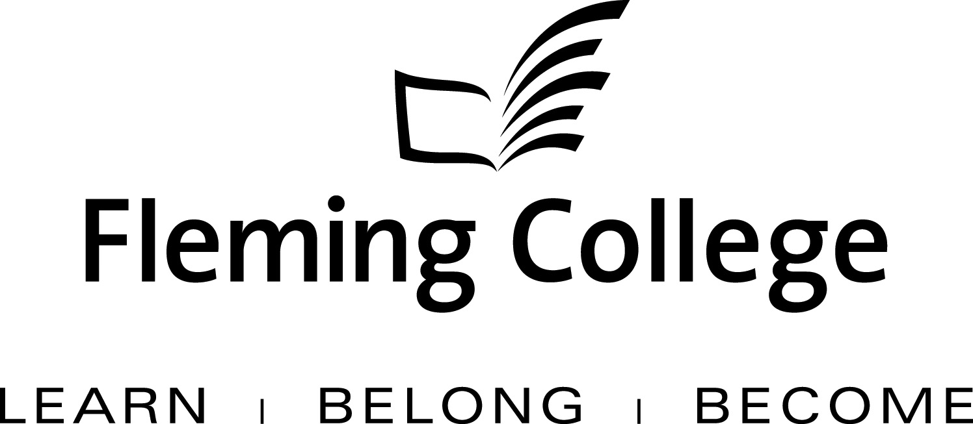

APDC/ASA EXECUTIVE SUMMARY TEMPLATE
FOR PROGRAM REVIEW

The Executive Summary will be presented to the Academic Planning and Development Committee and the ASA Committee of the Board of Governors for information and feedback.

Subject: | Education, Health and Wellness/Community Development and Health Program Review Report | December 2012
Presented by: | Carol Kelsey, Dean
Action: | For Discussion / Information

SOURCE
• Fleming’s Quality Assurance Process (College Policy 2-207)
• ASA Committee mandate (Board Policy 1-102J) to conduct reviews of existing programs of instruction on an ongoing basis, subject to current regulation, legislation and policy directives

BACKGROUND
Fleming’s quality assurance process includes a two-staged process that includes: Curriculum Renewal (conducted annually) and Program Review (conducted every five years). These two internal processes are integrated so there is an ongoing focus on curriculum quality.

The Program Review process is characterized by both depth and breadth of analysis. Program data is collated, reviewed and assessed against given criteria, providing a measure of both the vitality and viability of each program. Based on this analysis, long-term plans are then created to guide continuous curriculum improvement and build on the cumulative outcomes of annual curriculum renewal. At the end of this process, a Program Review Panel (convened by the Dean) is charged with the responsibility of making recommendations concerning program viability as well as suggesting program/curriculum revisions.

In adhering to the mandate of the APDC/ASA Committee to receive reviews of existing programs of instruction, the Executive Summary for the School of Education, Health & Wellness/Community Development & Health is hereby provided, for the Committee’s information.

PROGRAM STRENGTHS
The ECE program is in the enviable position of being in the midst of a very high labour market demand in Ontario, given the context of child care and early learning initiatives in the province. It has been estimated that the province will require more than 100,000 early childhood educators over the next several years.

The ECE program was an ‘early adopter’ of webconferencing for fourth semester students during block placement (in 2010/11), demonstrating faculty willingness to engage learners with new technology and prepare them for the future.

The program has a long history of community integration, with the ‘centrepiece’ Toddler program offered in third semester, and extensive support of the Family Gala in the City of Kawartha Lakes.

PROGRAM CHALLENGES
The maintenance of currency in a rapidly changing environment (including a somewhat de-stabilized industry) is a challenge for the program.

Ensuring that enough graduates are competent to enter the School system as early childhood experts working alongside teachers, as well as meet the needs of early child care (focused now on infancy to age 3 years) is a tall order for two main reasons: 1) we must cultivate more placement sites at a time when child care agencies are closing due to financial pressures; and, 2) our registered students are ‘high risk’, with over a third requiring remedial help with literacy skills. Both will also compromise our ability to accommodate the increased labour market demand.

We have been implementing various strategies to address low retention and graduation rate issues for the last 4 years, with some very modest success to date. The program’s KPIs have also suffered.

KPI RESULTS
KPIs 1 (Graduation Rate), 8 (Student Satisfaction with Learning Experience) and 9 (Student Satisfaction with Teachers) have been most problematic in this program, with worrisome downward trends in the latter two. The graduation rate, while still a concern, increased from 48% in 2010 to 53% in 2011 and 58% in 2012. KPI11 (Graduate Satisfaction with the Program) began with a 98% satisfied/very satisfied in 2007and has dropped to 89% more recently.

SUMMARY OF RECOMMENDATIONS
Recommendations Building on Program Strengths:

- It should be noted that the Fall 2012 intake at Frost campus was suspended, secondary to financial pressures (low enrolment) and to accommodate the Frost vision and its exclusive focus on the School of Environmental and Natural Resource Sciences. Fortunately, we were able to enlarge the intake at Brealey campus, with the idea of preserving and utilizing cultivated placement sites in the City of Kawartha Lakes. Further recommendations consider mechanisms that would enable individuals working in ECE to complete their education on a part time or accelerated basis, assisted through attention to PLAR, etc. Definitive continuing education offerings have been presented for the purpose of addressing issues within the rapidly changing environment.

- The most important curriculum change recommended is in the delivery format – in September 2012, we began implementing ‘flipped classrooms’ in the first semester. This brings congruence between current theories of early learning (learner centric) and the ECE curriculum itself. The plan is also to gradually increase e-learning components -both strategies for increasing student engagement, critical thinking and preparation for lifelong learning in the field. Embedding the principles and practices of inclusion (and diversity) throughout the curriculum was also deemed to be of great importance.

3) Revision is being made to the Toddler program, and negotiations are underway to conduct this in the Fall of 2013 at George Street United Church, which is the site of a new hub. Mutual benefit is anticipated with this partnership.

Faculty are also anxious to renew the Aboriginal Emphasis stream and related placement opportunities and we will be working with the School of Justice and Business studies to address this once more.

Field placement preparation and the field observation visits have been discontinued in the first semester, secondary to partner and operational considerations.

Recommendations Developed to Address Gaps Identified:

- Continued and enhanced faculty PD, development time and auditing opportunities are being used to ensure currency in content areas. Continuous attention to the environment will enable us to provide educational opportunities for registered ECEs in the community as well (e.g. Children’s Mental Health certificate and potential graduate certificate in Children’s Health and the Environment). Increased effort will be placed on cultivating placement sites within school boards.

- The literacy skills of these students has made it patently obvious that we need to collaborate with GAS and, beyond the two Communications courses, continue to embed communication skills within each piece of evaluation (for example, reflective practitioner assignments; DECA reports). Professional success workshops with an enhanced focus on portfolios will be developed. The January 2013 intake of ECE will be part of the implementation of the college’s new advising model, which focuses its efforts on high risk students and early intervention.

- The low retention and graduation rates will similarly be addressed through some of the mechanisms mentioned above, as we believe these two are inextricably related. We continue to work with guidance counsellors, high school recruiters and marketing to enhance prospective student understanding that this is a challenging field of applied psychology grounded in the science of child development. We are revisiting the idea of a dual credit offering once the planned curricular changes have occurred to our satisfaction.

Program Review Panel Meeting Date:
Two meetings of the panel (October 10th and October 19th) were scheduled and subsequently cancelled due to the availability of the seven external community members. The program review and list of questions were then circulated for comment on October 30, 2012 to the invited group. When only two responses were received, a reminder was sent out November 15, 2012. This was followed by individual calls by the coordinator, yielding further emailed responses.

It should be noted that the curriculum was presented to the Program Advisory Committee on April 13, 2012 and the group agreed to the recommended changes to the curriculum.

Program Review Panel Participants:
Dean: Carol Kelsey
Program Co-ordinator: Linda Hudson
Chair: Molly Westland
Curriculum Consultant: Pauline Smiley
Program Faculty/Support (maximum 4): Mary Lou Lummiss; Heather Kay; Niki Pollard
External Members (minimum 3): Leslie LeClair RECE, Community Living Kawartha Lakes; Teresa Burke, RECE, Executive Director, Nursery Two; Cheryl Herder-Kindergarten Teacher, Rhema Christian School

