EST Program and Curriculum Review Template

Instructions: Review all information that is stored on your program and curriculum review web page.
https://department.flemingcollege.ca/pcr

On this template, enter Key Findings only, in brief point form. This is intended to be a reflective, continuous exercise and it is not expected that there will be a written response to every single question. You will work with this document and update it annually. The primary focus on an annual basis will be on the curriculum areas and at the 5 year interval, the document will be a more comprehensive representation of further depth of analysis within each of the sections. Add links to additional information only if you will find it to be helpful in the future use of this document.

Program Coordinator: |  | Tracy Partridge |  | Chair:Molly Westland
Program Review Facilitator: |  |  | Tanya Stewart | Date Completed:
Program Name: | Esthetician |  |  | Program Code:EST
1.0 Industry Trends and Employment |  |  |  | Summary of Key Findings
Review and discuss the following:  - Industry / sector changes or issues identified by the Program Advisory Committee  - Recent labour market data or sector reports as provided by the Fleming Library Researchers.  - Recent or anticipated changes in occupational standards, level of entry and credential and / or standards of accreditation  - Based on the above, do these changes or issues necessitate changes to your program, either immediately, or in the next few years? |  |  |  | - The esthetician industry continues to grow and branch out into more specialties upon doing professional development after graduating. Preparing the students for these types of jobs and offering the PD is recommended by the EST Program Advisory Committee. Master Esthetician is up and coming in the United States and Europe, Canada needs to follow the trend.  - Students are working at makeup counters in high end cosmetic stores, medical esthetics clinics and are also doing very specialized front line booking and managing duties.
1.2 Labour Market and Employment Trends  Review and discuss the following:  - Graduate employment statistics over the last few years, including those of students employed in the field, in a related field, outside the field, or unemployed, and any emerging patterns in this data.  - Emergent employment trends such as new types of positions, changing job market, regional distinctions, changing employer profile, or emerging skill shortages |  |  |  | 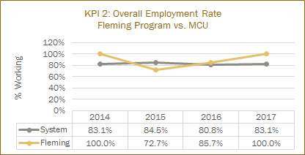  Despite some labour market reports which include estheticians in their data, a recent shift in consumer demand is now causing some markets to witness a ‘bidding war’ for qualified estheticians. https://www.theglobeandmail.com/report-on-business/small-business/talent/aesthetician-shortage-threatens-growth-of-spa-industry/article32426790/  Co-ordinator of the program notes a marked increase in the number of employers contacting her directly for her top students. In fact, many of the current cohort of students in the program have already been placed (33%) and are employed as they complete their diploma. It is anticipated 100% of the students will be employed in the industry at, or shortly after they graduate.
2.0 Key Performance Indicators  Review and analyze the formal Key Performance Indicator (KPI) results for your program. |  |  |  | Summary of Key Findings
2.1 Student Satisfaction  In addition to the formal Student Satisfaction KPI results, comment upon any other formal or informal discussions with students and graduates such as student focus groups, class councils, class representatives, individuals or delegations, or debriefing sessions following a field placement, clinical placement, or practical work integrated learning experience. |  |  |  | 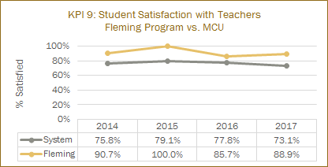  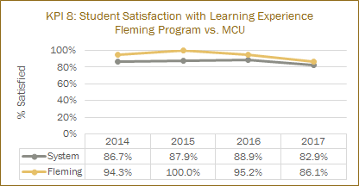  Strengths /Highlights of Program (from student focus group)  - New space  - Experienced teachers, they know what they are doing, very supportive.  - Working on “real” people  - Chinese Face Mapping  - Alternative Medicine Choices  - Coordinator is able to provide contact information for suppliers so after graduation the students can get supplies.
2.2 Retention Rate  - Use the IPP (Integrated Program Planning) data that focuses on Retention.  - Review patterns of retention on a semester by semester basis over the last five years.  - Comment on the effectiveness of any strategies adopted to improve student retention. |  |  |  | The long-term retention rate for this program is high, with approximately 75 - 85% of first semester students returning for sems two and three, consistently.  The majority of students who leave the program, do so between first and second semester. This can be attributed to an increased realization of program content, demands, and expectations. There is very minimal attrition between second and third semester.  Admission requirements for this program are broad, and Fleming accepts Workplace level as an academic background for the program. Admission requirements for similar programs at other colleges vary, with some focusing specifically on English and Science highschool courses EST program admission requirements province wide  Students entering the program seem ill prepared for the rigours of the courses, especially those courses with a science base. A review completed by Fleming Data Research, indicates that over the past three academic years, students entering the program, had very little science prep (previous courses) EST student highschool relevant courses and marks  Current strategies adopted to help maintain and improve student retention, include upper semester peer tutoring, and Academic Plans to fit the needs of the students.
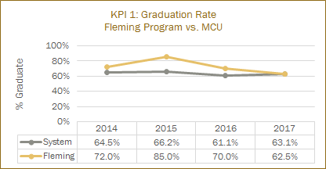
- For the past three years graduation rates reflect a variety of issues, including the final two years the program was located in Cobourg (2014/15, 2015/16), the community’s reaction to the program moving to Peterborough was to quickly enroll students before they would have to travel to attain the education. Many of those students expressed a disinterest in the program, but took it because it was the only college program offered in the community. The past year (2016/’17), showcases a lower graduation rate, primarily due to a group of students with a weaker level of education preparedness.
2.4 Graduate Satisfaction  - Review patterns of graduate satisfaction and provide comment. |  |  |  | 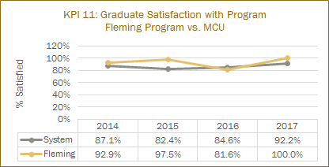  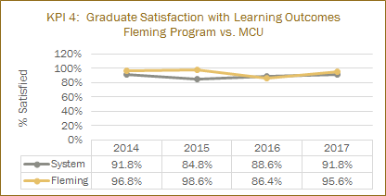
2.5 Enrolment Trends and Demand  - Your team will review and analyze the patterns in the number of program applicants, confirmations and actual registrants over the past 5 years. You will also examine changes, if any, in the student demographic profile and the impact, if any, of this changing student profile on program curriculum.  - Assess whether the program curriculum needs to change based on the above analysis.  - Use the FDR excel spreadsheet that provides Day 10 enrolment numbers for Fleming for the last 10 years, to assist you with your analysis.  - Please review the IPP (Integrated Program Planning) data that focuses on trends related to student demand, and the related ‘Situational Analysis’ information included for your program – select the Demand Trending Tab and Situational Analysis Tab. |  |  |  | -for the most part, enrolment for the EST Program hovered in the mid to high 20’s for the 10 years that it was offered in Cobourg.  -the second year was an exception with a double cohort of 43, which was never repeated again.  -the final year in Cobourg, Fall 2015, saw a decline to 19 due to students waiting for it to move to Peterborough the following Fall.  -the first year in Peterborough saw a jump back up to the norm or 29 and the program had a waitlist for the first time.  -roughly 62% of the students who began in the Fall of 2016 were from the Peterborough area (Bridgenorth, Peterborough, Lindsay and other close small areas) due in part to the networking with local high  schools with Dual Credit offerings.(Evolve - student program inquiry)  -students also reported that they did not have a way to get to Cobourg, so offering EST in Peterborough allowed them to take the program.  -future looks good with the program being Waitlisted as of the end of January 2017 for the Fall of 2017 AND for the Winter of 2018.  - the potential for an additional section in the Fall of 2017 exists, however, it does not seem to be good timing, considering the SIF construction project in the A wing where the program is housed.
3.0 Program Curriculum |  |  |  | Summary of Key Findings
3.1 Program Learning Outcomes and/or Sector Standards  - Review program level learning outcomes in preparation for curriculum mapping (vocational, essential employability skills, general education)  - Where applicable review sector standards to ensure program is keeping up with new trends, developments and requirements. |  |  |  | - Staff attends International Spa and Esthetics show in the spring of each year to learn about new trends, techniques, and products that are popular in the industry.  - PAC membership provides information re: the day to day needs of employers in the industry  - faculty then apply this information to existing courses and adjust learning outcomes and course content as needed on a semester-to-semester basis  - course outlines are rarely ‘rolled’ over in this program. There is always some adjustment being made to make the course stronger for the students. Whether it be a changing product, the amount of time spent on a skill, or with the assessment of a skill.
3.2 Program of Study, Course Outlines, Delivery and Program Map  - Review the feedback and suggestions received from Course-level survey completed by faculty at the end of each semester.  - Review the balance and frequency of assessment types across the curriculum and their appropriateness to learning outcomes for the course and program level outcomes.  - Collect a cross section of samples of student work as evidence of achievement of learning outcomes.  - Reflect and comment upon the variety of methods used to demonstrate program outcomes.  - Reflect and comment upon the degree of technology-enhanced delivery of the program outcomes.  - Discuss the degree and depth to which the program is providing work integrated learning experiences.  - Record the course in the curriculum that covers the college-wide sustainability learning outcome  - Review (or create) Program Curriculum Map(s) to ensure that there is alignment of current courses to the overall program outcomes, including the Vocational Learning Outcomes, the Essential Employability Skills, and adherence to the General Education Policy.  - Make recommendations to address any gaps identified or improvements required.  - Review the program’s current admission requirements and their suitability in relation to program rigour and student preparedness.  - Include an updated program curriculum map on your program and curriculum review web page. |  |  |  | Types of Assessment in the EST Program to Demonstrate Program Outcomes  - Technology enhances the learning outcomes in the program in many ways, including in-class activities, as well as, practical application of spa skills. For example, high frequency, galvanic steam machines, micro-dermabrasion, and LED light technology.  - i-clickers are used in manicure and pedicure for review of theory. A class set has been donated by EST graduates, for use by current students.  - For the core program courses, 50% to 75% of the course is focused on providing work integrated learning experiences. For example, Manicure COSM3 - 2 of 3 hours per week is applied learning, while 4 of 5 hours in Pedicure COSM6 is applied learning.  - The program’s decontamination system (Prevention), is used in all courses, and eliminates contaminants from being poured down the sink, causing environmental damage. All students are educated and tested on this system.  - Vegan and organic products are used in a variety of the core courses to emphasize health and wellness to the students  - The assessments listed below, demonstrate the program’s commitment to meeting a variety of learning needs and assessment applications to ensure all students are assessed fairly.  Examples of student work (below), illustrate the VLOs (#6,7,9) (add pics)  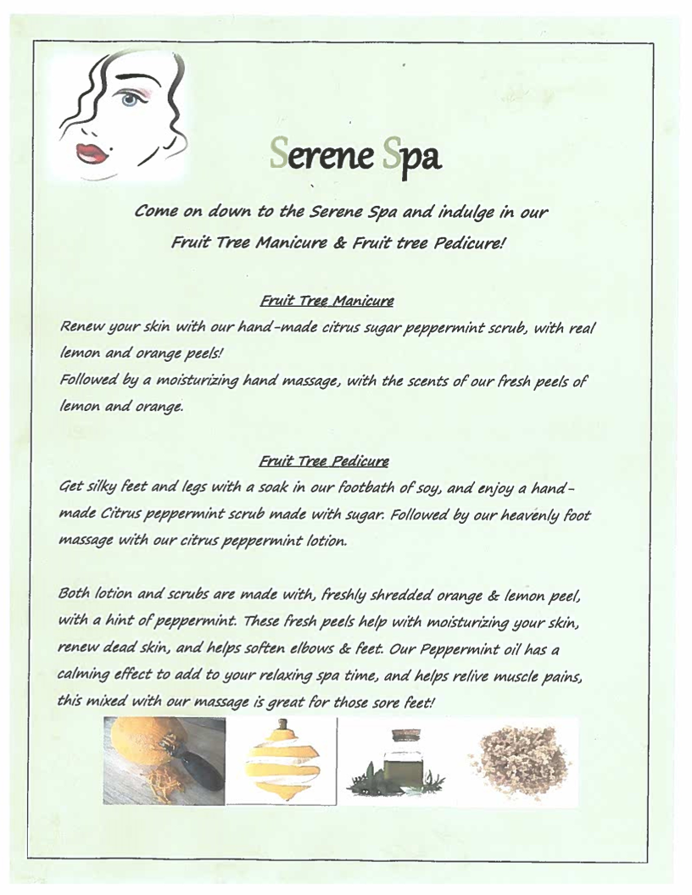  - COSM 8 Skin and Body Treatments assignment (a culminating written report, utilizing knowledge from Sems 1 & 2), worth 30% going forward, meets VLOs 3,4, 7,9  Manicure COSM3 and Pedicure COSM6  Written Tests  Written Exams  Practical Assessments  Practical Exams  Written Assignments  COSM3 and COSM6 - decrease the percentage attached to assignments and do more practical assessments throughout the semester. For example, reducing client consultation form from 10% to 5%, and assessing skills several times (polish application etc…)  Hair Removal COSM7  Practical Assessments  Written Assignments  Brow Portfolio  Fundamentals of Skin Care and Aromatherapy COSM37  Skin and Body Treatments COSM8  Advanced Skin and Body Treatments COSM10  Written Tests  Written Exam  Practical Assessments  Practical Exam  Consultation Assessments  Homework Assignments  Written Assignments  We found there was not enough percentage value in the final practicals and written exams, so students were able to pass the course by ‘showing up’ and doing the smaller assessments (2-3%), but their skill and knowledge did not meet the learning outcomes, however, the ‘numbers’ would still equal a pass in the course.  Recommendation: Raise the final practical assessment in COSM37 from 15% to 30%, and the final written from 20% to 25%.  COSM 8 - Increase main assignment from 25% to 30%  Nail Technology  Practical Case Studies  In Class Assignments  Assignment  Makeup Artistry COSM9  In Class Assignments  Makeup Portfolio  Practical Spa Experience One FLPL105  Practical Spa Experience Two FLPL106  In review of student application of skills in the public spa, faculty have witnessed students’ skill levels acquired in specific courses, decreasing because the students are not performing at the level they are required by the industry. If students are not ‘being assessed’, they are not applying themselves.  Recommendation:There should be practical assessments and a career portfolio assignment added to both courses, and re-introduction of a spa journal.  GAPS IN EST PROGRAM’S ASSESSMENT OF STUDENT’S SUCCESS  We are finding that students can pass if they do the assignments but don’t do well in their Practical Assessments. With the courses resulting in a hands on profession, this must be addressed before more students progress in the program without the hands on component being where it need to be.  The assignment ratio needs to be looked at in comparison to the Practical Assessments. Perhaps assigning more marks to practicals and less to assignments or doing more practicals and less assignments will alleviate this issue.  EST ADMISSION REQUIREMENTS  The Fleming College EST Program is the only esthetics program in Ontario that has High School Workplace Level as their minimum requirement.  This can be problematic for students as Workplace in high school does not prepare them for the level in which the Fleming EST program strives to achieve. All EST core courses require a 70% average to pass the course. A percentage of the attrition is likely due to those students entering with Workplace, but being expected to work at the Applied or Academic Level at college.  Communications One COMM201 and Fundamentals of Skin Care and Aromatherapy COSM37, historically are the problematic courses for students who enter with Workplace and even Applied from high school. Realistic expectations, attention to timelines, and a lack of quality work is missing.
4.0 Strategic Positioning and New Opportunities |  |  |  | Summary of Key Findings
4.1 College and School Alignment  - Review program alignment with college priorities such as vision, mission, values, strategic plan, academic plan and the educational mandate, and / or academic priorities of the School. |  |  |  | The Esthetician program meets the strategic priority of delivering outstanding student learning and experiences by having industry leading experts, top of the line products for the students to work with and a state of the art newly built lab. This newly built Spa and Clinic collaborates with the community by providing a publically accessible clinic for the City of Peterborough, that provides low cost, high value services of massage and Esthetic services. As well, we have been investigating online booking and documentation systems, that will bring the student experience to the current industry standard. These systems are being piloted summer 2017 for intended implementation Fall 2017.  The amalgamation of the massage and esthetician public clinics has created the ability for the programs to share resources such as booking and documentation systems and logistics to enhance the financial health of both programs.
4.2 Competitor Programs  - Analyze key parallels and differences between this program and those of its closest competitors, where applicable.  - Comment on the ’Value-added’ program distinctions and their attractiveness to prospective students. |  |  |  | - Delivering in a fast track format as opposed to two full years is a positive feature for prospective students.  - The Aromatherapy aspect of the EST Program is attractive to prospective students who want to lean towards the health and wellness aspect of esthetics as well as the beauty part.  - 60 hour Nail Technology course focusing on artificial nail applications is a draw for prospective students who wish to specialize as Nail Technologists in the spa industry. (many colleges have ceased to offer this program due to difficulty of teaching the course, artificial nails continue to be one of the most requested services in salons and spas)  - Offering two body courses as opposed to other colleges that offer one or just set hours in a skin care course is a marketing feature that we use because body treatments are very popular in the spa industry especially at destination spas.
4.3 Learning Pathways  - Comment on recent or anticipated initiatives that promote student pathways including secondary school partnerships, dual credits, program laddering, dual diplomas, and university transfer, articulations, and partnerships.  - Identify any new pathways that could be developed. |  |  |  | - The EST Program supports Dual Credits in the Manicure COSM 3 and the Makeup Artistry COSM9 courses.  - We network with several school boards, Catholic and Public, in Peterborough, Lindsay, Haliburton, Clarington and Bowmanville.  - A new aspect this year was the on site teaching at the Brealey Campus in the Fall of 2016. Historically we went to their schools but most come to the college now giving the Dual Credit students a real college experience.  Dual Credit Offerings for 2016/2017  Fall 2016  3 Makeup Artististry  2 Manicure  Winter 2017  4 Makeup Artistry  3 Manicure  Spring 2017  1 Makeup Artistry  1 Makeup Artistry (Summer School Offering)  Proposed Dual Credit Offerings 2017/2018  Fall 2017 Proposed Offerings  3 Makeup Artistry  1 Manicure  Winter 2018 Proposed Offerings  5 Makeup Artistry  3 Manicure  Spring 2018 Proposed Offerings  1 Makeup Artistry (Summer School Offering)  New Pathways with Hospitality  In discussions with the Hospitality Coordinator, Jennifer Rishor, we think there may be a way for Esthetician Graduates to enter the second year of Hospitality and get the second diploma as well. There are students who wish to work in managerial positions within spas that are located in large hotels and resorts. We plan to explore this idea further.
4.4 New Program or Redesign Ideas  - Are there opportunities for new program initiatives based on Program, School, or community strengths and alliances? |  |  |  | · Master Esthetician, a Fleming College Post Graduate Certificate, has been proposed and entered in to the Gate system of approvals.  · Master Esthetician will consist of courses/modules that will have Advanced Makeup Techniques and Sales, Medical Esthetics and Holistic Esthetics streams.  · Housed within the Post Graduate Certificate will be popular Professional Development courses that Estheticians take upon graduation to further specific interests or to stay current.  · Hairstyling, although it has been put on hold for now, continues to be the obvious choice for a new program that would complement the existing Esthetician Program, as it would share several courses in each diploma, creating spill over from one diploma to the other as the only course they would need to get the other diploma would be core courses. The Dual Credits are utilized by the Hairstyling High Skills Major classes from Holy Cross, St. Peter’s, Kenner and St. Stephen’s. They repeatedly inquire about Hairstyling at Fleming as the only local alternative is a private school.
5.0 External Relations |  |  |  | Summary of Key Findings
5.1 Community Partnerships  - Does your program have significant partnerships, relationships, connections, or offers of support from the community that help to enrich the program and the student experience?  - Are faculty, staff, and student involved in volunteer projects and events? |  |  |  | -Ste. Anne’s Spa continues to be an industry partner who supports the EST program by hiring several graduates each year, sponsoring awards, guest lecturing and allowing us to utilize their facilities to teach our Hydrotherapy component of the Advanced Skin and Body course.  -The Balnea Institute and Trish Green, owner, continue to support the EST program by guest lecturing and teaching unique body treatments in the Skin and Body and Advanced Skin and Body courses. They also sponsor awards and employ one of our graduates as their North American Educator for the United States and Canada.  -Urban Spa, local spa owner, Kerri Holley, graduate of our program, also supports us by guest lecturing and sponsoring our awards. She employs several of our graduates each year.  -Partnering with the The Peterborough Sport and Wellness Center to offer a free spa service when new members sign up (spa menu and special offer will be inserted in the New Members Package.  -Reaching out to local senior’s homes, Applewood Manor, etc. to offer 50% off to seniors on Friday mornings to stimulate more experiences for students in the ESt Program.  -students volunteer during the school year at events sponsored by the college for Mental Health Awareness, Health and Wellness initiatives, etc.  -students have historically worked at the Alderville Ladies Night where they are paid for their services during a night sponsored by the Alderville Aboriginal Community.  -EST plans to network with the International Students at Fleming and offer them specific experiences as a group in the spa. We would like to utilize their expertise in Henna Skin Art and have them share their skills with our Makeup Artistry course.
5.2 Program Advisory Committee  - Comment on the distribution of Committee membership by constituency, sector, and / or region.  - Comment on the vitality of the Committee (frequency of meetings, members’ level of participation, engagement, and turnover.) |  |  |  | The EST Program Advisory Committee meet once a year in November.  An electronic questionnaire is sent to PAC members prior to the annual meeting to stimulate discussion.  PAC members are often guest speakers and workshop leaders. For example, Trish Green leads a certification workshop for a specialized body treatment each year in the third semester.  This new program advisory committee was established in Fall 2014. The terms of membership are three years, with the option to renew once after completion of first term.  Members are as follows:  - Janice Scott, Owner of Aquaderm Med Spa, Cobourg  - Simone Dobbin, Owner of Euphoria Wellness Spa, Ptbo.  - Kerri Holley, Owner of The Urban Spa, Graduate of Fleming EST, Ptbo.  - Brandi Kalmuk, Graduate of Fleming EST, EST Faculty and Lab Tech, Cobourg  - Leila Hamwi, Vivacity Spa, Medical Esthetician, Graduate of Fleming EST, Bowmanville  - Natalie Kashowski, Spa Manager of Ste. Anne’s Spa, Grafton  - Trish Green, owner of the Balnea Institute, Burlington
5.3 Alumni Relations  - Describe the type and range of alumnae involvement in the program.  - Current and future strategies to engage alumnae in the program. |  |  |  | -alumni work in the program as Lab Techs, Dual Credit Faculty and Faculty in the EST Program.  -alumni also come in as Guest Speakers during the Semester Three business class.  -alumni sit on the Program Advisory Committee
6.0 Program Resources |  |  |  | Summary of Key Findings
6.1 Program Revenue and Expenses  - Please review Integrated Program Planning (IPP) information for your program.  - Are program resources adequate, in the context of program currency and student numbers? (e.g. laboratory equipment, software, library holdings, or tools essential to program delivery and student learning.  - Are there opportunities for further program specific external revenue such as sponsorship, grants, donations or gifts-in-kind?  - Review the existing revenue and expenses associated with your program using the IPP tool and provide comments below. |  |  |  | The EST program had a low IPP score of 19 for the 2015/2016 academic year. The external demand score was 35, quality score was 62 and the financial was 17. This was due to the known fact that the program was moving to Peterborough and applicant research showed that most students came from Peterborough to attend. This low enrollment for this academic year has been remediated by the move of the program to Sutherland campus. This has resulted in an over-full enrollment of 27 in the fall and 27 in the winter intakes. This application year, the program was deemed oversubscribed. Once the SIF construction has been completed, I will relook at having two sections of intake in the fall 2018.  The new Spa and Clinic is a beautiful, modern and purpose built space for the students to practise in that is available to the public as a revenue generation tool. The equipment is current and due to the increase numbers in the sections, new steamers etc. have been purchased. The  clinic has been budgeted to create $30 000.00 in revenue this year.  A mitigation plan was created for the program for the 2015/2016 academic year to address the enrollment challenges and I have great hope that with the growth in enrollment and the increased spa revenue, that the program’s IPE Financial and Demand scores will exceed targets.
6.2 Faculty and Staff Resources  Please comment on:  - The number and distribution of all faculty, technicians, and technologists associated with the program including full-time, part-time, sessional, and cross-appointments.  - Profile of the faculty, and staff associated with the program including cumulative credentials, scholarship, work-related and teaching experience, and expertise in education.  - Significant faculty or staff accomplishments such as professional recognition and awards, achievement of credentials, and appointments.  - Hiring priorities over the next few years based on the above. |  |  |  | There is one full-time faculty member who holds the program coordinator role. She is a passionate, knowledgeable and professional esthetician that strives to have the best program, products and experiences for the students. She is supported by a variety of part-time and partial load faculty. All who are equally committed to their profession. One long-standing partial load faculty complements the full-time faculty as her skill set provides a full package for the students. A variety of newer partial load faculty are being mentored and have been doing labs and now entire courses in the program.  If enrollment and CTO continues to climb, a look at a potential for a full-time faculty hire may be required in the next few years.

Program Improvement Plan

Based on the analysis of your key findings, identify areas that require attention and action in the next 1-3 year timeframe. Ensure that you only recommend actions that reflect the program’s priorities and its capacity to achieve them, and record the success of any changes implemented and the means by which they are being evaluated.

Recommended Improvements: | Timeframe | Person(s) Responsible | Action Taken  Proceeding = P  Completed = C  Not Feasible = NF
Reduce Semester Two, Introduction to Human Biology SCIE 112 from a 3 hour per week course to a 2 hour per week course (change from 45 hrs to 30 hrs)  Faculty Input | Short Term  ASAP  Mid-Term  Develop new course outlines  Long Term  Into effect for Winter 2019 | Coordinator  Chair  Academic Operations
Reduce Semester Three, Customer Care and Interpersonal Dynamics BUSN 68 from a 3 hour per week course to a 2 hour per week course (change from 45 hrs to 30 hrs)  Evidence: Faculty input | Short Term  ASAP  Mid-Term  Develop new course outlines  Long Term  Into effect for Spring 2019 | Coordinator  Chair  Academic Operations
Increase Semester Two, Skin and Body Treatments COSM 8 to 4 hours per week course from a 3 hours per week course (change from 45 hrs to 60 hrs)  Evidence: Faculty input, and student course evaluations | Short Term  ASAP  Mid-Term  Develop new course outlines  Long Term  Into effect for Winter 2019 | Coordinator  Chair  Academic Operations
Increase Semester Three, Advanced Skin and Body Treatments COSM 10 to 4 hours per week course from a 3 hours per week course (change from 45 hrs to 60 hrs)  Evidence: Faculty input, and student course evaluations | Short Term  ASAP  Mid-Term  Develop new course outlines  Long Term  Into effect for Spring 2019 | Coordinator  Chair  Academic Operations
There should be practical assessments and a career portfolio assignment added to both courses, and re-introduction of a spa journal. | Short=-term  Work Integrated Learning Experience for 280 hrs  Portfolio (going forward in Fall 2017) | Coordinator  Faculty
Raise the final practical assessment in COSM37 from 15% to 30%, and the final written from 20% to 25%.  COSM 8 - Increase main assignment from 25% to 30% | Short-term  Going forward in Fall 2017 | Coordinator  Faculty
Look at a potential for a full-time faculty hire | Review enrollment and CTO  January 2018  Potential posting Spring 2018 | Chair
Offering Fundamentals of Skin Care and Aromatherapy in the evening through Continuing Education, or offering the course each semester, not just Fall and Winter. January intake students currently have to wait until the following January to proceed with most of the program, if they fail this course in first semester. Students who are not successful wouldn’t have to wait until the next time it is offered, especially if it skips a semester in the calendar ie. not offered in the Spring Semester and the Fall Semester has a Waitlist.  Could also be offered to nurses who want to do Medical Esthetics and to estheticians in the industry who want to refresh or gain further skin care knowledge. | Short-term  Fall 2017  Assess how many current students are missing COSM37  Survey of local spas to determine ‘need’ and ‘desire’ for staff upgrading  Mid-term  Develop course, choose time, coordinate with Continuing Education  Winter 2018  Implement Spring 2018  Long-term  Develop pathway to be able to offer to nurses who want to add to their skill set with medical esthetics | Chair  Continuing Education  Coordinator
Continue to develop a cache of professional development courses for students, grads, and estheticians in the spa industry | Ongoing | Coordinator, Continuing Education
Re-visit the program’s current admission requirements and their suitability in relation to program rigour and student preparedness.  - Evidence: First semester retention rates, and graduation rates | Short-term  Review requirements, compare to other colleges, Fall 2017  Mid-term  Develop new admission requirements if possible  Long-term  Implement new guidelines  Fall 2019 | Dean, Chair, Co-ordinator
Investigate if there is a program in pre-health/general arts which could be a pathway to better prepare students entering into the esthetician diploma program, to achieve better success.  Evidence: FDR additional research re: intakes and the level of academic achievement in highschool sciences. (insert link) | Short-term  Review current PHS/GHS programs  Spring 2018  Mid-Term  Long-Term  2019/2020 Implementation | Dean, Chair, Co-ordinator, GAS Associate Dean
Explore possibility of three semester intakes to provide greater course availability for students to access throughout the year. If for example, a student had to drop ‘Skin Care’ in January, he/she may not be able to pick it up again until the following January, delaying his/her advancement in the program. This impacts student retention. This would also allow all students to be mentored by an upper semester group in the program. There would be possible intake from students who graduate highschool in January. | Mid-term  Research intake potential, availability of space, sequencing of courses  Spring 2018 | Chair, Co-ordinator
Investigate and prepare a proposal to introduce a hairstyling diploma program to respond to stakeholder requests (dual credit pathway clients - highschools with hairstyling high-skills major programs)  Evidence: Letters from highschool faculty can be provided if requested | Short-Term  Academic year 2018 | Director of Strategic Planning and Product Development  Coordinator  Chair
Need to prepare for the implementation of a future Master Esthetician post-graduate certificate program at Fleming.  - Evidence = industry trends, demand from graduates for school-based training, with practical and theoretical elements (student feedback, open house inquiries); PAC meeting minutes | Proceed through the ‘Gates’  (3 and 4)  Spring 2018 | Coordinator  Chair  Director of Strategic Planning and Product Development
Work with Hospitality Coordinator, Jennifer Rishor, to create a pathway into Hospitality for EST grads who want to work in hotels or destination spas. | Short-Term  Begin discussions Fall 2017  Mid-Term  Pathway proposal developed  Winter 2018  Long-Term  Implementation of pathway Fall 2018 | Coordinator  Coordinator of Hospitality  Chair  Chair Business  Pathway coordinator

