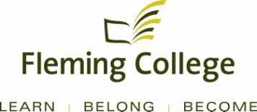

Curriculum Renewal
Annual Summary Report
School of Environmental and Natural Resource Sciences
(SENRS)

Forestry Technician

Prepared by:
Mary Ann Elliott, SENRS Chair and SENRS Program Coordinators
for Linda Skilton, Dean SENRS

Forestry Technician

Program: Forestry Co-ordinator: Gerald Guenkel Date: March 2012

A. Analysis of Indicators

Note: data is not recorded in this section of the template.

Reflect on, and discuss, the following indicators in the context of the curriculum and program:

1. Industry / Sector Trends

- Bio-energy
- Watershed management
- Forest restoration in oil and gas operations
- Non timber forest products
- Faculty need training in new approached in delivering materials to students

2. Curriculum Development

Revising third semester (see attached)

3. Student and Graduate Satisfaction

3.1 Key performance indicators # 4, 8, 9, and 11 (see Appendix C for a description of these).

4. Employment Trends

- Bio-energy
- Watershed management
- Forest restoration in oil and gas operations
- Non timber forest products

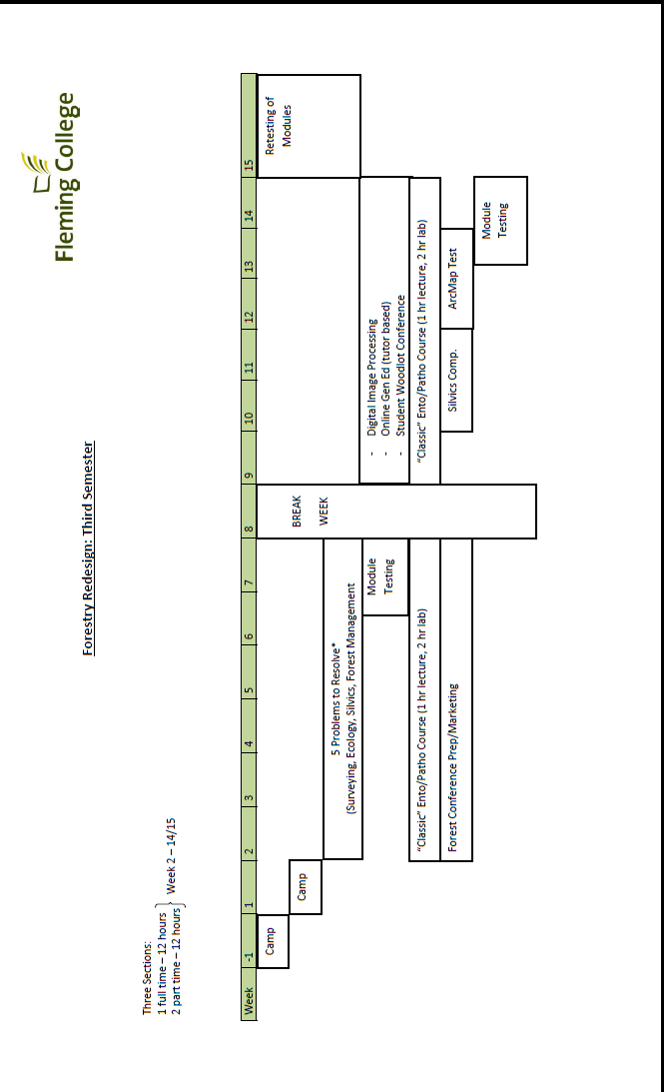
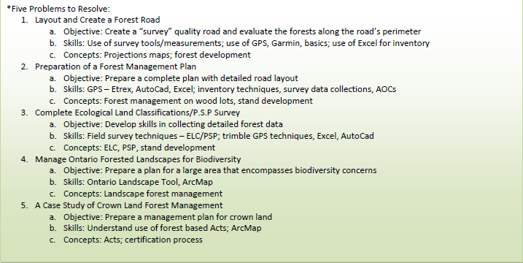

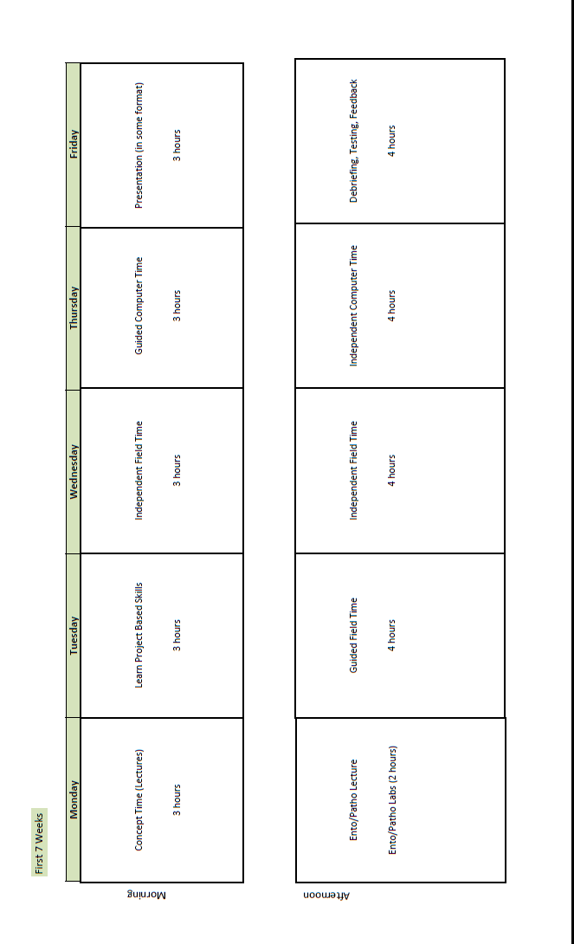
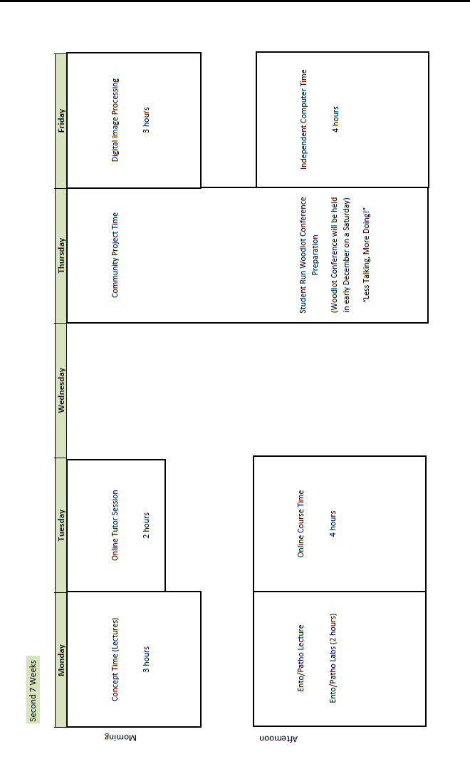

Program: Forestry Continued

B. Curriculum Strengths and Challenges

Summarize the curriculum strengths and challenges identified by the team.

Strengths:
- Focus on the forest from all aspects
- Meeting the challenge of incorporating new pertinent technologies into the program

Challenges:
- The student learning approach changing (I.e. lectures are of questionable value)
- Addressing forestry skills for out of province employment

C. Action Plan

Identify priority actions for the next year and the rationale for their inclusion. For each, indicate the project lead, and the proposed timelines for completion.

- More seamless education by providing the learner multiple outcomes from multiple courses during challenging projects / assignments
- Encourage more independent learning – teach students how to be more effective lifelong learners
- Action plan – revise third semester of the program
- Remove Human Relations course, replace with career awareness to prepare students for emerging employment opportunities

D. Deferred Actions

Record any issues that will need to be monitored, researched, or deferred for future action.

- Full use of webinars and online tutorials for all courses
- Distance learning

Common Themes

- Infrastructure Needs

All programs indicated there is a need to update existing equipment and facilities. Several programs share equipment and with the increased use and demand for these pieces, there is extensive wear and tear on most of the equipment. The cost to repair a lot of the equipment is expensive. Storage space also continues to be an issue.

Action:
Continue to advocate for capital equipment and a space plan that includes a designed area to store, sign out, monitor and maintain existing equipment.
- Industry Support

Various members of the Advisory Committees have requested lists of needed equipment to see if they could donate any of their surplus pieces.

Action:
Coordinators have to be proactive to make the requests for donations.

- Program Quality

It was identified that some of the protocols and procedures used, and the supporting materials, are outdated. There is the challenge to find time to update curriculum at the same time as moving forward to adopt corporate initiatives such as blending learning. There is also a need to develop new skills around assessment and evaluation, and the use of new technology in the learning environment.

Action:
Faculty are making a conscious effort to ensure relevance and currency in their curriculum, but they need professional development to incorporate different learning methods. There needs to be more support for individual assistance to redesign curriculum and its assessment, to embrace the advancement of technology, and to learn how and where to use technology.

- Human Resources

There has been an increased use of contract faculty, primarily due to enrollment growth, which can potentially compromise program content as the faculty may change from semester to semester. There have also been several retirements, whose specialized skill sets needs to be replaced.

Action:
Develop a hiring plan to replace the skill sets required as SENRS moves forward to start new programs and update existing ones. Five fulltime faculty and one full time instructor are in the approved plan for 2012/13.

- Articulation/Transfer Agreements

Program coordinators continue to be active in engaging in opportunities to create articulation agreements across colleges and universities. With increased competition for a shrinking student population, and the desire of employers to have graduates with both technical, applied skills as well as advanced learning, the environment is favourable to create more pathways for learning.

Action:
Coordinators identify potential articulation opportunities to the Chair, who will make the connections and initiate dialogue to establish agreements. Once established, a clear visual aid for marketing these opportunities to students needs to be created.

