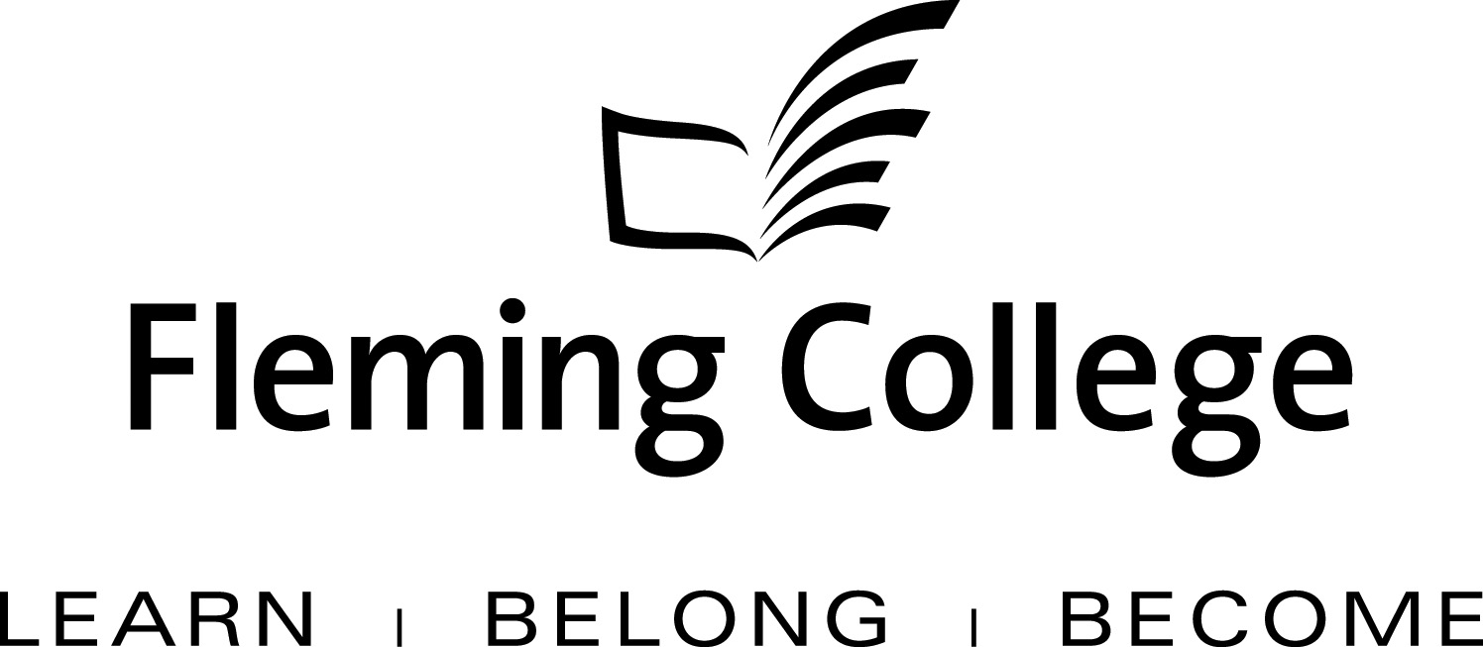

APDC/ASA EXECUTIVE SUMMARY TEMPLATE
FOR PROGRAM REVIEW

The Executive Summary will be presented to the Academic Planning and Development Committee and the ASA Committee of the Board of Governors for information and feedback.

Subject: | School of Environmental and Natural Resource Sciences Fish and Wildlife Program Review | April 2012
Presented by: | Linda Skilton, Dean
Action: | For Discussion / Information

SOURCE
• Fleming’s Quality Assurance Process (College Policy 2-207)
• ASA Committee mandate (Board Policy 1-102J) to conduct reviews of existing programs of instruction on an ongoing basis, subject to current regulation, legislation and policy directives

BACKGROUND
Fleming’s quality assurance process includes a two-staged process that includes: Curriculum Renewal (conducted annually) and Program Review (conducted every five years). These two internal processes are integrated so there is an ongoing focus on curriculum quality.

The Program Review process is characterized by both depth and breadth of analysis. Program data is collated, reviewed and assessed against given criteria, providing a measure of both the vitality and viability of each program. Based on this analysis, long-term plans are then created to guide continuous curriculum improvement and build on the cumulative outcomes of annual curriculum renewal. At the end of this process, a Program Review Panel (convened by the Dean) is charged with the responsibility of making recommendations concerning program viability as well as suggesting program/curriculum revisions.

In adhering to the mandate of the APDC/ASA Committee to receive reviews of existing programs of instruction, the Executive Summary for the School of School of Natural Resources and Environmental Science, Fish and Wildlife Program is hereby provided, for the Committee’s information.

PROGRAM STRENGTHS
The Fish and Wildlife program is the most popular program at the Frost Campus with approximately 160 students in semester 1; 170 students in semester 3; and 30 students in semester 5. Strengths identified as a result of the review:

- The one week fisheries fall camp doing lake survey exercises and fish sampling on Lower Buckhorn Lake is a highlight.
- Hands-on training in Fisheries and Wildlife management practices working to Provincial and industry standards.
- Strong technical component reinforced by applied lab work.
- Strong steady enrolment with strong KPIs.
- Good contribution to college overhead.
- Experienced and dedicated faculty and staff with close ties to the industry.
- An active advisory committee.
- Two week long camps in the third year and 2 work/field placements enhance graduate hands on skills and knowledge of the workplace
- The capstone research project in semester 6 utilizes industry data and prepares students both for the workplace and transfer into university
- Third year program courses are integrated and build on previous knowledge resulting in a holistic view of the overall educational experience

PROGRAM CHALLENGES

- Insufficient class time to cover all of the technical material appropriate to program. This
is particularly true of the:
- terrestrial wildlife assessment protocols and sampling techniques required for green energy employment and,
- soils and the basic environmental measurements component of habitat classification.

2. Increased number of students entering the third semester of the program are lacking the
skill set required to progress successfully to semester 4. This is evident with math,
which affects the student’s success in limnology in semester 3.

- Hiring consistent qualified contract professors for the Vertebrate Biology, Limnology 1 and the Wildlife courses is a challenge.

- There are limited funds available to hire full time professors combined with the difficulty
in recruiting and retaining contract faculty is an issue.

5. First semester students need to have a clearer understanding of the expectations of the
Fish and Wildlife Program.

  - Students progressing from common semester with a course failure or a low GPA are going to find F&W very challenging.
  - There is a lot of identification skills expected and of out-of-class work necessary to be successful in the F&W program
  - Finding employment in the F&W field is very competitive. Students need to be very good academically, willing to relocate to find work and willing to start in contract positions. Finding related work is by no means guaranteed.

- Students do not feel that the Chemistry and Statistics courses have relevance to their
program of study.

- Program needs to include job search and interview skills to assist students with
finding employment to increase overall and related employment rates.

- Admission into the Technology program in semester one has created challenges
related to progression into semester 5 and the direct entry process for applicants.

KPI Results
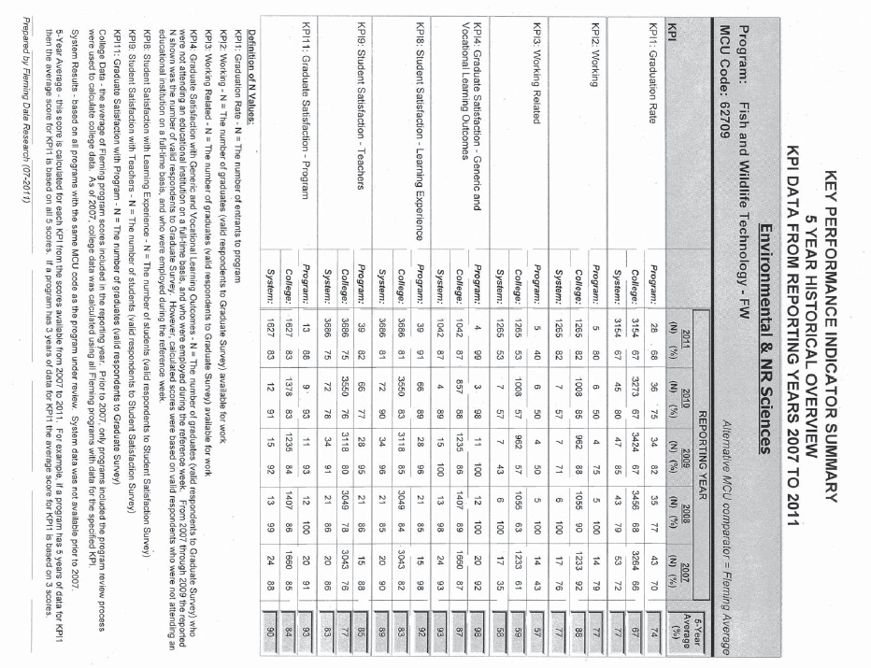
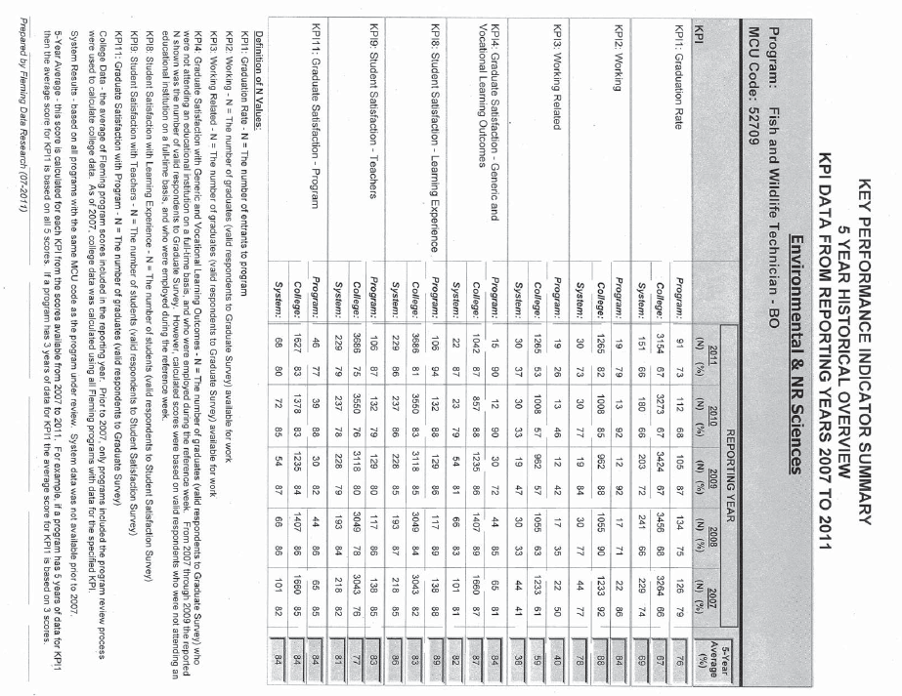
SUMMARY OF RECOMMENDATIONS

A summary of the recommendations is contained within the full report.

Recommendations Building on Program Strengths:

- Hire a full time position for the wildlife portion of the program and an additional position
to deliver the advanced and research related courses in third year.

- Provide more certification opportunities for students including replacing Big Game and
Fur 1 with an advanced Habitat Assessment course to allow wetland certification.

3) Consistent service course faculty or embed the courses in SENRS to ensure
relevance and application to the program.

Recommendations Developed to Address Gaps Identified:

- Redesign appropriate course content to include the wildlife component required by the Green Energy Market.

- Improve applied learning opportunities by using technology and blended learning strategies.

3) Include a Career Advancement techniques, portfolio development and interview skills course to better prepare students for the workplace.

Program Review Panel Meeting Date:
March 22, 2012 program staff
April 4, 2012 program review panel

Program Review Panel Participants:
Dean: Linda Skilton
Program Co-ordinator: David Wood
Chair: Mary Ann Elliott
Curriculum Consultant: Glenn Allen
Program Faculty/Support (maximum 4): Denis McGee, John Knight.
External Members (minimum 3): Matt Burley, Brett Tregunno, Harry Szeto

