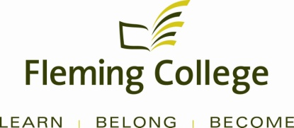

STRICTLY CONFIDENTIAL

APDC/ASA EXECUTIVE SUMMARY
FOR PROGRAM REVIEW

Subject: | School of Environmental and Natural Resource Sciences  Program Review Report
Program | Heavy Equipment Techniques
Presented by: | Linda Skilton
Action: | For Discussion / Information

SOURCE

• Fleming’s Quality Assurance Process (College Policy 2-207)
• ASA Committee mandate (Board Policy 1-102J) to conduct reviews of existing programs of instruction on an ongoing basis, subject to current regulation, legislation and policy directives

PROGRAM STRENGTHS

The Heavy Equipment Techniques program is a successful program that continues to attract students. Graduates of this program continue to find related and well-paid work. Recent expansions in natural resources and government investment in infrastructure has increased the number of available jobs for technicians that can repair, maintain and overhaul heavy equipment.

Trends reported by the Program Advisory Committee include the current mining boom and the older ages of technicians that work in the Aggregate Processing Industry. Mining requires Heavy Equipment Technicians as well as graduates of the Electrical Power Generation Program to work in their industry. Both of these trends will have a positive impact on employment opportunities for graduates of the program.

The program has close ties with industry and industry members on the Program Advisory Committee provide the sectoral standards and recommendations which are followed by this program. These relations have provided much needed equipment as well as free access for the program to use a variety of online training modules which are incorporated into the program and form part of increasing e-learning opportunities for students. The program also belongs to the Canadian Association of Equipment Distributers and the Ontario Chapter and the Caterpillar Foundation. These memberships provide machines, financial support and diagnostic equipment for the program.

The Heavy Equipment Technician program’s focus on safety is paramount. There is heavy emphasis on safety throughout the program. As the program continues to grow, faculty strive to maintain this critical focus.

The second semester paid internship is a direct industry link with many students being hired by the company that hosted their internships.

Feedback from students in a program advisory committee meeting in October 2012, supported that current students are highly satisfied with the program. They reported that faculty “know their stuff” and take time out to help the learners when needed. The students also like working on the new equipment as they know this is a reflection of the industry. Industry members supported that this is reflected when they hire Fleming graduates as they are easy to train and have the basic skills required performing the technical work.

PROGRAM CHALLENGES

While a large enrolment can be beneficial for program viability, increasing numbers of students has challenged the program staffing, equipment, and facility. More technician hours are required as, for safety reasons; only 20 students can be in the machinery lab at a time. The increased enrolment is also stressing internships and there needs to be more exploration to find new companies that will provide internships.

Although there is some newer equipment, the industry is changing with more computerization and electrical components including such areas as electric drive systems, low emission engine technology and remote tracking. Due to this increase in technology, demand for skills in this trade now includes more computerized training to maintain and repair these advanced systems. Technicians are increasingly mobile and need to be able to use a variety of diagnostic equipment on-site. The program lacks these new components and will need them in the future.

Fewer students are coming into the program with any mechanical skills as high schools have cancelled many programs such as automotive courses. This requires more one-to-one training in simple skills that many students used to have and is time-consuming for faculty.

KPI RESULTS

This program performs consistently well with KPIs. This program boasts some of the highest KPIs at Fleming as well as across the college system. Students and graduates are highly satisfied with this program. Motive Power Fundamentals(46405) was used as part of the analysis as graduates of this program also work in the same positions as our graduates and share common curriculum and they are all Certificate-level programs.

The five year averages are higher than for competitor programs and Fleming programs. The students and graduates are highly satisfied with the program and the majority are working in related jobs over the five-year reporting span. In 2012, 100% of the graduates that reported were working in their field of study.

According to KPI 4 (Graduate Satisfaction- Generic and Vocational Learning Outcomes), 93% of graduates reported high satisfaction compared to 87% at Fleming and 94% from comparable programs (system). In this program, 93% reported satisfaction with their learning experience (KPI 8), higher than both the college average of 82% and the system average of 91%. Students were also satisfied with their teachers at a very high rate of 91% (KPI 9), higher than the college average of 76% and comparable to the system average of 90%. Graduates also reported high satisfaction with the program with a 97% score, much higher than the college average of 83% and comparable to the system average of 96%. These are from the 2012 reporting year.

STUDENT DEMAND

Two different intakes were used in this analysis as Fleming only has a January intake for this program. Other colleges have a September intake and Conestoga has both a January and September intake.

Two of the northern colleges are doing very well with enrollment and Fleming is also quite consistent with enrollment. Cambrian has a consistently high intake in their program, most likely due to increasing job opportunities in Northern Ontario with a five-year average from 2007-2011 of 60 students. Confederation is also consistent with a five-year average of 40 students. Other competitors have smaller numbers. Fleming maintains a good enrollment averaging 48 students per year. The numbers dropped from 2009-2011 but there has been a rebound in 2012 with 40 students compared to 33 students in 2011.

COMPETITOR ANALYSIS

Fleming’s program performs very well in relation to other programs. The conversion ratio is 3:1 every reporting year except for 2011 when the ratio was 4:1. Conestoga had no students in their January intake. Fall intakes for other colleges ranged from 4:1 (Conestoga and St. Clair) to a 35:1 at Niagara College. Northern has not had an intake since 2008.

FINANCIAL ANALYSIS

This program performs well financially contributing 30.5% to overhead.

SUMMARY OF RECOMMENDATIONS

A summary of the recommendations contained within the full report.

Recommendations Building on Program Strengths:

- While the program does have much of the required diagnostic equipment, the faculty will do an inventory to identify current equipment that is working well, needs updating, and identify future equipment needs.
2) Review and if needed, realign the program with MTCU standards and industry standards to ensure all standards are taught, assessed and reinforced within the program. Current industry standards are being met but a comparison of standards would be beneficial to demonstrate the teaching and assessment of all outcomes.
3) Continue to nurture and develop industry partners for equipment donations, student internships, and training.
4) The addition of the fourth semester in Electrical Power Generation Technician has been successful. The option of another stream in Advanced Systems leading to a Technician (diploma) will be explored. These advanced systems are a major trend in the industry.

Recommendations Developed to Address Gaps Identified:

1) Based upon inventory results and identified trends, purchase new equipment to maintain currency of knowledge and skills for students to meet future employers’ needs.
2) The program has outgrown the facility and a proposal has been prepared to examine what is needed to accommodate the larger numbers of students.
3) Evaluate online training modules to replace outdated modules. Provide excellent and timely feedback for students and faculty.
4) A new course called Innovations in Industry will include an emphasis on customer service.
5) The program requires more faculty and technicians with increasing enrolment. Many students are now entering the program with few mechanical skills. There is a need to evaluate these basic skill levels early in the program in order to offer a support structure that will bring these learners “up-to-speed” with the cohort.
6) Several courses do not have early evaluation in the semester. Curriculum will be modified to increase early assessment across all courses. In addition, faculty will explore ways to provide students with more timely feedback and investigate other ways to keep students up to date on their progress.

PROGRAM REVIEW PANEL

Meeting Date: January 28, 2013

Program Review Panel Participants:

Dean: Linda Skilton
Chair: Mary Ann Elliott
Program Co-ordinator: Scott Heard
Curriculum Consultant: Glenn Allen
Program Faculty/Support (maximum 4): Carmen Moore
External Members (minimum 3): Dave Jackson, David Pali, Steve Jeffrey, Larry McLean

APPENDICES
KPI RESULTS
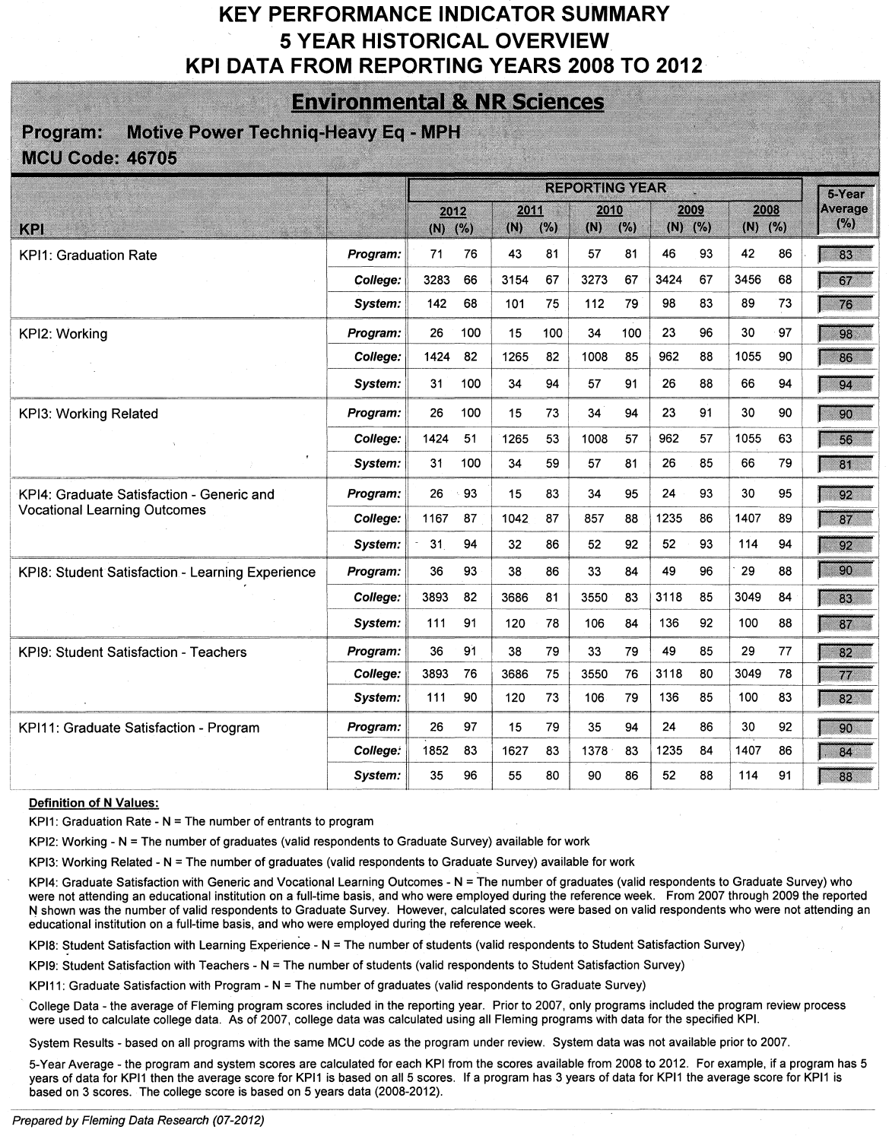
STUDENT DEMAND

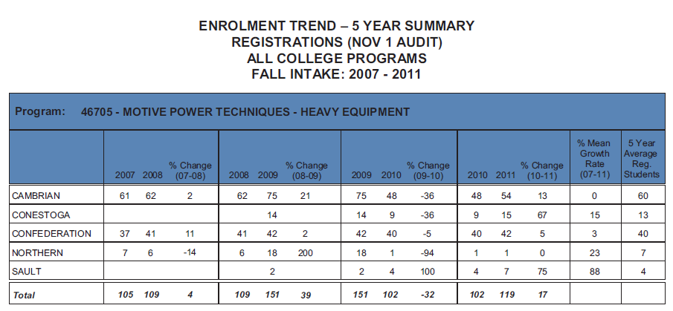

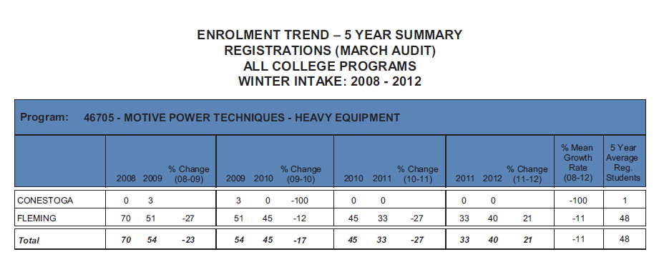

COMPETITOR ANALYSIS
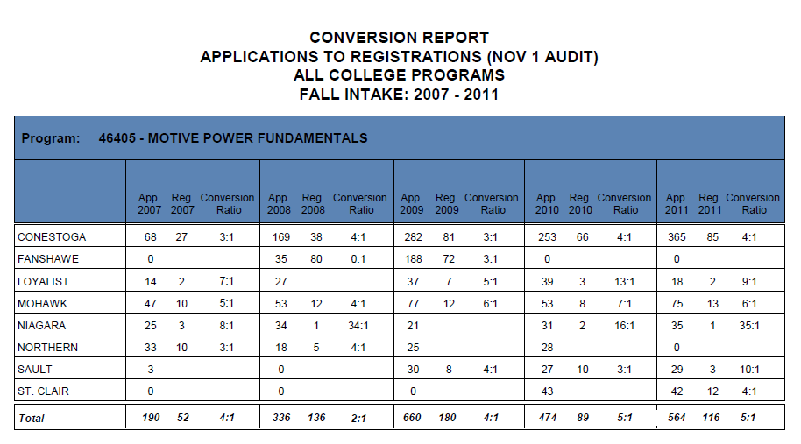

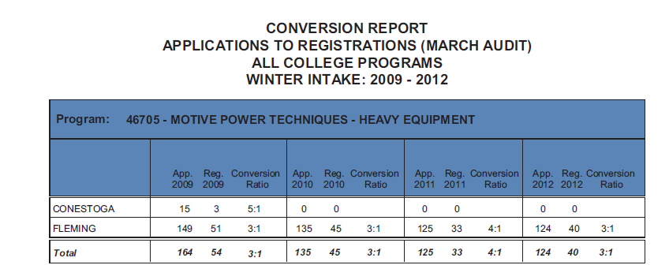
SOURCE: FLEMING DATA RESEARCH – PROGRAM LEVEL REPORTS
http://fleming0.flemingc.on.ca/SEM/FlemingDataResearch/ProgramReviewwelcome.html

