Program and Curriculum Review Template

Instructions: Review all information that is stored on your program and curriculum review web page.

https://department.flemingcollege.ca/pcr

Program Coordinator: | George Seto | Chair: | Jason Jackson
Review Facilitator: |  | Date Completed: | June 21, 2018
Program Name: | Computer Engineering Technician/Technology | Program Code: | CTN/CTY
1.0 Industry Trends and Employment |  | Summary of Key Findings
- Labour Market & Occupational Standard Trends  Review and discuss the following:  - Industry / sector changes or issues identified by the Program Advisory Committee  - Recent labour market data or sector reports as provided by the Fleming Library Researchers.  - Recent or anticipated changes in occupational standards, level of entry and credential and / or standards of accreditation  - Based on the above, do these changes or issues necessitate changes to your program, either immediately, or in the next few years? |  | File in shared drive CTN_CTY_2016_Program_Review  In addition, we also consulted with industries and employers to get a better sense of the how to maximize our position in the program redesign (through PACs), industry trends, and labour market data.  See Program Map for details

1.2 Graduate Employment & Employment Trends  Review and discuss the following:  - Graduate employment statistics over the last few years, including those of students employed in the field, in a related field, outside the field, or unemployed, and any emerging patterns in this data.  - Emergent employment trends such as new types of positions, changing job market, regional distinctions, changing employer profile, or emerging skill shortages | CTN  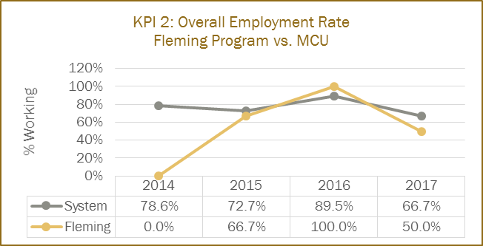  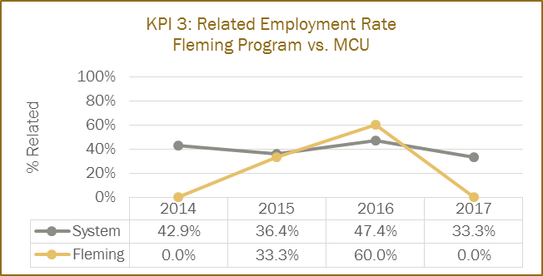  CTY  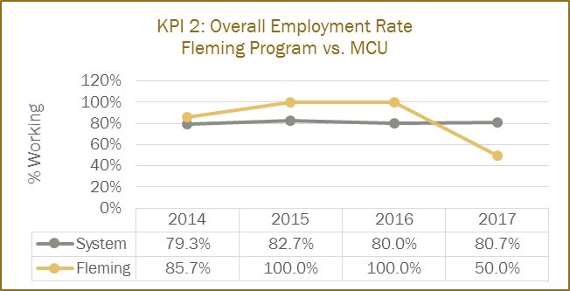  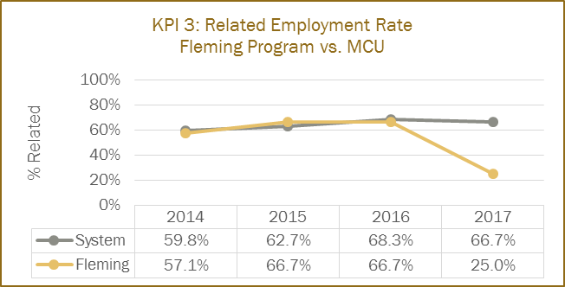  From above data, we can see while overall trends seem to be lower than MCU, we recognize that our region is far from atypical and we are expanding our program and our vision to capture more employability and opportunities for our graduates (addressed in the program redesign, please see details).
2.0 Key Performance Indicators  Review and analyze the formal Key Performance Indicator (KPI) results for your program. | Summary of Key Findings
2.1 Student Satisfaction  - In addition to the formal Student Satisfaction KPI results, comment upon any other formal or informal discussions with students and graduates such as student focus groups, class councils, class representatives, individuals or delegations, or debriefing sessions following a field placement, clinical placement, or practical work integrated learning experience. | CTN  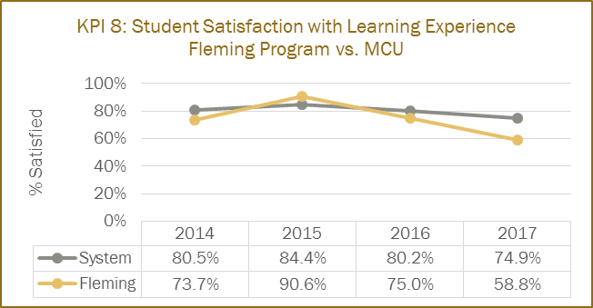  CTY  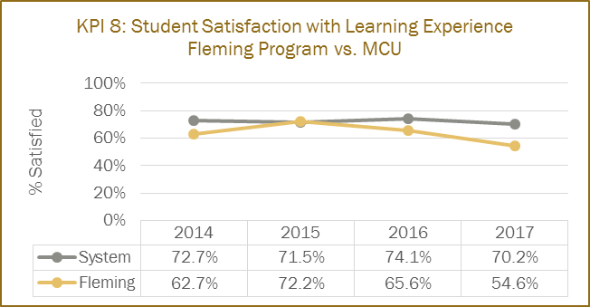  Focus group input was captured in program redesign and PACs to account for the student, faculty and industry input to have a successful outcome in the new program redesign.
2.2 Retention Rate  - Use the IPP (Integrated Program Planning) data that focuses on Retention.  - Review patterns of retention on a semester by semester basis over the last five years.  - Comment on the effectiveness of any strategies adopted to improve student retention. | CTN  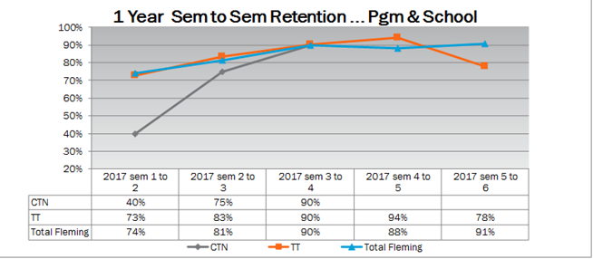  CTY  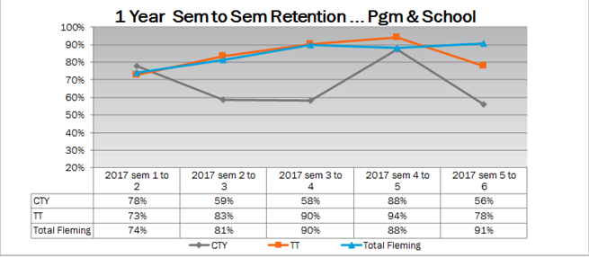  New Program redesign focused on a common first year to allow the student to switch in the school to the program that suits their interest and achieve their career objectives.

2.3 Graduate Rate  - Review patterns of graduation rates on a semester by semester basis over the last five years. | CTN  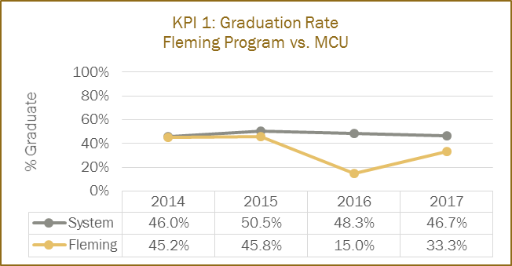  CTY  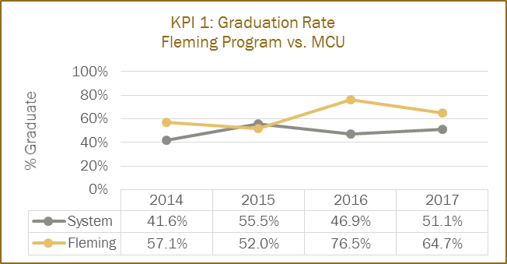  Based on current Data CTY program seems to be ahead of MCU rates, while our CTN program lags behind and steps have been taken to account for that in the program redesign.

2.4 Graduate Satisfaction  - Review patterns of graduate satisfaction and provide comment. | CTN  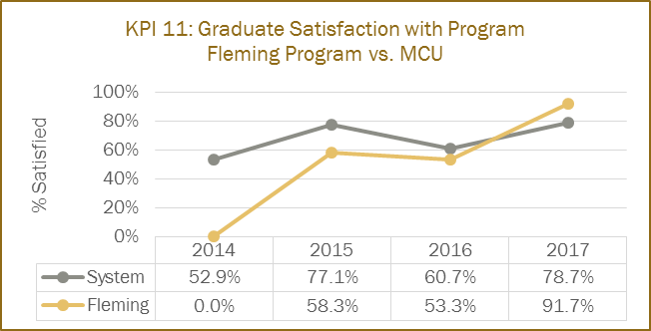  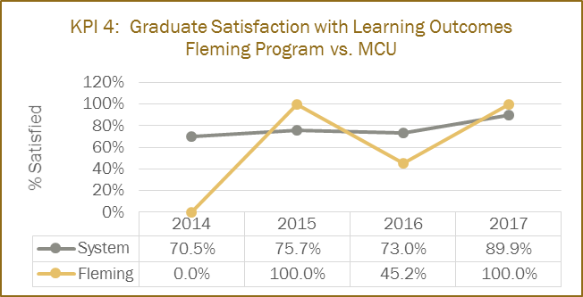  CTY  Patterns displayed suggest that there is a need to overhaul the program in-order to meet the students and industry expectations.

2.5 Enrolment Trends and Demand  - Your team will review and analyze the patterns in the number of program applicants, confirmations and actual registrants over the past 5 years. You will also examine changes, if any, in the student demographic profile and the impact, if any, of this changing student profile on program curriculum.  - Assess whether the program curriculum needs to change based on the above analysis.  - Use the FDR excel spreadsheet that provides Day 10 enrolment numbers for Fleming for the last 10 years, to assist you with your analysis.  - Please review the IPP (Integrated Program Planning) data that focuses on trends related to student demand, and the related ‘Situational Analysis’ information included for your program – select the Demand Trending Tab and Situational Analysis Tab. | CTN  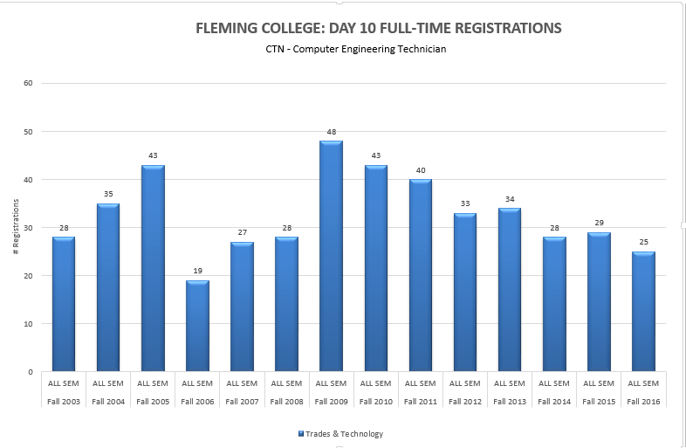CTY  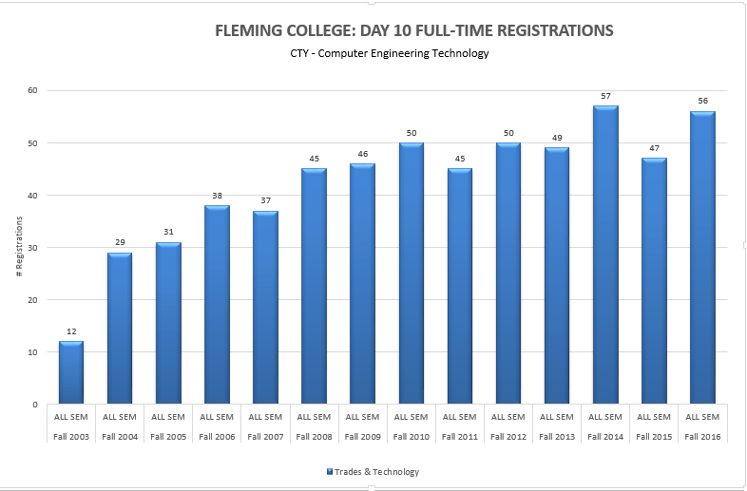  Based on above data, and team review of current program, the reivew process has taken into account the data and trends and accounted for it in the program plan. (see detail program review and recommendations).
3.0 Program Curriculum | Summary of Key Findings
3.1 Program Learning Outcomes and/or Sector Standards  - Review program level learning outcomes in preparation for curriculum mapping (vocational, essential employability skills, general education)  - Where applicable review sector standards to ensure program is keeping up with new trends, developments and requirements. | Outcomes have been reviewed.  Industry standards and trends have been reviewed, resulting in program changes, see plan for details, implementation new academic year

3.2 Program of Study, Course Outlines, Delivery and Program Map  - Review the feedback and suggestions received from Course-level survey completed by faculty at the end of each semester.  - Review the balance and frequency of assessment types across the curriculum and their appropriateness to learning outcomes for the course and program level outcomes.  - Collect a cross section of samples of student work as evidence of achievement of learning outcomes.  - Reflect and comment upon the variety of methods used to demonstrate program outcomes.  - Reflect and comment upon the degree of technology-enhanced delivery of the program outcomes.  - Discuss the degree and depth to which the program is providing work integrated learning experiences.  - Discuss the degree and depth to which the program includes Indigenous perspectives and record the courses in the curriculum in which Indigenous perspectives are covered  - Record the course in the curriculum that covers the college-wide sustainability learning outcome  - Review (or create) Program Curriculum Map(s) to ensure that there is alignment of current courses to the overall program outcomes, including the Vocational Learning Outcomes, the Essential Employability Skills, and adherence to the General Education Policy.  - Review pre and co-requisites to ensure that they do not hinder progress in the program, unnecessarily.  - Make recommendations to address any gaps identified or improvements required.  - Review the program’s current admission requirements and their suitability in relation to program rigour and student preparedness.  - Include an updated program curriculum map on your program and curriculum review web page. | Has been reviewed  Has been reviewed  Has been reviewed  Has been reviewed  Has been reviewed  Field placement or applied projects for students in semesters 3 and 4  No indigenous perspective, Not applicable  Sustainability not unique to the program  Curriculum map complete  Reviewed  See plan  Reviewed and determined appropriate  Updated/ reviewed
4.0 Strategic Positioning and New Opportunities | Summary of Key Findings
4.1 College and School Alignment

- Review program alignment with college priorities such as vision, mission, values, strategic plan, academic plan and the educational mandate, and / or academic priorities of the School.
- Review program webpage and promotional messaging to ensure accuracy and currency.
4.2 Competitor Programs  - Analyze key parallels and differences between this program and those of its closest competitors, where applicable.  - Comment on the ’Value-added’ program distinctions and their attractiveness to prospective students. | New discipline being explored after consultation with industry leaders and focus group utilizing unique current cutting edge topics in the computer engineering field.
4.3 Learning Pathways  - Comment on recent or anticipated initiatives that promote student pathways including secondary school partnerships, dual credits, program laddering, dual diplomas, and university transfer, articulations, and partnerships.  - Review all transfer credits.  - Identify any new pathways that could be developed. | Common first year with computer security and investigations (CSI), program laddering from CTN to CTY to assist students to choose the proper pathway for their career objective.  Reviewed  Exploring possible pathway with university programs (Trent university and others) based on program redesign.
4.4 New Program or Redesign Ideas  - Are there opportunities for new program initiatives based on Program, School, or community strengths and alliances? | Please see attached detailed map/plan.
5.0 External Relations | Summary of Key Findings
5.1 Community Partnerships  - Does your program have significant partnerships, relationships, connections, or offers of support from the community that help to enrich the program and the student experience?  - Are faculty, staff, and student involved in volunteer projects and events? | Yes currently and we are exploring new avenue for community participation.  Yes currently and we are exploring new avenue for community participation.
5.2 Program Advisory Committee  - Comment on the distribution of Committee membership by constituency, sector, and / or region.  - Comment on the vitality of the Committee (frequency of meetings, members’ level of participation, engagement, and turnover.) | Members are diversified group consisting of both private and public-sector technologies from local community, national and international members.  Committee meetings are held once a year
5.3 Alumni Relations  - Describe the type and range of alumnae involvement in the program.  - Current and future strategies to engage alumnae in the program. | Alumnae are actively participating in many capacities such as guest speaking opportunities, providing tours of their facilities, applied project and placement opportunities.
6.0 Program Resources | Summary of Key Findings
6.1 Program Revenue and Expenses  - Please review Integrated Program Planning (IPP) information for your program.  - Are program resources adequate, in the context of program currency and student numbers? (e.g. laboratory equipment, software, library holdings, or tools essential to program delivery and student learning.  - Are there opportunities for further program specific external revenue such as sponsorship, grants, donations or gifts-in-kind?  - Review the existing revenue and expenses associated with your program using the IPP tool and provide comments below.  - Review all textbooks for cost, format (hard-copy, e-book, rental), use in multiple semesters, content (curriculum alignment, Canadian content, readability, engagement level), ancillary materials (question bank, Powerpoint, online support, image bank), publisher support, AODA compliance, and conflict of interest. | Reviewed.  There currently number of deficiencies due to over subscription of other technology programs, such as lab space for homework, lab time for lab work, computer equipment and space.  Yes  Reviewed  Reviewed.
6.2 Faculty and Staff Resources  Please comment on:  - The number and distribution of all faculty, technicians, and technologists associated with the program including full-time, part-time, sessional, and cross-appointments.  - Profile of the faculty, and staff associated with the program including cumulative credentials, scholarship, work-related and teaching experience, and expertise in education.  - Significant faculty or staff accomplishments such as professional recognition and awards, achievement of credentials, and appointments.  - Hiring priorities over the next few years based on the above. | Currently 3 fulltime, 1 technologist (shared among other computer programs), 7-part time, no sessional and 2 cross-appointments  Faculty have lots credentials mostly focused on experience in the field and some industry certification (cisco), most have min of three years diplomas and some have Bachelor’s degrees in related fields.  Cisco Academy lab is the longest associated academy in Canada, applied project semester is unique to Fleming College  More focus on engineering degrees and Master’s program and focus on infield experience at engineering level, and actively participating in cutting edge /current technologies
6.3 Program Delivery Capital Assets  - Please review existing program space and equipment  - Determine needs for space and equipment to fulfill future needs | Need more modern space to deliver cutting edge technologies.  Augmented /virtual/mixed reality studio/lab, applied project lab space, maker space, Internet of things (IoT) lab, equipment for machine learning (AI), lab equipment to support above course content

Program Improvement Plan

Based on the analysis of your key findings, identify areas that require attention and action in the next 1-3 year timeframe. Ensure that you only recommend actions that reflect the program’s priorities and its capacity to achieve them, and record the success of any changes implemented and the means by which they are being evaluated.

To make sure your goals are clear and reachable, each one should be:
- Specific (simple, sensible, significant).
- Measurable (meaningful, motivating).
- Achievable (agreed, attainable).
- Relevant (reasonable, realistic and resourced, results-based).
- Time bound (time-based, time limited, time/cost limited, timely, time-sensitive).

New Recommended Improvements | Timeframe | Person(s) Responsible | Approval: Dean, Chair, or VPA or  Not Feasible, with rationale
See Program Map Details for new/modified courses for Fall 2019 launch | Fall/19 | George Seto
Course development assigned during Fall/18, Winter/19, Spring/19 to meet Fall/19 launch date of Common First Year, CTN/CTY/CSI Program Redesign. | Fall/18-Spring/19 | George Seto
Previous Recommended Improvements | Timeframe | Person(s) Responsible | Update and Rationale: Proceeding = P  Completed = C  Not Feasible = NF

