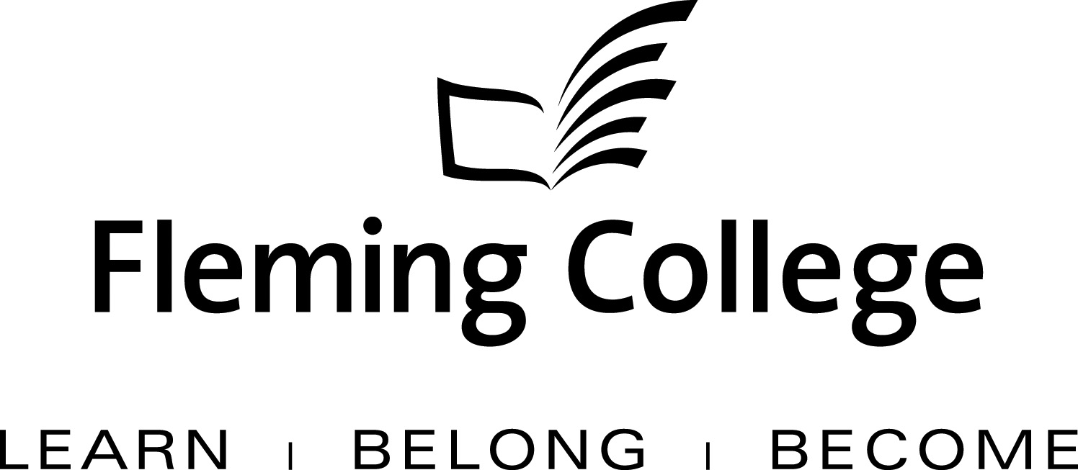

APDC/ASA EXECUTIVE SUMMARY TEMPLATE
FOR PROGRAM REVIEW

The Executive Summary will be presented to the Academic Planning and Development Committee and the ASA Committee of the Board of Governors for information and feedback.

Subject: | School of Law Justice and Community Services Program Review Report
Presented by: | Paul Legacy
Action: | For Discussion / Information

SOURCE
• Fleming’s Quality Assurance Process (College Policy 2-207)
• ASA Committee mandate (Board Policy 1-102J) to conduct reviews of existing programs of instruction on an ongoing basis, subject to current regulation, legislation and policy directives

BACKGROUND
Fleming’s quality assurance process includes a two-staged process that includes: Curriculum Renewal (conducted annually) and Program Review (conducted every five years). These two internal processes are integrated so there is an ongoing focus on curriculum quality.

The Program Review process is characterized by both depth and breadth of analysis. Program data is collated, reviewed and assessed against given criteria, providing a measure of both the vitality and viability of each program. Based on this analysis, long-term plans are then created to guide continuous curriculum improvement and build on the cumulative outcomes of annual curriculum renewal. At the end of this process, a Program Review Panel (convened by the Dean) is charged with the responsibility of making recommendations concerning program viability as well as suggesting program/curriculum revisions.

In adhering to the mandate of the APDC/ASA Committee to receive reviews of existing programs of instruction, the Executive Summary for the School of Law Justice and Community Services is hereby provided, for the Committee’s information.

3.0 Law Clerk
PROGRAM STRENGTHS
This program has been redesigned to be part of the Law Clerk/Paralegal dual diploma. As such it is well positioned as a standalone diploma as well as a makeable fifth semester program.

Many opportunities for applied learning exist in this program. Faculty make extensive use of ‘the courtroom’ for Mock Trials as well as demonstrating court room procedure.

The program includes a good balance of procedural and substantive law instruction, as a result, graduates are job ready for a very intense career.
This program receives excellent industry feedback.

PROGRAM CHALLENGES
Curriculum in the first three semesters must adhere to the Paralegal accreditation. The vocational outcomes must be aligned with both the law clerk standards and the paralegal standards.

The Law Clerk standards are established by the traditional Ministry process, where as the Paralegal standards are established by the Law Society of Upper Canada. If a program does not meet the Law society standards graduates can not be accredited to work in the profession.
The challenge that arises as a result of this includes curriculum and staffing issues, for example faculty teaching in the paralegal program must be accredited by the law society. All Ministry diploma programs must meet general education standards; however the Law Society deems general education to be a deviation from the prescribed curriculum.

Courses shared with paralegal must be taught by individuals accredited by the law society, which requires individuals currently working as professionals, therefore, hiring and scheduling provides a unique challenge.

KPI RESULTS

Graduate satisfaction jumped from 65% in 2008 to 90% in 2012. tThis may be a result of recent curriculum changes resulting from the accreditation of the paralegal program

SUMMARY OF RECOMMENDATIONS

Recommendations Building on Program Strengths:

- Continue to promote Law Clerk and Paralegal as a dual diploma option.
- Many course changes have been made as a result of the Paralegal accreditation requirements; we must keep the Law Society requirements in mind as we work through curriculum changes in the future.

Recommendations Developed to Address Gaps Identified:

1) Review learning outcomes for the forth semester courses.

2) Increase to compliment in this program must meet paralegal requirements because programs share faculty.

Program Review Panel Meeting Date: Friday February 3, 2012

Program Review Panel Participants:

Dean: Paul Legacy
Program Co-ordinator: Diana Collis
Chair: Debra Holts
Curriculum Consultant: Terri Geerinck (invited unable to attend)
Program Faculty/Support Diana Collis:
External Members Barbara Moyle, :

