Ontario Colleges Quality Assurance Service (OCQAS) Guide to Academic Excellence Reference

Academic Quality Terminology
Learning outcomes represent culminating demonstrations of learning and achievement. They describe performances that demonstrate significant integrated learning by graduates of the program has been achieved and verified.
There are several types of learning outcomes, such as those that occur at program level and also those that occur at a course level for specific learning achievements that are identified on a course outlines. An example of a course level learning outcome: “Collect and record data using standardized protocols for soils, wetlands and ecosystem determination in a field setting.” This specific course outcome, provides a specific metric to be able to assess students. Courses generally have between 4-9 course learning outcomes.

Course Outlines: Are generated on an annual and semester basis for each course taken within a program of study at Fleming College. These course outlines serve as a contract between the student and the College and provide the student with all course level learning outcomes as well as information specific to the course such as evaluation, required resources, and sequence of delivery.

Curriculum Mapping: Analyzing the mapping of a program’s curriculum to its Program Standard (VLO, EES, GNED) is an essential part of quality assurance. Building on the course outline reviews conducted as part of annual curriculum review, it provides the opportunity to review cumulative effects of changes made to the program’s curriculum over the last five years, determine whether it meets the requirements of the Program Standards, and plan for updates to the program. The exercise of performing this analysis is called Curriculum Mapping.

Program Review is the quality assurance mechanism that is used to ensure that the six accreditation quality standards have been developed from by the Management Board of OCQAS (Ontario Colleges Quality Assurance Service) have been achieved. There are two components of program review: Annual Program Review and Cyclical Program Review.

Annual Program Review is a component of program review and quality assurance whereby all course outlines are reviewed and curriculum mapping to the program standard occurs on an annual basis. A program improvement plan is developed.

Cyclical Program Review builds on annual program review activities by including a comprehensive analysis of three to five years of data compiled and soliciting direct feedback from stakeholders, labour market research, employers, and students. An in-depth course outline review and curriculum mapping is completed as well as updates to the Program Improvement Plan.

Program Standards are created at a program or provincial level and apply to all similar programs of instruction offered by publicly-funded colleges across the province. A program standard is composed of:
- Vocational Learning Outcomes (Vocational Standards if applicable)
- Essential Employability Skills,
- General Education Requirement.

Credentials Framework, shows the relationship between the Program Standards and the entirety of the courses within that program.
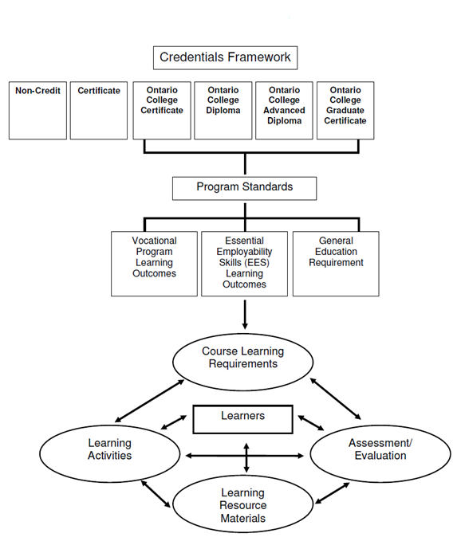
Figure 1: Credential Framework

Vocational standards apply to all similar programs offered by colleges across the province. The Vocational Standard captures the vocationally specific learning outcomes which apply to each diploma and certificate program. Not all programs have a vocational standard. In this case, the College will have established internal Vocational Learning Outcomes, and these are reviewed and used for curriculum mapping purposes.

Vocational Learning Outcomes (VLOs) captures the vocationally specific learning outcomes which apply to each diploma and certificate program.

College Specific Vocational Learning Outcome: credentials offered at Fleming College must formally embed the Sustainability VLO: “Students will be able to explain the interconnections between the broad principles of sustainability - which include human health and well-being, ecological health, social issues, and secure livelihoods- in order to support a better world for all generations.”

Essential Employability Skills (EES) relate to the essential employability skills (previously known as Generic Skills) needed for both career and personal success (communication skills, numeracy skills, thinking and problem-solving skills, information management skills, interpersonal skills, and personal skills). There are eleven Essential Employability Skills learning outcomes which apply to each program:
- communicate clearly, concisely and correctly in the written, spoken, and visual form that fulfills the purpose and meets the needs of the audience.
- respond to written, spoken, or visual messages in a manner that ensures effective communication.
- execute mathematical operations accurately.
- apply a systematic approach to solve problems.
- use a variety of thinking skills to anticipate and solve problems.
- locate, select, organize, and document information using appropriate technology and information systems.
- analyze, evaluate, and apply relevant information from a variety of sources.
- show respect for the diverse opinions, values, belief systems, and contributions of others.
- interact with others in groups or teams in ways that contribute to effective working relationships and the achievement of goals.
- manage the use of time and other resources to complete projects.
- take responsibility for one’s own actions, decisions, and consequences.
Essential Employability Skills only to Ontario College Certificate, Diploma and Advanced Diploma programs. Apprenticeship and Graduate Certificate programs are not required to meet these standards.

General Education requirement (GNED) relates to provincial requirements for general education courses that provide all learners with choice and breadth of experience beyond the vocational areas. General education courses cover areas of general interest and are divided into five themes:
- Theme 1 - Arts in Society
- Theme 2 - Civic Life
- Theme 3 - Social and Cultural Understanding
- Theme 4 - Personal Understanding
- Theme 5 - Science and Technology
General Education Requirement apply only to Ontario College Certificate, Diploma and Advanced Diploma programs. Apprenticeship and Graduate Certificate programs are not required to meet these standards.

