Curriculum Renewal:

Analysis and Action Plan Template 2017/18

Program Coordinator: | Alex smith | School: | Health and wellness
Program Code: |  | Date Completed: | June 2018
Program Name: | Recreation and Leisure Services

A. Analysis of Indicators

Note: data is not recorded in this section of the template.

Reflect on, and discuss, the following indicators in the context of the curriculum and program:

- Industry / Sector Trends

  - Identify any new or emergent industry or sector related issues and trends over the past year that will impact your program? Societal trends that value healthy lifestyles, fitness and leisure time continue to support the need for quality Recreation programming and special events ,in locations such as Long term care facilities, Community Centers ,and Boys & Girls Clubs
  - Enrollment across the system for RLS is low.The decision to move towards a common first year with FHP and the five semester dual diploma option was very timely, and hopes are that this change will stabilize our enrollment moving forward .For students registering for the program .Interest remains strong in the area of Seniors Recreation, where there is demand for our graduates.

  - What are the Advisory Committee recommendations from the past year that will affect the positioning, nature, or scope of your program? The Advisory Committee indicated support for the common first year curriculum change made in September of 2017, as a way of differentiating our program from other Colleges.

  - What information / observations have been generated via faculty and staff professional development, engagement in sectoral and profession associations, or involvement in community and employer networks connected to the field? Faculty and Staff have been actively engaged with community hosts around student field placements and in supporting the involvement of new community partners for field placement and applied learning. Faculty have also engaged in professional discussions with staff from other Colleges, Professional associations, provincial program meetings, and the Ministry through the program standards review process, and those engaged in arranging certifications such as High Five (quality Programming) maintained professional affiliations attended conferences and remained current through professional development.

2. Curriculum Development

Identify any curriculum changes in the last year such as changes in course content and course materials, course / program outcomes, innovative delivery approaches, and/or assessment practices. Am very pleased to advise that the last group of students under the old curriculum *(Intake Fall 2016) for RLS have now graduated, and that our new common first year and Dual Diploma option has been successfully implemented, with students (through survey) having decided to stream toward FHP or RLS for their final two semesters commencing in September 2018.

Based on conversations with our first year students to this point in time, the program has been quite successful, and no major revisions are expected after the first year of delivery. *(Intake Fall 2016)- It should be noted that a course bridging plan is in place to assist students who do not have all the course credits to graduate due to the curriculum change made in the Fall of 2017.

Significant work has already been accomplished by Faculty in the preparation of courses for the Fall of 2018 but additional fine tuning will be required and will occur this spring and early summer.
Given smaller student numbers for the Fall RLS year two some targeted marketing has already commenced to attract graduate students interested in RLS to apply to the Advanced Standing option.

Given smaller student numbers for the Fall RLS year two some targeted marketing has already commenced to attract graduate students interested in RLS to apply to the Advanced Standing option.

*(Intake Fall 2016)- It should be noted that a course bridging plan is in place to assist students who do not have all the course credits to graduate due to the curriculum change made in the Fall of 2017

  - Does the current curriculum align with the college’s e-learning strategy which strives to have all Fleming graduates experience technology enhanced learning in each semester of their program? Identify courses where possible .Yes ,the program courses are all linked to the College D2L learning system.

  - Does the current curriculum align with the College’s Strategic Plan to “infuse sustainability across the curriculum and across the student experience so that graduates understand and address sustainability issues.” (Goal 3.3) Please identify which courses/experiences in the students’ program that sustainability issues are addressed. Sustainability topics are streamed through all our core program courses, in particularly, Foundations Of Recreation and leisure Facility management, Program Planning, Business Marketing Finance, and Inclusive Recreation

  - Identify any recent or anticipated initiatives that promote student pathways including partnerships with high schools, program laddering, university transfer / articulations, or continuing education? As of 2017 the RLS program is now articulated with Hartpury University England

  - Identify any new competitor programs and/or re-positioning of existing programs? RLS and FHP programs revised as a Dual Diploma delivery, effective 2017

  - Identify if there are any new or changing provincial standards, standards for accreditation, credentials, and / or industry or sector certifications over the past year? High Five for working with older adults has been introduced by Parks and Recreation Ontario this year, and will be promoted to our students as a recommended certification.

3. Applied Learning

  - Does the current program contain a discrete Applied Learning opportunity for students? If yes, which category of Applied Learning is fulfilled?
__x_ Field Work (Indirect Supervision)
___ Field Work (Direct Supervision)
___ Co-op
__x_ Applied Project / Applied Research Project

  - If the answer to 3.1 is no, are there plans to create a discrete Applied Learning opportunity for students within this program? Why or why not?

4. Student and Graduate Satisfaction

4.1 Comment upon this year’s Key performance indicators (KPI # 4, 8, 9, and 11) regarding student and graduate satisfaction (*reference Fleming Data Research website)

Student Satisfaction for the RLS program in relation to the overall College system has fluctuated over the past four years and in 2016/17 about 4.5% below the system. We are optimistic that with our Dual Diploma related common First year that the next set of data will show improvement.
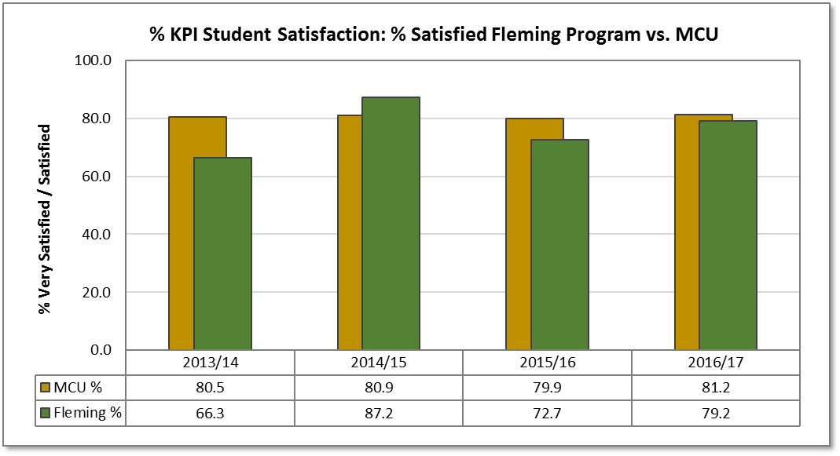

4.2 Review and discuss student retention on a semester by semester basis over the past year. Generally student retention in the RLS program remains positive, particularly, from semester 2 through to graduation.

B. Curriculum Strengths and Challenges

Summarize the curriculum strengths and challenges identified by the team.

- Effective September 2017 the new dual diploma option for RLS and FHP programs was launched. Preceding this new delivery ( 2016 -17), required a course by course extensive review and updating of the curriculum/courses to ensure compliance with provincial program standards of both programs.

C. Action Plan

Identify priority actions for the next year and the rationale for their inclusion. For each, indicate the project lead, and the proposed timelines for completion. What resources are required to complete the action plan, i.e., software, equipment, and training?

*Registration across the province to Recreation and Leisure programs has declined, and competition from other Colleges particularly Durham, Georgian, ( relatively new programs) and Loyalist has affected our intake numbers. To offset this competition we must actively promote and market our new Dual Diploma delivery which differentiates Fleming’s program from the competitor Colleges. The Program Coordinator and our marketing department will be responsible for this ongoing need.

With the removal of a second semester field preparation course the introduction of mandatory volunteer hours in program related agencies/services need to be explored to better prepare students around field placement decisions that have to be made in semester 3 of the program. The program Coordinator and Faculty will take responsibility for this with implementation viewed for the2019 Cohort student group in RLS and FHP programs.

Associated to lower intake numbers into semester 1 and 2, we need to continue to market the RLS- Advanced standing program. Marketing Department and the Program Coordinator will be responsible over the remainder of 2018, and into the early months of 2019.

Other options for strengthening the programs semester 3 and 4 student numbers need to be explored, such as two semester pathways to RLS from the Outdoor Adventure Skills program, and OTA/PTA. The Program Coordinator will facilitate this discussion by January 31st 2019.

Listed below for the purpose of the program coordinator monitoring implementation are the grid change proposals submitted in June 2018.

ANNUAL PROGRAM REPORT-CURRICULUM VERIFICATION-2019/20.

PROGRAM- RLS GRID CHANGES:

NOTE: Effective Fall 2018, COMP 268 replaces COMP345 for new RLS Cohort. This was approved by our Chair Nick Stone in May 2018.

C.V. GRIDS- FALL 2019 (1199)- RLS Semester 1
- Remove COMP345 and replace with COMP 268 1-3 hour Lab.
- RECR146-Room Requirements-2hr Gym, and 2 hours offsite , but require a 2hr seminar room with moveable desks and chairs. Note offsite agency visits cannot occur at 8am.
- HLTH 299-Room requirements –Large room with moveable desks/chairs for lecture and seminar.
- RECR22- Room Requirements 1hr L, and 2hr seminar- Both rooms must have moveable desks/chairs
C.V. GRIDS-WINTER 2020 (1201)-RLS Semester 2

- RECR24-Change delivery pattern to 1-1hr lecture and 1-2hr Seminar. This change is based on student input, as too much material and information missed if they miss one or two classes and less opportunity to catch up. Will improve the quality of the learning experience and student ability to maintain task group relationships. Room requirements-Rooms with moveable desks/chairs as there is significant group work.
C.V. GRIDS-Fall 2019-(1199)-RLS Semester 3

- COMP268- Remove this course from the Fall 2019 RLS Semester 3 Grid, as the course has been delivered in the 2018 Fall semester , and as of 2019 is a Semester 1 course.
- GNED Elective – ADD this course to the Fall 2019 RLS Semester 3 Grid, and REMOVE as an online course from the 2020 RLS semester 4 Grid. Due to the former semester 3 course ( COMP268,) now being delivered in semester 1 to RLS/FHP students, the RLS semester 3 now (2019) is reduced from six to only five courses.* This change will be supportive of students not comfortable with online courses, and allow increased focus for all students on their learning experience at their Field Placement. We did consider replacing Comp268 with a Community Development course but felt that competency in that area is well covered by RECR22, and HLTH302.
C.V. GRIDS-Winter 2020-(1201)-RLS Semester 4

- REMOVE course SSFC 19 online General Education Elective from RLS semester 4 Grid. * See above for rationale.
ANNUAL PROGRAM REPORT-CURRICULUM VERIFICATION-2019/20.

PROGRAM-RLD GRID CHANGES:

C.V. GRIDS-WINTER 2020 (1201)-RLD Semester 3

- RECR24-Change delivery pattern to 1-1hr lecture and 1-2hr Seminar. This change is based on student input, as too much material and information missed if they miss one or two classes and less opportunity to catch up. Will improve the quality of the learning experience and student ability to maintain task group relationships. Room requirements-Rooms with moveable desks/chairs as there is significant group work.

C.V. GRID- RLD-Spring 2020 (1205)

*Recreation and Leisure Services (RLD)

*REMOVE course FLPL 217 Integrated seminar from the 2020 Spring Grid.

Explanation: Unfortunately the addition of this course in association with a 7 week Field Placement increased the students to the status of being full time students rather than p/t and the subsequent payment of *full time fees for a 7 week semester. (Source of Information Sheila McGrath)
To replace this aspect of the learning the student faculty connection would be retained in the Field Practice & Evaluation course FLPL56 through the D2L Discussion board .

Special NOTE: If there is anything we can do to make this removal happen prior to the 2019 Spring Semester it would really be appreciated.

- One of the two students this semester was international and the fee issue was very significant. I do expect some International students in the RLD option this Fall.

PROPOSAL:

Effective Fall 2018 remove COMP345 from the semester 1 FHP/RLS curriculum, and replace with COMP268 –Recreation and Leisure Computer Applications (currently a semester 3 RLS course delivered in the Fall semester).

FALL 2018-Comp 268- Recreation and Leisure Computer Applications would then be delivered to the current returning RLS students (estimated 20 students) plus the new Cohort of FHP/RLS students (estimated 50 students ? ). Total Estimated 70 students ie 2 sections.

FALL 2019-COMP268 would be delivered to the 2019 Cohort semester 1 FHP/RLS students only.

Some Background Information/Notes:

*Addresses the requirement to provide a computer course to the 2017 (RLS) and 2018 Cohort groups .
*COMP 268 would provide basic instruction on Windows, Email Use, and D2L access.
*Have reviewed the Program standards for FHP and RLS, including Essential Employment Skills and the COMP268 course addresses compliance well for both programs.
*This change supports the dual diploma FHP/RLS common first year with students exiting the first year with sound technology underpinnings in the Recreation and Leisure Industry.
* This change will be added value for FHP students as the course addresses computer applications relevant to both FHP & RLS such as “Perfect Mind” registration system.
*Reduces the RLS Fall 2019 Program curriculum by one 3 hour course.

Your Consideration approving this proposal for implementation in September 2018 is appreciated.

Alex Smith and Mary Stever

Attachments: Draft VOL’s FHP and RLS
Draft EES FHP and RLS
Course Outlines COMP345 and COMP268

D. Deferred Actions

Record any issues that will need to be monitored, researched, or deferred for future action.

E. Attach an updated Program Curriculum Map to your report
Please file an updated Program Curriculum Map in folder named Program Curriculum Map.:
S:\shared data\CLT\School Name\Program Name\Program Curriculum Map

