2019-2020

Business – Human Resources (BHC)

Data Package - Cyclical Program Review

Contents
Program Efficiency Review (see data package) 2
Retention Data 2
KPI 1: Graduation Rate Fleming Program vs. MCU graph from Program Review 2
KPI 2, Overall Employment Rate; Fleming vs MCU 2
KPI 3, Related Employment Rate; Fleming vs MCU 2
KPI 4: Graduate Satisfaction with Learning Outcomes Fleming Program vs MCU 2
KPI 11: Graduate Satisfaction with Program Fleming Program vs. MCU 2
Overall KPI Student Satisfaction Capstone (Q13+Q24+Q39+Q49) 2
Q13 Capstone: Knowledge and Skills – Future Career 2
Q24 Capstone: Learning Experiences – Program Quality 2
Day 10 Enrolment Numbers 3
Current Admission Requirements 3
Pre and Co-requisite Courses (see data package) 3

Program Efficiency Review (see data package)

Retention Data

KPI 1: Graduation Rate Fleming Program vs. MCU graph from Program Review: Detailed Analysis of Fleming Program

KPI 2, Overall Employment Rate; Fleming vs MCU

KPI 3, Related Employment Rate; Fleming vs MCU

KPI 4: Graduate Satisfaction with Learning Outcomes Fleming Program vs MCU

KPI 11: Graduate Satisfaction with Program Fleming Program vs. MCU

Overall KPI Student Satisfaction Capstone (Q13+Q24+Q39+Q49)

# of Responses
 | 2017/18 | 2018/19
Comparator # | 204 | 294
 | 2017/18 | 2018/19
Fleming # | 6 | 13
Fleming Program Results by Semester Level
 | % Very Satisfied / Satisfied |  |  |  |  |  |  |  | # of Responses
 | 2017/18 | 2018/19 |  |  |  |  |  |  | 2017/18 | 2018/19
Semester 2 | 91.7 | 68.8 |  |  |  |  |  | Semester 2 | 3 | 8
Semester 4 | 50.0 | 85.0 |  |  |  |  |  | Semester 4 | 3 | 5
Grand Total | 70.8 | 75.0 |  |  |  |  |  | Grand Total | 6 | 13

Q13 Capstone: Knowledge and Skills – Future Career

# of Responses
 | 2017/18 | 2018/19
Comparator # | 204 | 294
 | 2017/18 | 2018/19
Fleming # | 6 | 13
Fleming Program Results by Semester Level
 | % Very Satisfied / Satisfied |  |  |  |  |  |  |  | # of Responses
 | 2017/18 | 2018/19 |  |  |  |  |  |  | 2017/18 | 2018/19
Semester 2 | 100.0 | 75.0 |  |  |  |  |  | Semester 2 | 3 | 8
Semester 4 | 66.7 | 60.0 |  |  |  |  |  | Semester 4 | 3 | 5
Grand Total | 83.3 | 69.2 |  |  |  |  |  | Grand Total | 6 | 13

Q24 Capstone: Learning Experiences – Program Quality

# of Responses
 | 2017/18 | 2018/19
Comparator # | 204 | 294
 | 2017/18 | 2018/19
Fleming # | 6 | 13
Fleming Program Results by Semester Level
 | % Very Satisfied / Satisfied |  |  |  |  |  |  |  | # of Responses
 | 2017/18 | 2018/19 |  |  |  |  |  |  | 2017/18 | 2018/19
Semester 2 | 66.7 | 62.5 |  |  |  |  |  | Semester 2 | 3 | 8
Semester 4 | 66.7 | 100.0 |  |  |  |  |  | Semester 4 | 3 | 5
Grand Total | 66.7 | 76.9 |  |  |  |  |  | Grand Total | 6 | 13

Day 10 Enrolment Numbers

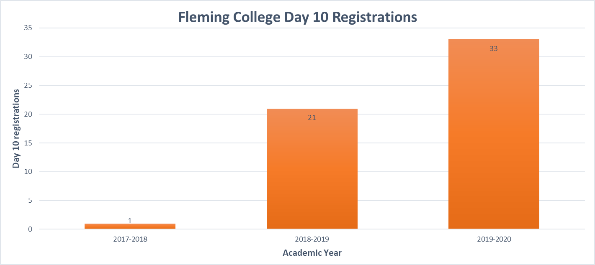

Pre and Co-requisite Courses (see data package)

