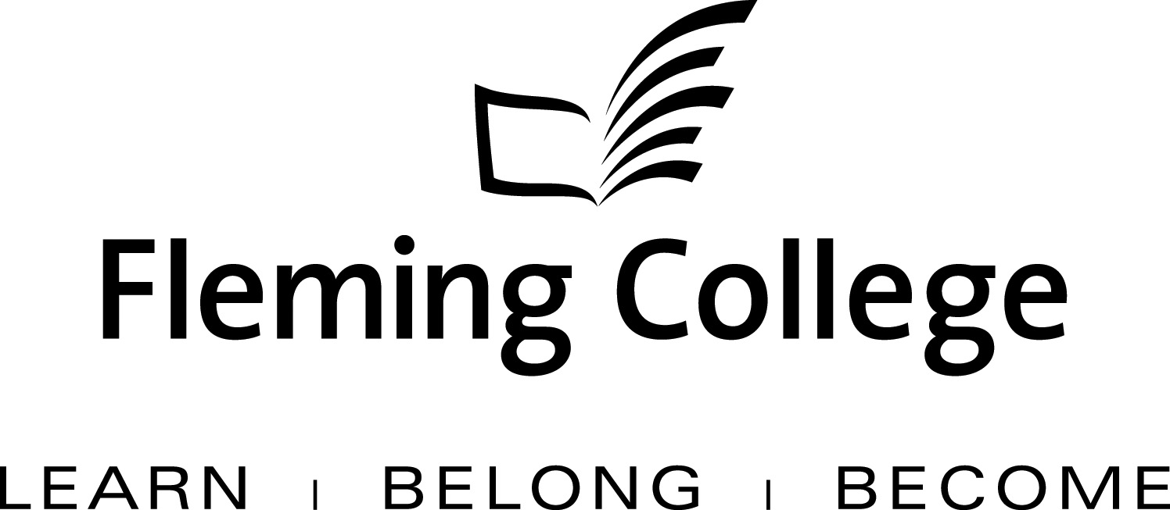

APDC/ASA EXECUTIVE SUMMARY TEMPLATE
FOR PROGRAM REVIEW 2009/10

The Executive Summary will be presented to the Academic Planning and Development Committee and the ASA Committee of the Board of Governors for information and feedback.

Subject: | School of Environmental and Natural Resource Sciences Program Review Report:  Forestry Technician
Presented by: | Linda Skilton
Action: | For Discussion / Information

SOURCE
• Fleming’s Quality Assurance Process (College Policy 2-207)
• ASA Committee mandate (Board Policy 1-102J) to conduct reviews of existing programs of instruction on an ongoing basis, subject to current regulation, legislation and policy directives

BACKGROUND
Fleming’s quality assurance process includes a two-staged process that includes: Curriculum Renewal (conducted annually) and Program Review (conducted every five years). These two internal processes are integrated so there is an ongoing focus on curriculum quality.

The Program Review process is characterized by both depth and breadth of analysis. Program data is collated, reviewed and assessed against given criteria, providing a measure of both the vitality and viability of each program. Based on this analysis, long-term plans are then created to guide continuous curriculum improvement and build on the cumulative outcomes of annual curriculum renewal. At the end of this process, a Program Review Panel (convened by the Dean) is charged with the responsibility of making recommendations concerning program viability as well as suggesting program/curriculum revisions.

In adhering to the mandate of the APDC/ASA Committee to receive reviews of existing programs of instruction, the Executive Summary for the School of Environmental and Natural Resource Sciences is hereby provided, for the Committee’s information.

Forest Technician Program (FT)

PROGRAM STRENGTHS
Strengths identified as a result of the review.

One of the biggest strengths the program are the faculty/staff and the inherent interest they have in seeing the students succeed. The program attracts students from a large geographic area in Ontario, the Maritimes and B.C.
The Forest Technician program is one of 10 programs in the School of Environmental and Natural Resources in which students can seamlessly move from one program to another and complete a dual diploma over the course of a three-year period.
The FT program introduced an International Exchange program in 2008 which has been very successful in enhancing the experience of the students and the staff.
Word of mouth is our selling point; Fleming graduates sell Fleming. Fleming College has the largest Forestry Program in Canada.

PROGRAM CHALLENGES
May include implications associated with any of the following: Enrolment, Human Resource issues, Marketing, Budget, etc.

It is a challenge to maintain sufficient qualified faculty in the mix as people retire.
Meeting the needs of the economic downturn and not jumping on every band wagon is also a challenge, i.e. global warming is important to know about, but where do our students fit into this on the ground, and how do we address these emerging issues within curriculum? The program needs to look at climate change as well; this is where people will be looking for help with their forests (e.g. insects and disease implications, invasive species, overall forest health). As well, the students should be knowledgeable about bio-energy and non-timber values/uses of the forest (e.g. Canada Yew, etc.).
Our classical Forestry students (northern Boreal Forest) are being mixed with Urban Forestry and the two are starting to blend.
The program needs to ensure that technology and equipment are up to date and that hands-on skills and training are emphasized within the program. Some new equipment is also needed.
The College needs to tailor the Forestry Program in a way that more First Nations people would see the value in it (e.g. by including an emphasis on non-timber values and forest products). There needs to be some First Nations perspective infused in the curriculum.
Continued emphasis needs to be placed on the international placement opportunity, as well as the expansion of field opportunities for students (i.e. via a co-op or internship placement, and/or through field days for all program students).

SUMMARY OF RECOMMENDATIONS

Program Review Panel Meeting Date: Thursday, September 24, 2009

Program Review Panel Participants: Barb Elliot, Gerald Guenkel, Lawrie Gulston, Helen Knibb, Linda Skilton, Debbie Yarnell, Steve Munro (by phone), (Rob Baker provided comments prior to the meeting)

Summary Recommendations:
The following summarize the recommendations approved by the Program review panel:

- Support succession planning for program faculty and staff to ensure both a transition period between new and seasoned staff, and the provision of appropriate professional development for all faculty and staff as needs arise.

- Maintain replace and/or purchase technology and equipment to meet emerging education and training needs for program graduates (e.g. enhance program collections, replace aging equipment, and purchase appropriate software and computer technology as required).

- Provide enhanced placement opportunities for students based on a model that best meets the needs of the program and students (e.g. 2-week field placement, internships, weekly field days, etc.).

- Evaluate core program curriculum and revise to ensure relevance for students (Geomatics on Surveying, Air Photo and Silviculture courses, etc.).

- Continue to work towards an Urban Forestry degree partnership with a recognized university in Ontario.

- Maintain viable international placement opportunities for students.

- Explore program options that meet the needs of aboriginal students and communities.

- Revitalize the Program Advisory Committee by soliciting new membership and diversity of membership (including women) in order to enhance the profile of the program across Canada.

- Work closely with the Alumni Office to enhance alumni involvement in the program (e.g. guest lecturers, field placement opportunities, etc.).

