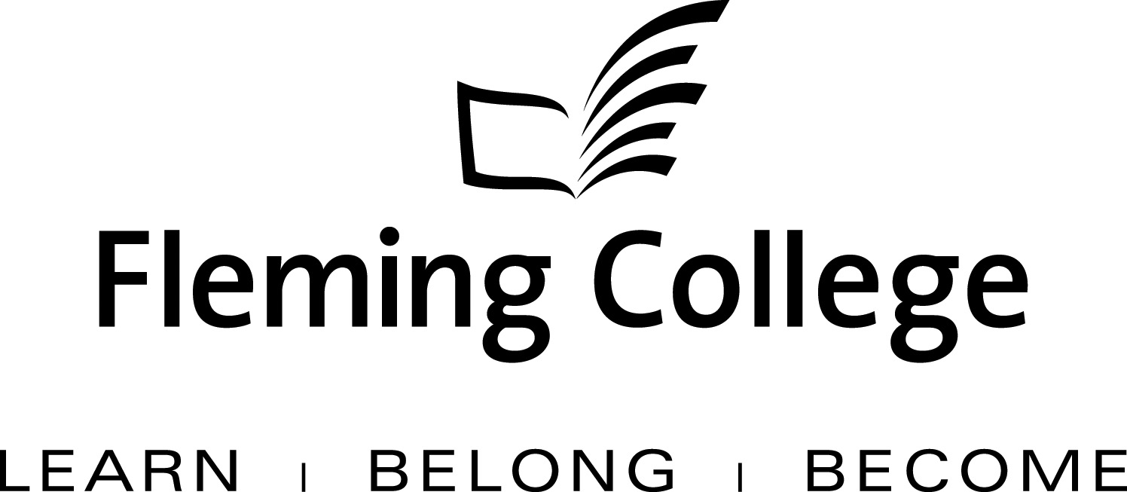

APDC/ASA EXECUTIVE SUMMARY FOR PROGRAM REVIEW
Artistic Blacksmith

The Executive Summary will be presented to the Academic Planning and Development Committee and the ASA Committee of the Board of Governors for information and feedback.

Subject: | Haliburton School of the Arts, Artistic Blacksmith One Year Certificate Program Review Report
Presented by: | Sandra Dupret (Dean)
Action: | For Discussion / Information

SOURCE
• Fleming’s Quality Assurance Process (College Policy 2-207)
• ASA Committee mandate (Board Policy 1-102J) to conduct reviews of existing programs of instruction on an ongoing basis, subject to current regulation, legislation and policy directives

BACKGROUND

Fleming’s quality assurance process includes a two-staged process that includes: Curriculum Renewal (conducted annually) and Program Review (conducted every five years). These two internal processes are integrated so there is an ongoing focus on curriculum quality.

The Program Review process is characterized by both depth and breadth of analysis. Program data is collated, reviewed and assessed against given criteria, providing a measure of both the vitality and viability of each program. Based on this analysis, long-term plans are then created to guide continuous curriculum improvement and build on the cumulative outcomes of annual curriculum renewal. At the end of this process, a Program Review Panel (convened by the Dean) is charged with the responsibility of making recommendations concerning program viability as well as suggesting program/curriculum revisions.

In adhering to the mandate of the APDC/ASA Committee to receive reviews of existing programs of instruction, the Executive Summary for the School of the program review of Artistic Blacksmith, Haliburton School of the Arts is hereby provided, for the Committee’s information.

PROGRAM STRENGTHS

There are only 2 artist blacksmith programs available in Canada; our program and one at Selkirk College, BC. Fleming College receives 40-50 applicants to the program annually, with an average of 16 students enrolling in the program (maximum capacity is 16.). There has been a mean growth rate of 1% for the program over the past 6 years. The vast majority of our students come from outside the SSFC catchment (83% - 90%). With the advent of the Visual and Creative Arts Diploma (VCAD) since September of 2008 and the new Integrated Design program in 2014, the direct entry students are usually younger, looking for an opportunity to build their portfolio and the first two semesters of the VCAD program provide a creative foundation for students. The foundation addresses the development of an advanced level of critical thinking and increased professional integrity and work ethic.

All ABS program faculty are professional artists who primarily support themselves with their studio and teaching practices. Faculty members are enthusiastic and passionate about their experience and how they share it with their students and prepare them for the industry. Faculty communication is maintained before, during and after their teaching schedules through the administrative coordinator who interfaces with faculty, between faculty and with the students to ensure consistency in information, processes and feedback on the delivery and curriculum of the program.

This intensive program is offered over a 4 month period (2 semesters in 1) with independent studio time available in the evenings for practicing skills, assignment completion, and creative experimentation. The fully equipped studio with 16 forge and anvil stations allows students to experiment with both coal and propane in addition to a full range of metal fabrication tools and safety equipment necessary for the delivery of the program. Through small class sizes and an emphasis on individual participation, faculty are able to share their diverse knowledge with each student individually.

PROGRAM CHALLENGES

The program review, which included feedback from faculty, students and technical staff, identified a comprehensive program, which explored the many aspects of blacksmithing arts in a short amount of time. The content of the program is strong in depth and breadth for a foundation program, and the order of curriculum delivery is appropriate to student learning. While the program is already realizing a reasonable balance between theory and project work, it was identified that the amount of time allocated to project work would be best if substantially expanded via an extension of the program. This review afforded the opportunity to rebalance the curriculum to include additional time for project work

The program is quite intense and students can struggle with the fast pace and intensity of the work. Providing a solid assessment plan for art courses presents special challenges, especially for full time practicing artists who are new to the teaching process or returning faculty with a variety of different approaches to assessment. As well, with the intensive one week delivery format of many of the courses, faculty members are to present assessment plans to students on the first day of classes, midweek assessment status and final grades within the week. Recognizing these gaps, measures have been put into place to provide appropriate professional development for faculty using assessment workshops.

Course delivery is designed to reflect real world studio practices. The intense delivery does not allow sufficient time to deliver the foundation level experience with concurrent outside placements. As well the face to face delivery requirements and nature of a studio-based curriculum, limits its e-learning opportunities.

KPI RESULTS

As a unique Ontario college program, there are no comparator college statistics. This does present a challenge in that similar programs cannot be gauged in the comparison and only Fleming’s averages can be used which does not present as accurate a picture as if similar programs are being used. The program does demonstrate good KPI results and only a couple of areas present unique challenges.

Student satisfaction with their learning experience in 2013 was excellent at 85% satisfactory (which was 4% higher than the overall college satisfaction rate). Graduate satisfaction with vocational outcomes was 97% and graduate satisfaction with the program itself was at 82%.
The program graduation rates are outstanding at a rate of 88% (again at a significant 22% higher rate than the overall college.)

While the overall employment rate in this program is at 81% (3% lower than the college average) the percentage of students working in their field is significantly lower at only 37% (versus 54% for the overall college.) As this is a foundational program, students require further education and experience or apprenticeship in order to work in the field. As well, it is not unusual for artists to have employment outside their field, as many artists find it challenging to support themselves solely on their art.

SUMMARY OF RECOMMENDATIONS
A summary of the recommendations contained within the full report.

NOTE: Recommendations should clearly differentiate between those strategies that build upon strengths versus those developed to address any gaps that may exist

Recommendations Building on Program Strengths:

- Link design, drawing and applied design courses through project based learning to better strengthen the alignment of the design course with architectural styles and include a basic introduction to the use of software in the drafting of working drawings.
- Focus the earlier portion on program to the design and execution of samples, techniques and processes for forge worked elements as the program strength lies in the integration of traditional forging practices with contemporary fabrication skills.
- Maintain a focus, in the studio project courses, on the advancement of individual skills.
- Separate the current ‘Advanced Blacksmithing” into two Studio Project courses, similar in content but slightly realigned to afford a series of ornamental ironwork projects, of increasing complexity, to be completed under the directions of different professional masters. These projects should allow the student to develop projects of personal design and interest.

Recommendations Developed to Address Gaps Identified:

- Selection of a common design resource textbook that is consistent with all of the art certificates and visual and creative arts diploma to provide students with a clear and consistent message of the design process. Textbook would also be a valuable reference as students after graduation

- Identify overlaps in the curriculum and ensure faculty are aware of what other faculty are teaching and Ask faculty to connect with each other and create avenues for project based learning

- Revise the Art History delivery format to be more in line with HSTA deliveries that incorporate hands-on experiences in the learning

- A recommendation that ABS Certificate be developed into a 2year Ontario College Diploma program, with the increased time devoted to the practicing of techniques in the advancement of structure, quality of finish, and appreciation for the application of the design process in the development of personal style that will meet the needs of the industry by providing curriculum that expands traditional forge artistry as well as incorporating a greater level of contemporary sculpture fabrication has been advanced. This will allow the more serious Certificate Graduates to learn and grow with guidance and mentorship - reflecting the historical tradition of apprentice blacksmiths who travelled in search of work with masters

Program Review Panel Meeting Date:
May 9, 2013

Program Review Panel Participants:

Dean: Sandra Dupret
VCA Program Co-ordinator: Darlene Bolahood
Administrative Co-ordinator: Jennifer Bain
Program Faculty/Support (maximum 4) : Sandra Dunn; John Little; Kim McBrien; John Monteath; Rene Petitjean; ; Charles O’Neil; Marta Scythes
External Members: Karen Gervais, Visual Arts Faculty, Haliburton Highlands Secondary School; Gary Greenwood; Heidi Hudspith, Alumni, Fibre Arts; Lauren Ogilvie, Alumni, VCAD; Percy Payette, Head of Arts Department, Lindsay Collegiate & Vocational Institute; Emma Quin, Executive Director, Ontario Craft Council

