Program Review Self Study Template—Emergency Management

Indicator  1.0 Industry Trends | Summary of Key Findings
1.1 Sectoral Standards and Industry Trends  Review / discuss:  - New or emergent industry / sector themes or issues that may have a potential impact on program positioning  - Industry / sector issues identified by the Program Advisory Committee  - Recent labour market data or sector reports  - Recent or anticipated changes in occupational standards, level of entry and credential and / or standards of accreditation  - Program alignment to labour market and sectoral trends | Emergency Management remains a relatively new area of study, though the field continues to grow and adapt to industry needs. Individuals certified in Emergency Management, and more recently, in Business Continuity continue to be sought after as employees in both the governmental and private sectors.  The most significant industry theme to emerge that has significant impact on our program positioning is the release of the first Canadian Emergency Management Business Continuity Standard, Z1600CSA. This standard was first released in 2009, and the overall industry adoption of Z1600 has been in process since then, with many entities, in both the government and private sector. Curriculum renewal work was immediately completed within the program to ensure that there was strong alignment between EMP courses and this standard. All EMP courses now connect to themes within the standard Past graduates of our EMP program have been highly successful in getting jobs with the certifications that Fleming offers, but to ensure we stay ahead, some focus must shift to finding an external certification body to add weight and increased credibility to our post-graduate certificate by adding a “Certified Emergency Manager” accreditation. This standard also introduced “Business Continuity” as a major element of the EMP program. While Fleming’s program always contained elements of business continuity, focus has now shifted toward seeing a more even division between Emergency Management and Business Continuity as foundations of both the industry, and indeed, our program.  The added accreditation would strengthen the alignment of the program with current sectoral trends, as would the addition of the words “Business Continuity” to our program title.  Recent data suggests that the labour market is moderate to high. HRSDC says, “Based on projections and considering that there was a shortage of labour supply in this occupation, it is expected that the number of job seekers will remain insufficient to fill job openings over the 2011-2020 period. Although employment growth will remain relatively high over the projection period, it will slow down significantly compared to the strong growth recorded in recent years. One of the main reasons for this slowdown is the budget freezes or cuts put in place by the federal government and some of the provincial governments. The slowdown will, however, be partially offset by the increase in the need to replace workers who retire. With regard to labour supply, the number or school leavers, who represent the vast majority of the job seekers, and immigrants will continue to increase; however, mobility will be more limited because fewer workers from other occupations will be attracted to this occupation as a result of the deterioration of its labour market conditions.”
Program Advisory Committee Feedback  Review / discuss:  Key regional issues identified by the Program Advisory Committee that may not have emerged in labour market data  The Advisory Committee’s assessment of the response, or capacity to respond, to the above issues or trends | The EMP PAC consistently identifies that there is a need for Emergency Management/Business Continuity courses to be available to a broader population, beyond the post-grad certificate level program. Suggestions include:  - Continuing Education courses that align with the certificate program of study so that students could work toward their designation part-time.  - Blended learning opportunities that may permit remote students to participate.  - A general education course in “disasters” that might increase the awareness of students from a broad range of programs in the possibility of pursuing the EMP post-grad certificate.  The PAC has also identified the need to further explore some form of field placement opportunity for students.
1.3 Industry Liaison  Review / discuss:  - Program initiatives to maintain involvement with the industry / sector such as field placement supervisions, clinical, faculty renewal, professional learning, other professional affiliations, or community-based projects | EMP is actively involved in many community partnerships  - Red Cross, from a participant’s perspective in the first semester, to an organizer and facilitator role within our semester two client relationships.  - Faculty engagement with the industry is extremely strong as 100% of contract staff are working currently in the EM or BC fields.  - Fleming EMP has been approved by the Ontario Association of Emergency Managers Education committee that endorses the direction and knowledge covered by the curriculum.  - Program coordinator regularly attends conferences

2.0 Curriculum Development and Framework | Summary of Key Findings
2.1 Curriculum Framework  Review / discuss:  - The program faculty’s approach to, and philosophy of, teaching and learning | EMP provides students the opportunity to build on their past life experiences and education. EMP accepts all backgrounds and education levels making this a unique opportunity to learn from, and share experiences with, others. EMP develops personal confidence by conducting training presentations and team work. Critical thinking blended with a sound knowledge base and confidence make the EMP Grad so valued in the workplace. The students are work ready after experiencing real clients during the two semesters. In this program, we embody that teaching and Learning is two-way. Faculty encourage students to come out of their comfort zones and succeed in the teamwork that is embedded in the program. As program faculty, we strive to maintain all of the following  - Staying current in the field  - Using current and relevant job postings to design learning activities, assignments, and projects and integrate the abilities required in the assessments.  - Using applied projects keep students engaged  - Respecting the challenges experienced by the students and our colleagues in the field  - Expecting of our students what the field expects of us as professionals  - Respecting what students bring to the classroom, experience, previous training, goals, and challenges (LSS, supports)
2.2 Outcomes from Curriculum Renewal  Review / discuss:  - Key outcomes from the Curriculum Renewal processes of the past few years  - Progress to date in implementing the recommendations arising from Curriculum Renewal  - Success of the changes implemented and the means by which they are being evaluated | Curriculum Renewal is vital to EMP as our field is rapidly changing. From Advisory Committee recommendations to comments from past grads, EMP has been in a state of change to keep not only current, but cutting edge. Critical changes from the curriculum renewal process in the recent years include  Aligning the EMP program to the CSA Z1600 Canadian Standard, expanding the focus on Business Continuity within our program, and expanding our offerings of site visits and guest speakers to enhance the real world applications of our program. Because our program is small, we are able to closely monitor the success of these changes through a combination of student feedback, regular faculty interaction, and contact with our industry partners. We are also in regular contact with our graduates, who report back to us about their experiences in the field.
2.3 Curriculum Map  Review the Program Curriculum Map and discuss the extent to which there is alignment of vocational and course outcomes  Review / discuss the distribution and progression of Vocational Learning Outcomes, Essential Employability Skills, and General Education themes across the curriculum.  Submit an updated curriculum map as an attachment. | Attached Appendix A

2.4 Curriculum Sequencing  Review / discuss:  The extent to which course content, levels of learning, and assessment methodology are successfully sequenced and aligned between courses and across semesters | Courses are successfully sequenced across the two semesters.
2.5 Delivery Mode  Review / discuss:  - The primary modes used to deliver curriculum such as lecture, seminar, lab, applied project, field camp and web based or hybrid courses  The rationale for, and appropriateness of, these delivery modes in relation to program learning outcomes | As this is a single cohort program with a limited enrollment, our delivery mode is, by design, small-class focused. Through a combination of teacher-led content delivery and student-driven team simulations and activities, participants in this program get to experience a balance of traditional and applied learning.  The program focus is on real-life experiences and the result is a graduate who is workplace ready.
2.6 Evaluation Methods  Review / discuss:  - The program approach to learning assessment  - The balance and frequency of assessment types across the curriculum and their appropriateness to course / vocational outcomes | There is a balance between tests, assignments, and presentation projects, and some of the practicum courses have been shifted to a Pass/Fail assessment model.  This is a content heavy program, and our alignment to external standards does demand the content rigor of traditional testing.
2.7 Curriculum and Diversity  Review / discuss:  - Program strategies that support student diversity and promote understanding of diversity, including program culture / climate, curriculum content and approaches to teaching and learning | Team work is embedded in EMP which necessitates tolerance, respect, collaboration, communication, interpersonal difference.  Emergency Management work does often include dealing with a diverse range of individuals, cultures, and socio-economic groups. EMP students are taught to see this diversity as a learning opportunity.

2.8 Credentials Framework  Review / discuss:  - The Ontario College Credentials Framework and the extent to which the program aligns with the provincial standards  - The program’s current admission requirements and their suitability in relation to program rigor and student preparedness | This program has no provincial standards. The current EMP program outcomes are locally determined and based on professional standards and ethics in the field and are revised/updated as the field changes.  As a post-graduate certificate, the admission requirements are an Ontario College Diploma or an undergraduate university degree. Professionals who are currently Emergency Managers and professionals with equivalent and related work experience in the field of emergency management will also be considered for admission on an individual basis.
2.9 Learning Pathways  Review / discuss:  Recent or anticipated initiatives that promote student pathways including high school articulations, dual credit, program laddering, dual diplomas, and university transfer, articulations, and partnerships | Though there are no formalized pathways into the program, many of EMPs students are graduates of Fleming’s Security and Risk Management or Police Foundations programs.  York University presently offers a Masters of Arts in Disaster and Emergency Management and it is worth investigating the potential for a formalized pathway relationship between York and Fleming.

3.0 Student and Graduate Satisfaction | Summary of Key Findings
3.1 Formal Measures of Student and / or Graduate Satisfaction  Review / discuss:  - Key Performance Indicator results for the program with a focus on #s 4, 8, 9, and 11  - Program status and positioning in relation to the KPIs of other programs of a similar type (where applicable)  - Feedback and summary report from Learning Support Services (LSS) summary  - Themes or issues emerging from a review of course evaluation summaries | It is worth noting that KPI data can be difficult to interpret in single-cohort programs as the samples sizes are, by nature, extremely small. In all of the KPI categories, across all five years of reporting, the single largest sample size is 23, with many significantly smaller than that.  KPI 1: Graduation Rate:  - As a post graduate certificate, graduation rates are as is typical, much higher than the College score. We do have graduation rates just slightly below the System scores, but not enough to be cause for significant concern.  KPI 2 Overall Employment Rate  KPI 3 Related Employment Rate  KPI 4 Graduate Satisfaction with Generic and Vocational Learning Outcomes  KPI 11 Graduate Satisfaction with Program  - It is difficult to comment on any kind of pattern based on extremely low respondent numbers in the Emergency Management program. See Appendix 1, attached, for originating data.  KPI 8: Student Satisfaction with Learning Experience  KPI 9: Student Satisfaction with Teachers  - As noted above, it is difficult to determine any clear pattern based on small sample sizes, however, it is worth noting that our scores in both of these categories for 2012 were disappointingly low. A recommendation will be made to devote time to investigating this further and developing a response plan, if necessary.
3.2 Other Measures of Student and Graduate Satisfaction  Review / discuss outcomes from:  - Student or graduate focus groups  - Student Advisor observations / reports  - Formal or informal discussions with students and graduates such as class councils, class representatives, individuals or delegations  - Debriefing sessions following a field placement, clinical placement, or practicum | Student feedback has been critical to the EMP program over the past 6 years. As a single-cohort program, we are in a position to gage student feedback and engagement in a consistent fashion throughout our two semester program. Student suggestions can be received, reviewed, and potentially implemented relatively quickly.  Our faculty is also in frequent contact with recent graduates, who get back in touch to let us know how their skills have transferred to the workplace. This valuable information allows us to make shifts in our approach to ensure we are graduating students who are as “job-ready” as possible. A clear example of graduate feedback driving change is connected to the Business Continuity focus within the program.

4.0 Employment Trends | Summary of Key Findings
4.1 Employment  Review / discuss:  Graduate employment statistics over the last few years, including those of students employed in the field, in a related field, outside the field, or unemployed, and any emerging patterns in this data  Student preparedness for entry-level positions  - Emergent employment trends such as new types of positions, changing job market, regional distinctions, changing employer profile, or emerging skill shortages | The overall employment rate (KPI2) was 85% slightly higher than comparator programs with an average of 79%. The number of graduates in related employment was low at 24%, lower than the comparator colleges at 29% and 57% for all programs at Fleming.  The overall employment rate in this program was 92% (KPI2- 2009-10) higher than Algonquin’s rate of 68%. This was also higher than the system average for all programs of 75% and the Fleming rate of 82% for all programs. Related employment data (KPI3) indicated that 67% of graduates in that reporting year were working in related jobs much higher than Algonquin’s rate of 43%. This is higher than the system average for related work across all programs of 50% and Fleming’s average of 53% also.  With a 92% employment rate, graduates are prepared for a wide variety of positions with the development of transferable skills within the program. It should be noted that employment in this sector can fluctuate with changes in government funding etc. Graduates need to be good at what they do and be mobile and flexible in order to be successful when they enter the field.  Employment trends require a knowledge and experience base in relevant technologies, digital graphic design, environmental monitoring systems, digitization and digital photography.
4.2 Other Graduate Destinations  Review / discuss:  Alternative graduate destinations such as further education, international opportunities, volunteer service, or other experiences | - Graduate programs, such as York’s MA in Disaster and Emergency Management  - International volunteering opportunities, e.g. Red Cross  - Other sectors that value the EMP education, e.g. police and fire

5.0 Strategic Positioning | Summary of Key Findings
5.1 College Alignment  Review / discuss:  Program alignment with college priorities such as vision, mission, values, strategic plan, academic framework, and the educational mandate, and / or academic priorities of the School  Opportunities for new program initiatives based on Program, School, or community strengths and alliances | The program aligns with the college priorities and values including a focus on applied learning and community involvement. This program aligns with the college’s vision and mission including high expectations, close relationships with faculty, and applied learning.  This program’s unique setting in the community of Peterborough supports the development of strong collaborations and partnerships. The program is well-known and respected within the community and beyond, uses innovation in its teaching, projects and stays current with the new trends and practices.  Students have completed their curriculum based internships across Canada and around the world.
5.2 Competitor Programs  Review / discuss:  Key parallels and differences between this program and those of its closest competitors, where applicable  ’Value-added’ program distinctions and their attractiveness to prospective students | There are only two competitor programs, at Durham and Sheridan. The key parallel that exists is that both Durham and Sheridan originally based their Emergency Management programs on Fleming’s model.  Fleming has worked to distinguish its program, however, and continues to do so with its focus on Business Continuity in both in-class and practicum applications. Fleming’s EMP program also provides students with an opportunity to build strong client relationships in the industry while completing CSA and EMO certificates.

6.0 Enrolment Trends | Summary of Key Findings
6.1 Demand for the Program  Review / discuss:  - Patterns in the number of program applicants, qualified applicants, and actual registrants over the past 6 years  - Changes, if any, in the student demographic profile, including level of maturity, diversity, prior knowledge, technological literacy, work experience, and expectations  - Impact, if any, of this changing student profile on program curriculum | Application numbers have ranged from a high in 2007 of 67 to a low of 39 the following year. The conversion ratio has historically been 4:1 or 3:1, but this most recent year was 2:1 and it was also in this most recent year that we had our largest cohort of 29.  As a post grad certificate, the majority of the students in this program fall in the 20-25 age group. Demographics also show that there appears to be an increasing appeal to import students, and in fact, some international students are currently in the program. Though there is no immediate impact to the program curriculum based on changing demographics, if the numbers of international students continues to rise, some faculty development around best practices for instructing international students may be required.

6.2 Student Progression  Review / discuss:  Patterns of student success and retention on a semester by semester basis over the last six years  The effectiveness of any strategies adopted to improve student success and retention | As a single-cohort, post grad certificate program, retention rates are extremely high and well above the college rates.

7.0 External Relations | Summary of Key Findings
7.1 Alumnae  Review / discuss:  The type and range of alumnae involvement in the program  Current and future strategies to engage alumnae in the program | - Sit on the advisory committee  - Teach in the program  - Staff at partner sites  - Send us job postings  - Provide resources to stay connected in the field  - Employers of new graduates
7.2 Community Relations  Review / discuss:  - Significant partnerships, relationships, connections, or offers of support from the community that help to enrich the program and the student experience  - Faculty, staff, and student involvement in volunteer projects and events  - Contributions to the not for profit sector such as committee or board service by program-associated faculty and staff  - Community recognition in the form of student bursaries, awards and scholarships | Significant community partnerships:  - Municipal and County government  - Private sector industry relationships  - Canadian Red Cross  - Student awards from municipalities, private industry, and Peterborough’s Emergency Management Department
7.3 Program Advisory Committee  Review / discuss:  - The distribution of Committee membership by constituency, sector, and / or region  - The vitality of the Committee such as the frequency of meetings, and members’ level of participation, engagement, and turnover  - The extent to which Committee operations are aligned with the Fleming College Advisory Committee Orientation Manual and Advisory Committee policy. | The committee meets once per year and is very engaged. They routinely bring new ideas and concepts and all members are actively involved in the industry and the success of Fleming’s program. This advisory committee is well managed and functions at a high level according to the Dean of the School of Justice and Business Studies. The prescribed advisory meeting format is respected, followed and adhered to in meetings. All committee operations are aligned with the Fleming College Advisory Committee Orientation Manual and Advisory Committee policy.  Membership includes representation from:  - provincial, municipal and county governments  - past students  - private sector  - community services: fire and police

8.0 Program Resources | Summary of Key Findings
8.1 Human Resources  Review / discuss:  The number and distribution of all faculty, technicians, and technologists associated with the program including full-time, part-time, sessional, and cross-appointments  Profile of the Dean, faculty, and staff associated with the program including cumulative credentials, scholarship, work-related and teaching experience, and expertise in education  Significant faculty or staff accomplishments such as professional recognition and awards, achievement of credentials, and appointments  Contributions to the professional community or industry by program-associated faculty and staff including board / committee service, research, and presentations / publications  Current staffing levels for the program in relation to program  numbers, curriculum, delivery modes and areas of specialization / generalization  Hiring priorities over the next few years based on the above  Current professional development and renewal plans in relation to program or student needs | There are no full-time faculty associated with this program. The coordinator is a partial load professor, and the remaining faculty complement is part time.
8.2 Physical Resources  Review / discuss:  - Program costing information  - Scope of current program resources such as laboratory equipment, software, library holdings, or tools essential to or which enhance program delivery or student learning  - The adequacy of above resources in the context of program outcomes, program currency, and student numbers  - Program specific external revenue such as sponsorships, grants, donations or gifts-in-kind  - Other externally generated revenues, if applicable | This program contributes 18.6% to the college.  The recent move to the Annex learning space has been excellent—it’s a great opportunity for students to get hands on practical experiences.

Based on an analysis of your key findings, identify areas that require attention.

Develop recommendations and an action plan that reflects the program’s priorities and its capacity to achieve them.

Recommendations Building on Program Strengths:

- Change the title of the program from Emergency Management to Emergency Management and Business Continuity and revise Program Outcomes to reflect this inclusion
- Explore the possibilities for a co-op and/or apprenticeship opportunity for students
- Strengthen the pathway between Fleming’s Justice and Business programs and the EMP post grad certificate
- Work with other Justice programs in the development and implementation of a “Skills for Justice” scenario room
- Develop relationship and explore educational opportunities with Seneca’s Air Flight School coming to the Peterborough Airport
- Update website and develop social media presence as a way to attract strong student candidates and share success stories of program and graduates

Recommendations Developed to Address Gaps Identified:

- Review assessments across the program to ensure an effective and relevant combination of assessment strategies
- Explore Continuing-Education opportunities for elements of the program to be delivered as either continuing education or contract training opportunities.
  - For example, blended learning options that would be attractive to part-time or remote students, or an Emergency Management outreach program that could provide customized contract training to community partners in police (Peterborough Lakefield Community Police), fire (Eastern Ontario Fire Service), healthcare (Peterborough and Cobourg hospitals), etc.
- Develop a relationship and potential pathway with York University’s Master of Arts in Disaster and Emergency Management

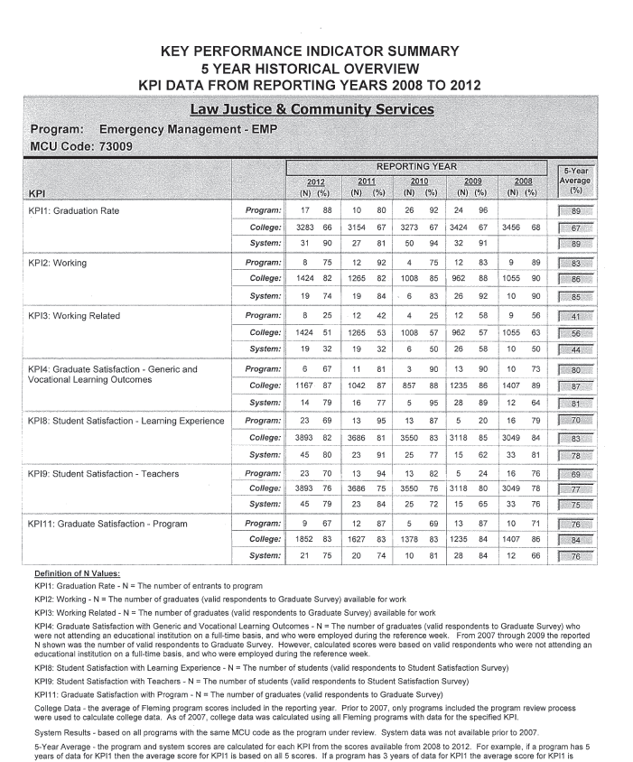

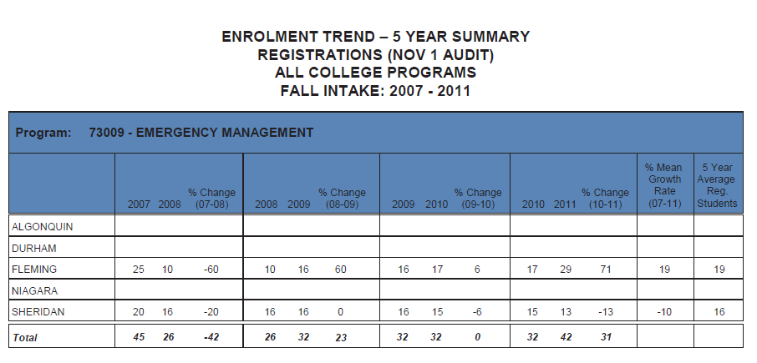

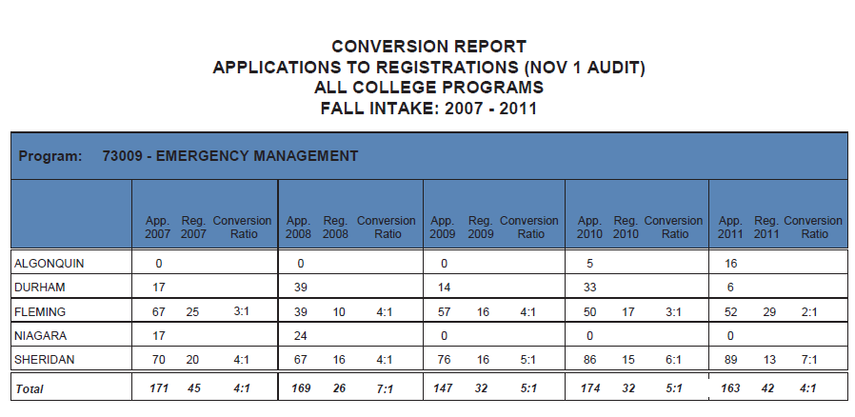

"Policy And Program Officers, Researchers And Consultants (416)." Human Resources and Skills Development Canada. N.p., n.d. Web. 17 Aug. 2012. <http://www23.hrsdc.gc.ca/occupationsummarydetail.jsp?&tid=60>.

