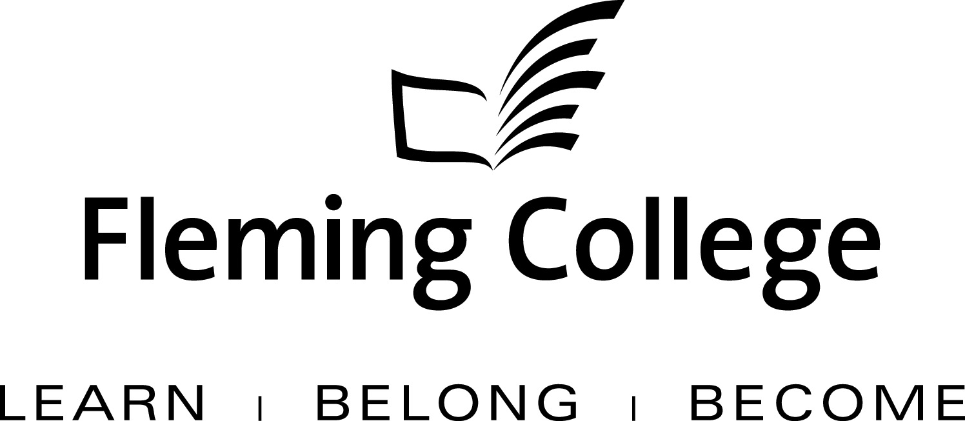

APDC/ASA EXECUTIVE SUMMARY TEMPLATE
FOR PROGRAM REVIEW

The Executive Summary will be presented to the Academic Planning and Development Committee and the ASA Committee of the Board of Governors for information and feedback.

Subject: | School of Law, Justice, and Community Services Program Review Report
Presented by: | Paul Legacy
Action: | For Discussion / Information

SOURCE
• Fleming’s Quality Assurance Process (College Policy 2-207)
• ASA Committee mandate (Board Policy 1-102J) to conduct reviews of existing programs of instruction on an ongoing basis, subject to current regulation, legislation and policy directives

BACKGROUND
Fleming’s quality assurance process includes a two-staged process that includes: Curriculum Renewal (conducted annually) and Program Review (conducted every five years). These two internal processes are integrated so there is an ongoing focus on curriculum quality.

The Program Review process is characterized by both depth and breadth of analysis. Program data is collated, reviewed and assessed against given criteria, providing a measure of both the vitality and viability of each program. Based on this analysis, long-term plans are then created to guide continuous curriculum improvement and build on the cumulative outcomes of annual curriculum renewal. At the end of this process, a Program Review Panel (convened by the Dean) is charged with the responsibility of making recommendations concerning program viability as well as suggesting program/curriculum revisions.

In adhering to the mandate of the APDC/ASA Committee to receive reviews of existing programs of instruction, the Executive Summary for the School of Law, Justice and Community Services is hereby provided, for the Committee’s information.

PROGRAM STRENGTHS

This program is rare in the college system and is unique in Canada and has an excellent reputation, including international interest. Many graduates gain employment in museums, galleries and related arts and heritage agencies at federal, provincial and municipal levels in Canada as well in international settings. Some graduates have achieved high profile positions. As a post-graduate certificate program, it attracts highly motivated students with high standards and expectations. The two full-time faculty in the program are current in the sector and well-respected often presenting at conferences and consulting on various projects. Part-time faculty are practitioners in the field and are highly valued members of the teaching team. One of the main reasons students are attracted to the program is for its one year of course work followed by its highly regarded 15 week full-time internship.

The program blends theory and practice as well as immersion in the field. The keystone of the program is the long-standing partnership with the Peterborough Museum & Archives. This partnership, unique to museum studies training programs in Canada, provides students with access to the full-range of resources and activities specifically related to the operation of museums on a daily basis. Students benefit from the guidance and mentorship of museum staff in an encouraging and supportive learning environment. Witnessing the day-to-day operations, challenges and successes, students are fully immersed in this environment.

A dedicated, accessible teaching space linked to the museum, the Fleming Annex at the Peterborough Museum & Archives is a valuable asset to the program and supports the partnership through its shared use.

Additional community partnerships have been forged with Trent University, City of Peterborough, and various galleries, museums and other associated sites and organizations. The applied projects, a mainstay and focus in the program are done with clients who usually provide a budget to assist with related costs. The projects are well done and welcomed by the partners and the community and often receive accolades. It should be noted that these positive outcomes depend on extensive faculty involvement and partner commitment.

PROGRAM CHALLENGES

The program is quite intense and students often struggle with the fast pace and intensity of the work. Faculty also spend many hours designing and assessing the extensive number of applied projects, many of which must be evaluated on-site, during business hours.

The program is given a budget by the learning partners for many of the projects, for example, exhibits which involve large budgets that demonstrate a significant contribution. This creates layers of accounting details to sort through and aspects of project management to organize, implement and monitor in order to be accountable to the partner. The public visibility of these projects and others that impact on the partner’s profile in the community introduces another level of pressure and accountability.

Current and emerging trends in the field identified by the Program Advisory Committee are difficult to integrate into the curriculum because of budget constraints and the lack of development time for faculty. Digitization, museum software, and more reliance on computer technology without funds to purchase the required equipment is becoming an increasing challenge in the program. Often, specialized training in these areas is provided externally and tie-ins to museum applications can be difficult when not taught by museum professionals. Faculty require training opportunities and time to apply this training to curriculum. Many pieces of equipment require upgrading including computers (laptops as well), cameras, work stations, and digital recorders to remain current with expectations and requirements in the field.

KPI RESULTS

As a unique Ontario college program, there are no comparator college statistics. This does present a challenge in that similar programs cannot be gauged in the comparison and only the system averages (all colleges) or Fleming’s averages can be used which does not present as accurate a picture if similar programs are being used. The program does demonstrate good KPI results and only a couple of areas have been targeted for improvements.

The overall employment rate in this program was 92% (KPI2- 2009-10) higher than Algonquin’s rate of 68%. This was also higher than the system average for all programs of 75% and the Fleming rate of 82% for all programs. Related employment data (KPI3) indicated that 67% of graduates in that reporting year were working in related jobs much higher than Algonquin’s rate of 43%. This is higher than the system average for related work across all programs of 50% and Fleming’s average of 53% also.

With a 92% employment rate, graduates are prepared for a wide variety of positions with the development of transferable skills within the program. It should be noted that employment in this sector can fluctuate with changes in government funding etc. Graduates need to be good at what they do and be mobile and flexible in order to be successful when they enter the field.

KP1 from 2009/10 graduation rate was 96% higher than the system average of 81%. KPI2, from 2008/09 of overall employment rate was 85% higher than the system average of 78%. Related employment, KPI3 (2008/ 09) was 60% compared to the system average of 54%. KPI4, graduate satisfaction with the generic and vocational outcomes from 2008-2009 was 86% higher than the system average of 85%. However, this KPI was lower than the college (all programs) by 1.81%. According to KPI8 (2009/10), students are highly satisfied with the program with 94% which is higher than the system average of 85% and the college average of 83%. Key performance indicator 9 (2009/ 10), satisfaction with teachers is at 92% much higher than the system average of 79%. Graduate satisfaction with the program (2008-09) of 68%, KPI11, is slightly lower than the system average of 71% and 3.37% lower than the college average for all programs. With the opening and use of the new Annex in 2009, KPIs should show more improvement and KPI11 in particular should increase with the new building’s better space and facilities than the previous crowded school portable.

SUMMARY OF RECOMMENDATIONS

Recommendations Building on Program Strengths:

- While many course changes have been made with this review including rewriting and refreshing learning outcomes, incorporating PAC feedback into the program and the removal of a course (and its outcomes covered in a different course), to lighten the load for students and provide more time for projects and faculty assessment, more intense planning time is required for other recommendations. Thus one recommendation is to facilitate a more concentrated planning time for all program faculty by providing a common block of time for faculty (minimum of 7 weeks) to meet and plan more extensive changes. This should be on the SWF for full-time faculty and paid hours for part-time faculty.

- Develop and deliver Adobe Creative Suite training specific for museum applications and install a dedicated photo studio at the Fleming Annex at the PMA, or within the museum, along with the purchase of the appropriate equipment (DSLR, photo lights, etc.). Students have to pay for the workshop and supplies for the pilot which was successful. This may not be sustainable and options need to be identified including the college offering it and budgeting for it.

- Create and enhance cross-over opportunities between MMC and CCM programs. A successful pilot for a 3 day joint Orientation occurred in September 2011. This orientation creates synergy in the groups and will be proactive in such areas as team dynamics as many projects are completed in teams. This orientation takes planning time and a small budget to implement it effectively.

- As a pilot, the Introduction to Museums course was significantly modified and delivered in a compressed 5-day format. A review has highlighted the need for a dedicated budget to deliver this course.

Recommendations Developed to Address Gaps Identified:

- The program is in great need of more and updated equipment, software and associated training for faculty to stay current in the technological aspects of the field. A complete list of requirements was included in the detailed review and submitted to the Dean and VPA. These resources can be shared with the CCM program.

- Increase human resources at the program level to support, facilitate and embed current and evolving technologies into curriculum, applied learning experiences/projects and virtual program activities.

- Develop and enhance web presence including program profile and tools for student learning and professional applications. This is two-fold: 1. Public access to program information for example, program FAQs, internship details, community-based projects, job postings, additional training opportunities, etc. 2.Controlled access (students, faculty, learning partners) to learning tools and resources that will support development of e-portfolios, web-based open source collections management systems, community-based projects, blogging, pod-casts, information sharing, etc.

- Establish a process for screening applicants to ensure appropriate fit and student success given the intensive, applied nature of the program. Initial feed-back from the learning partners supports this to support the highest quality of end results and products. This should assist in improving KPI results in the future.

- Develop a dedicated budget for each of the two large, community-based exhibit projects. This will enable us to have a more positive and balanced relationships with the community partners and provide an incentive for community partners working with us.

- Establish two courses in Education and Interpretation Programming – rename the courses to align with Learning in Museums and Audience Experiences. This will require specialized, outside expertise and a budget for curriculum development.

- With higher student numbers and other issues such as the time commitment for exhibit and project work, hire a coordinator for each program rather than one coordinator for both or establish two separate co-ordinatorships (7 hours each). This will alleviate some workload issues and allow for better time management and more involvement with community partners.

- With the loss of faculty renewal, faculty are experiencing more challenges in staying current in the field. Faculty renewal should be re-instated to ensure continued currency of faculty and to develop and/or maintain the relationships involved in a wide range of community projects related to the program.

Program Review Panel Meeting Date: May 6, 2011

Program Review Panel Participants:

Dean: Paul Legacy
Program Co-ordinator: Gayle McIntyre
Chair: Deb Holts
Curriculum Consultant: Terri Geerinck
Program Faculty/Support: Deborah Scott, Cindy Colford
External Members: Susan Neale, Director Peterborough Museum and Archive; Kim Reid, Curator, Peterborough Museum and Archive; Jonathon Oldham, faculty Trent University, assistant Peterborough Museum and Archive.

