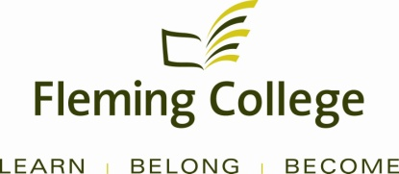

STRICTLY CONFIDENTIAL

APDC/ASA EXECUTIVE SUMMARY TEMPLATE
FOR PROGRAM REVIEW

Subject: | School of Justice and Business Studies Program Review Report
Program | Sporting Goods Business
Presented by: | Jim Drennan
Action: | For Discussion / Information

SOURCE

• Fleming’s Quality Assurance Process (College Policy 2-207)
• ASA Committee mandate (Board Policy 1-102J) to conduct reviews of existing programs of instruction on an ongoing basis, subject to current regulation, legislation and policy directives

PROGRAM STRENGTHS

As the only program in the province devoted to delivering college-level applied learning in the sports equipment industry, Fleming’s Sporting Goods Business diploma is unique in the college system. As such, it attracts students who are focussed, motivated, and engaged.

Though related, the Sports Business Management, Marketing, and Administration programs at Seneca, Humber, Algonquin, Durham, Niagara and St. Clair Colleges do not offer the same industry specific curriculum and applied education as the Sporting Goods Business program at Fleming College.

The program is very well respected and our graduates are highly sought after across the country and internationally. At present, we have former graduates employed at NIKE Canada, adidas Canada, Trimark Sportswear, Easton-Bell Sports, Athletic Knit, Reebok CCM, Maple Leaf Sports & Entertainment, Salomon Canada, Mizuno Canada, Rawlings Sporting Goods Canada, Norco Performance Bikes, Vans, Ride Snowboards, Canadian Tire Corporation, Forzani Group, Bauer Hockey, Wolverine Worldwide, RMP Athletic Locker, Under Armour Canada, Helly Hansen, Canada Goose, Canlan Ice Sports, ADAMS Golf at TaylorMade Canada, National Sports, Sport Chek, Si Vous Play Sports, Source for Sports, Golftown, Superfeet, Toronto Argonauts, Mica Sport Canada and Huffy Bicycles. This reality is also supported by our internal data: according to Fleming’s Key Research Findings documents, the labour market for graduates of this program is strong, meaning that there are between five and six positive labour market indicators, (based on a consolidation of various Ontario, Canadian, and US sources including HRSDC, Sector Council Reports, US Bureau of Labour Statistics, and the MTCU Employment Profile.

The focus on applied learning opportunities results in a hands-on, industry-focussed environment that means when our students graduate, they are workplace-ready. Our feedback from industry partners who have hired our graduates and a recent alumni survey repeatedly confirms this. Our program has high community value, a result of having industry relationships and paid co-op placements directly embedded in opportunities for learning.

There are many positive features of the co-op placement.
- Students become more integrated and involved in the operations of the placement companies ultimately leading to a better educational experience.
- Students earn income that will help fund their college education.
- Hosts benefit through the opportunity to have projects, assignments or workloads completed that may have been “set aside” due to more pressing day to day issues.
- Hosts have an opportunity to evaluate the skills and abilities of the students and the potential fit for succession planning and future employee(s).

The required 16 week paid co-op placement replaced the standard two – 70 hour field placements in the spring 2010 semester. The change was based on student and industry feedback around the length of the placements, the lack of training opportunities and educational experiences and the difficulties to course scheduling it caused at Fleming College. Field placements were scheduled for weeks 8 & 9 of the 3rd & 4th semesters and this caused issues & stress between students and faculty because of missed classes. The spring 2014 semester will be the fourth year of the paid co-op placement.

A constant for the Sporting Goods program has been the involvement and interaction of the faculty and the small classroom setting, which has always led to a positive and cohesive educational experience. The full-time program coordinator and part-time faculty who split their time between teaching and working in the industry, are together responsible for the core sporting goods courses including the co-op preparatory course, and all academic advising. This provides students with industry specific and real world experiences in the classroom. This is also now being supported by computer based business simulations that allow the students to put what they learn into practice. Sporting Goods students will have one class each semester that integrates this educational technology. Classes using simulations include Business Essentials and Retail Essentials supported by Interpretive Simulations – Biz Café & Retail Entrepreneur, International Business – Glo Bus and Sports Equipment Product Knowledge II – Smartsims MIKES Bikes Advanced.

The process has also begun to explore and support future articulation agreements so students can continue their studies after Fleming College. A stumbling block in the past has been the uniqueness of the Sporting Goods Business program, the lack of University programs that focus on the same industry, and the reluctance of domestic colleges and universities to accept the credits that students have taken. Recently, however, positive contact has been made with Sheffield Hallam University in England regarding their International Sport Business Management (top up) degree. The course prepares students for work in areas such as national and international sports organisations, sport and leisure industries, sports equipment and supply industries, professional sports team, advertising and public relations agencies, public services, the media, events and project management. Sheffield Hallam has asked for information on the Sporting Goods program as well as the learning outcomes for review. This information will be presented once the program review is completed and updated. Other domestic and international universities are also being investigated for articulation agreements.

PROGRAM CHALLENGES

Declining enrollment in the rural regional colleges has been an issue and has had a direct impact on the applications and enrollment for the Sporting Goods program. After internal discussions with the Dean for the School of Business, School of Business Chair and the Fleming College Marketing department, it was determined that more marketing support and focus must be put in place to support the program’s unique curriculum and career opportunities versus other sport business and marketing programs.

The vast majority of students who enter this program are direct entry from secondary school. Our student feedback has also revealed that they also tend to be students who were not necessarily investigating college as an option, until they discovered this program. This means that students need to know about, and be looking specifically for this program in order to enroll. In other words, this program serves a population of students who were not otherwise looking to engage with the college system—a critical reason why we must ensure strong marketing support that is efficiently and carefully targeted.

A significant challenge faced by the Sporting Goods Business program is that we are a small, single-cohort program. In 2011/12, our contribution to overhead was 36% which exceeds the expected 35% set by the College but will drop due to lower than expected enrollment for the Fall 2013 semester. To help meet these challenges, internal discussions will be taking place during the spring 2014 semester to discuss operational efficiencies and connections with common first year business courses. We feel strongly though, that the reputation of the program, combined with the community value of our industry relationships, does offset this temporary shortfall in financial contribution.

The graduation rate for Sporting Goods students has been an ongoing issue and math skill development is an area that has been identified as an area of concern. In response to recent survey feedback from both current students and program alumni, we are currently in discussion with math faculty and the coordinator to revise the math curriculum that is being taught to ensure it is both relevant and applicable for students in our program, and also that we provide support for students who may require it in order to be successful.

The length and paid component of the co-op does not come without challenges. While it is not in line with our current framework for co-op, many of the companies within the sporting goods industry prefer to use the un-paid internship model. Many colleges that have successful co-op programs also have formalized co-op offices that support the students and their placement search; currently Fleming College does not follow this model due to so few programs requiring co-op as part of their program of study. Contacts and placements for co-op are based on the industry relationships of the program coordinator and the support of the program alumni. While there has been support for the creation of a co-op office (or more general Applied Learning Office) at Fleming College the future of this is unknown.

There have also been some internal discussions about whether the Sporting Goods Business program should become a part of the Fleming College Applied Agency and in so doing, replace the current co-op model with an applied learning project. (This is assuming, of course, that the Agency is able to continue given current space issues.) The Fleming Applied Agency has aggressively taken on, and is successfully meeting the challenges of, real-world clients. According to clients, the Agency Group Partners (our Fleming students) are more than living up to the promise made in the Agency’s branding slogan: “More Energy + Brighter Minds = Better Marketing Solutions.” As Agency Partners in The Fleming Applied Agency, students are expected to develop and manage client projects using industry-accepted standards. The goal is not just to test applications of past classroom learning; Fleming wants to give its graduates a significant competitive edge when they begin their career. More intensive discussion regarding the co-op versus the applied learning model will take place during the spring 2014 Common Block Development peridods.

KPI RESULTS

It is worth noting that KPI data can be difficult to interpret in single-cohort programs as the samples sizes are, by nature, extremely small. In all of the KPI categories, across all five years of reporting, the single largest sample size is 23, with many significantly smaller than that.

KPI 1: Graduation Rate:
- The graduation rate for Sporting Goods Business has been consistently below the college and system rates with the five year average figure of 54% landing 12 points below the college and system which were both at 66%. Several recommendations made in the program review are aimed squarely at improving retention among Sporting Goods students, specifically through addressing one of the most common barriers to graduation: the incoming math skills of Sporting Goods students.

KPI 2 Overall Employment Rate
KPI 3 Related Employment Rate
- The numbers of graduates who are currently working directly in the field, or in a related field, translate into very strong KPI results—16% and 15% ahead of the system respectively.
- Please note, however, it is difficult to comment on any kind of pattern based on extremely low respondent numbers in the Sporting Goods Business program. See Appendix 1, attached, for originating data.

KPI 4 Graduate Satisfaction with Generic and Vocational Learning Outcomes
KPI 11 Graduate Satisfaction with Program
- The KPI results for graduate satisfaction are also positive—8% and 6% over the system respectively.
- Once again, however, it is difficult to comment on any kind of pattern based on extremely low respondent numbers in the Sporting Goods Business program. See Appendix 1, attached, for originating data.

KPI 8: Student Satisfaction with Learning Experience
KPI 9: Student Satisfaction with Teachers
- The KPI results for student satisfaction are acceptable, but could be improved, at either 5% over the system and 1% below the system respectively.
- Though there are somewhat higher respondent numbers for these indicators, they are still small enough to make it difficult to determine any clear pattern.

Please see Appendix 1 for program excerpt from the KPI Report

STUDENT DEMAND

- The student demand for the Sporting Good Business diploma is weak. Fleming is the only school to offer this program, but the enrollment growth has been negative throughout the last five years, giving the program a mean growth rate of -13% and an average registration of 27 students.
  - The recent marketing push for this program (as a part of a broader campaign advertising Fleming’s remarkable new athletic fields), has already resulted in 40% growth in early application numbers as compared to last year—as of January 22nd, 2014).

Please see Appendix 2 for program excerpt from the Enrolment Trend Report

COMPETITOR ANALYSIS

- As our program is unique in the system, it is difficult to provide a clear competitor analysis. In terms of conversion data, the program’s conversion ratio has been on a slow worsening trend, from 3.6:1 in 2008 to 5.1:1 in 2012. This trend is not dramatically out of line with the trend seen in our closest competitor programs, the Sports Management Programs at Durham and Humber.

Please see Appendix 3 for program excerpts from the Conversion Report.

FINANCIAL ANALYSIS

- The financial analysis for Sporting Goods Business is moderate.
  - Contribution to overhead: 33.6%
  - Program Weight: 1.10
  - Funding Unit: 2.10

Source: Program Costing Analysis from the ‘Key Research Findings Report’ on the FDR website. http://fleming0.flemingc.on.ca/SEM/FlemingDataResearch/Enrollment/Enrollmentwelcome.html

SUMMARY OF RECOMMENDATIONS

A summary of the recommendations contained within the full report.

Recommendations Building on Program Strengths:

- Review the Co-operative Education element to ensure that it is providing students with the best possible applied learning opportunity.
- Increase the use of computer simulations as culminating experiences for students, e.g. “Mike’s Bikes.”
- Work to develop articulation agreements with other post-secondary programs, both within Canada and internationally.

Recommendations Developed to Address Gaps Identified:

- Continue targeted marketing via traditional advertising, social media, and secondary school outreach.
- Explore the benefits of joining the common first year within the Business program cluster.
- Review and revise curriculum to adequately support students in achieving required program learning outcomes without putting up unnecessary barriers to graduation, e.g. ensure that math skills students are learning are appropriate for career path and then provide support for students who may require it.
- Review the co-op model, specifically to investigate whether a transition toward an applied learning project (either through the Fleming College Applied Agency or otherwise) would provide a more valuable learning experience for students.

PROGRAM REVIEW PANEL

Meeting Date: Friday, January 24th

Program Review Panel Participants:

Dean: Jim Drennan
Chair: Deb Holts
Program Co-ordinator: Charlie McGee
Curriculum Consultant: Wendy Morgan
Program Faculty/Support: Jessica McIntosh
External Members: Neil Wensley (Product Marketing Manager, Easton Bell Sports), Ryan Donnan (VP, Sales and Marketing, Kobe Sportswear), Brad Mrakava (Sales and Marketing Director, Saucony Canada), Tim Anderson (Director, Licensing and Product Development, RMP Athletic Locker)

Appendix 1: KPI – 5 YEAR HISTORICAL OVERVIEW

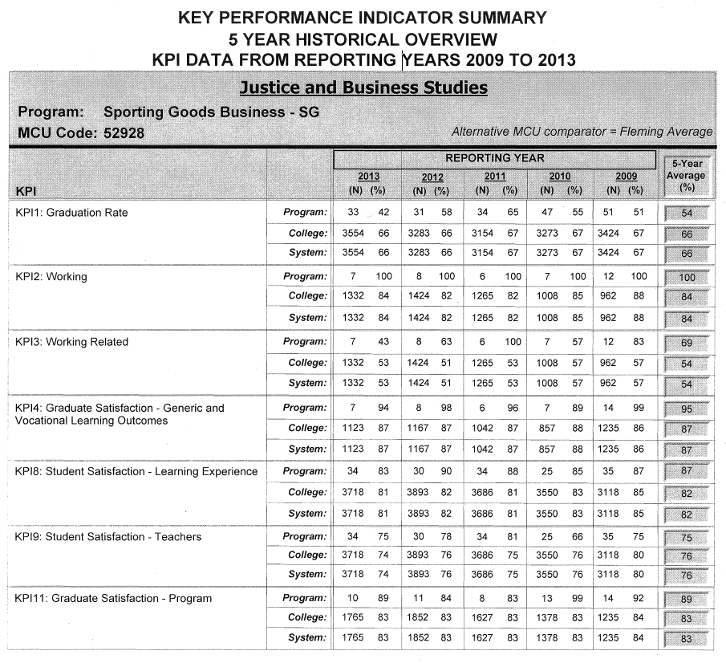

Appendix 2: STUDENT DEMAND
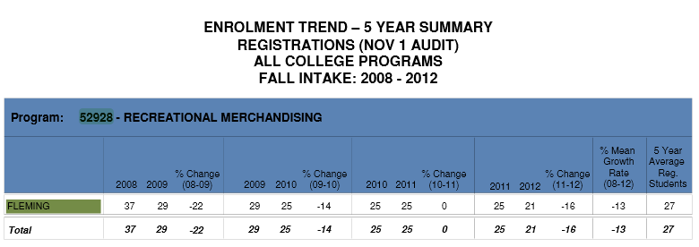

Appendix 3: COMPETITOR ANALYSIS
