Requisition Cheat Sheet
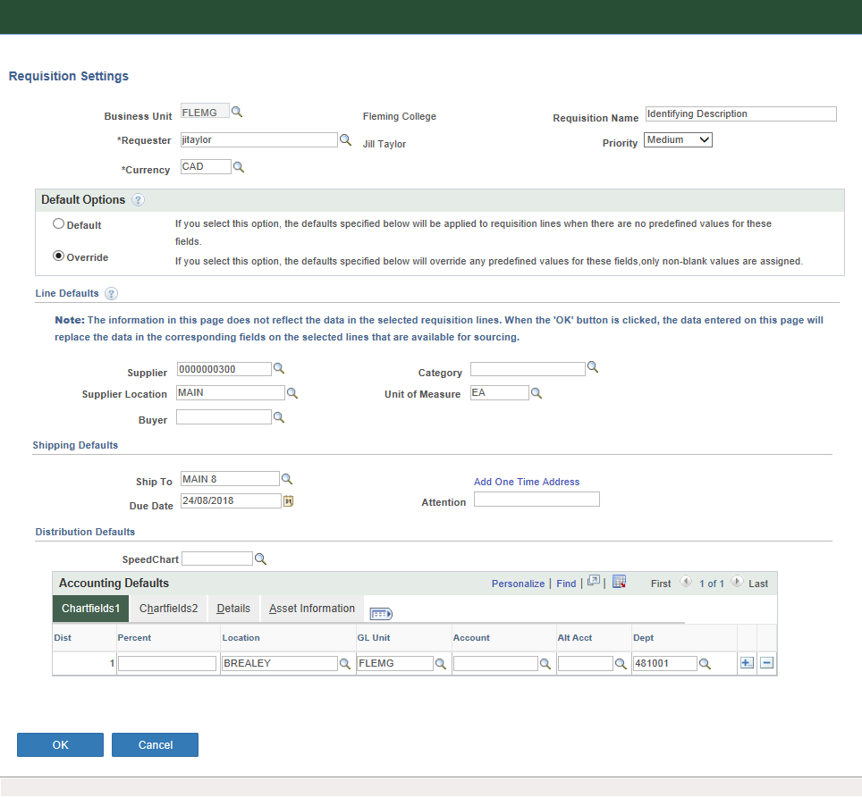
Go to eProcurement>Requisition

Key fields on this first page, the Requisition Settings page, are circled.

Requisition name - will appear in Manage Requisitions when you are searching for a requisition. Make it something unique and telling.

Currency - very important if you know you are entering a USD requisition enter it here at the beginning. It is very difficult to change the currency part way through a requisition.

The Default vs Override buttons - Most requesters have defaults set up on their profile. When you first go to this page your defaults are populated. Generally Ship to addresses and Depts are defaulted. If you are ordering for other than the default values you have to click the override button. Then anything that you enter on the fields below will carry through to every line on the requisition. Override was selected here because I changed my default dept from 141010 to 481001.

Line defaults – these are useful if you are entering a requisition with a lot of lines. The values entered here will automatically populate to every line.

Accounting Defaults – most important is the dept. If you don’t see it when you first open this page, you will likely find it on the Chartfields 2 Tab. Use the Personalize link to move the dept to the Chartfields 1 Tab. If your Dept field is empty it is because you do not have a default dept set up on your profile (likely because you order for many different depts.).

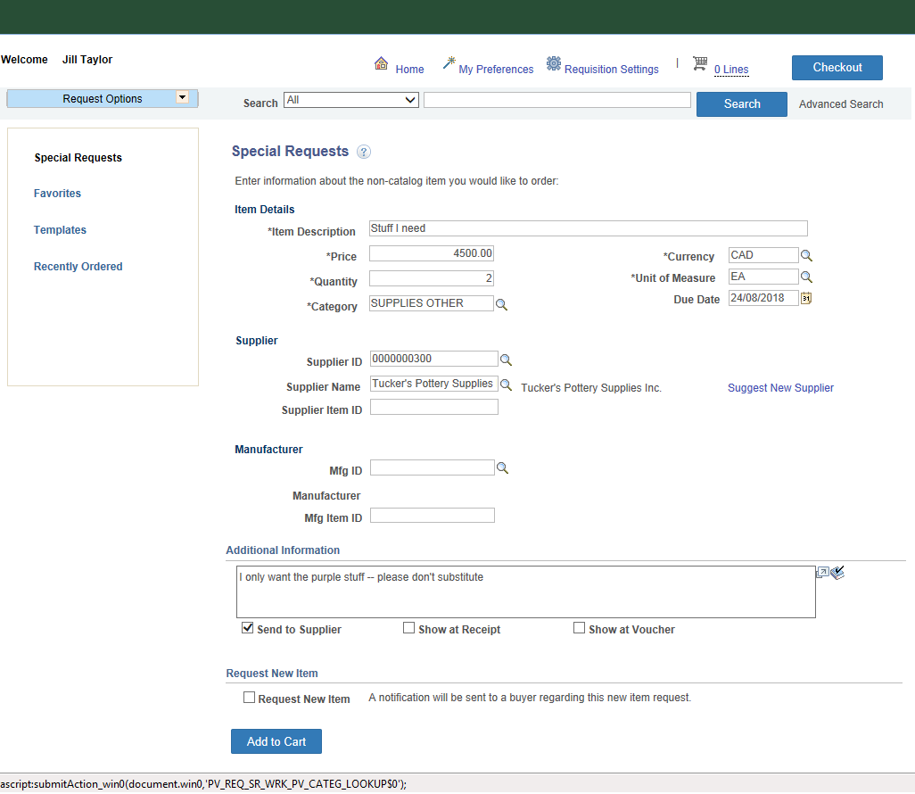
Clicking OK on the Requisition Settings page opens the Special Requests page. Enter the item description, price and quantity.

Due date is a mandatory field and is the date you want the items delivered by or the date that you want the work done.

Category - Use the magnifying glass for lookup. The category and the account are related. Search for the category by Description or category. If you know the account you want Search by Description and enter the account code in the search box.

Additional Information - may be instructions you want to provide to the vendor, the receiver or to accounting. Check off the boxes accordingly. Capital approval #s are to be entered in the line comment box.

When item details are entered click

The line is entered and the screen is cleared to add your next item. If you have entered all of your lines click
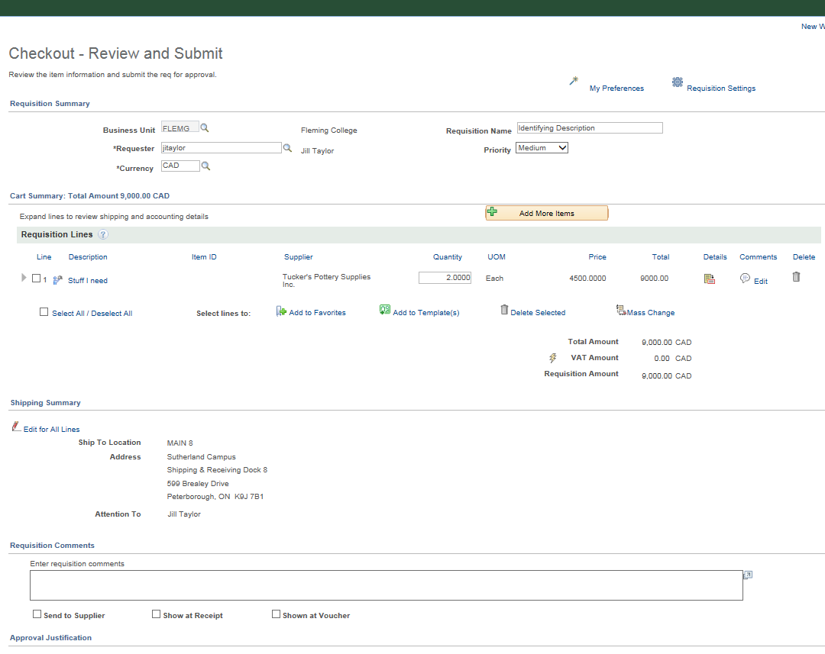
***TIP***

If you have to enter a requisition with more than three lines, go to the checkout page and

You can edit the requisition and add more lines. Save periodically if it is many lines.

ADDING ATTACHMENTS - The in the Line Comments area shows that a comment exists on this line. This is also where attachments are added to the requisition.

The small triangle to the left of the line expands or contracts line details.

Click on the Edit Comments Link and the page to the left opens. The comment that was entered on Line 1 shows up here with the Send to Supplier box checked.
Click Add Attachments and the File Attachment box opens. You can browse to your file and click Upload.

***PLEASE NOTE THAT EACH QUOTE MUST BE IN A SEPARATE FILE/UPLOAD. THE SUCCESSFUL VENDORS QUOTE SHOULD BE IDENTIFIED AS Q1 IN THE FILE NAME. ***

*** OTHER ITEMS TO INCLUDE AS ATTACHMENTS WOULD BE AN APPROVED NON-COMPETTIVE FORM, THE SOLICITATION DOCUMENTS (ie/ SHORT FORM INVITATIONAL RFQ, RELEVANT DWGS, SPECS), ETC

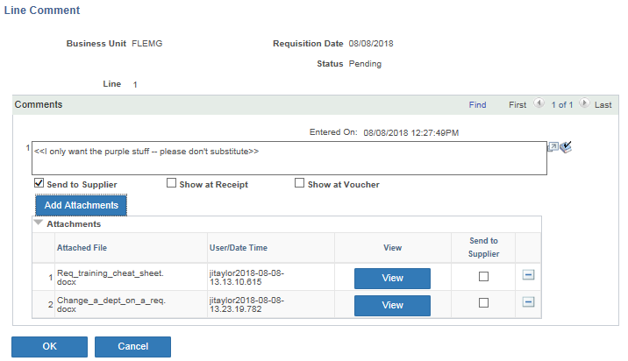
Click the button again to add another file.

Two files have been attached. Click View to open the attachment if you want to verify you have attached the correct document.

Click Ok to return to the requisition.

Please add all attachments to Line 1 of a requisition, unless the attached file pertains to one line specifically.

NOTE: Once documentation added to req DO NOT email or send hard copies to Purchasing.

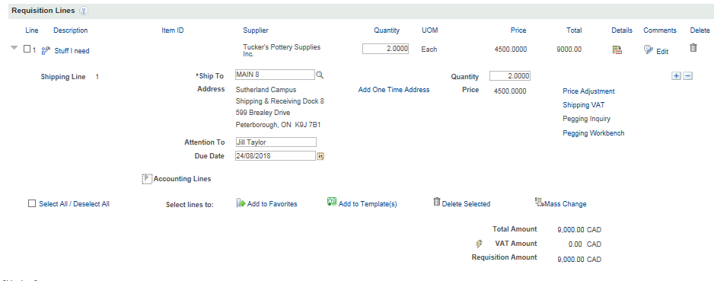

The comment bubble icon now includes a paperclip to show that attachments are included.

Line 1 of the requisition has been expanded.
Only the Ship to information is shown.

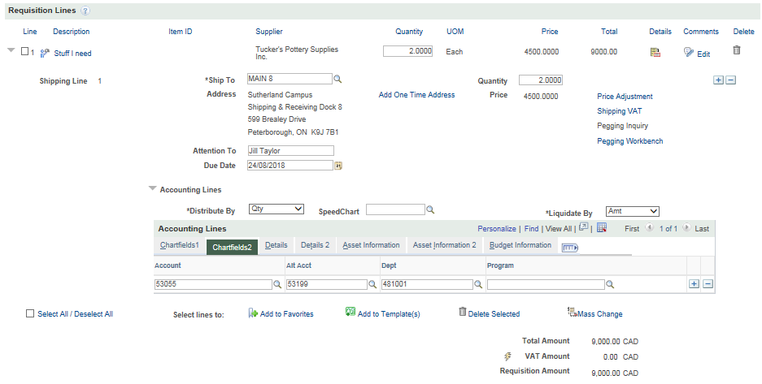
Accounting Lines must be expanded to see the accounts and depts charged.

Open the Accounting Line Details to verify the correct account and dept have been charged.

Note the account and dept are seen here on the Chartfield2 tab of the accounting details.

Personalize in the Accounting Lines area allows you to move the account and dept to the first tab.

Once personalized those settings are maintained for all of your requisitions.

COST SPLITTING: If you have a line item where the cost is to be split between two depts., click the + sign to add another distribution line and add a new account and dept. The split can be done by the number of items, or by percentage.
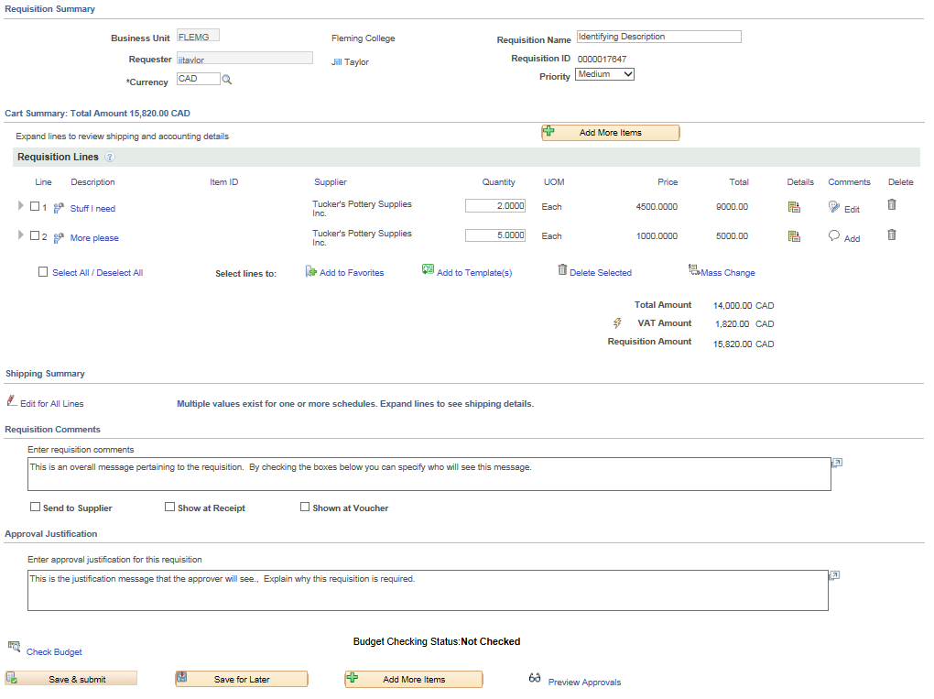
This requisition was Saved for Later which assigns the requisition id.

You can click the Select All lines and use Mass Change to correct the dept on all lines.

You can select lines to add to your favourites or create a template for items frequently ordered.

Requisition Comments that are relevant to the whole requisition are entered here. The Requisition Comments can be sent to the vendor, the receiver or AP by checking off the corresponding boxes.

Approval Justification comments show up prominently to the approver. The other comments are visible to the approver as well, but they have to open another page to view those comments.

SAVE FOR LATER if entering a requisition with a lot of lines, or if you need to come back to add something to the requisition and you don’t want it to be forwarded for approval until you are done.
Preview Approvals will show who the requisition will be routed to for approval.
If the approver is not the approver you expect, you should double check the dept that has been entered on the req lines.
Save and Submit to finalize and route the requisition for approval.

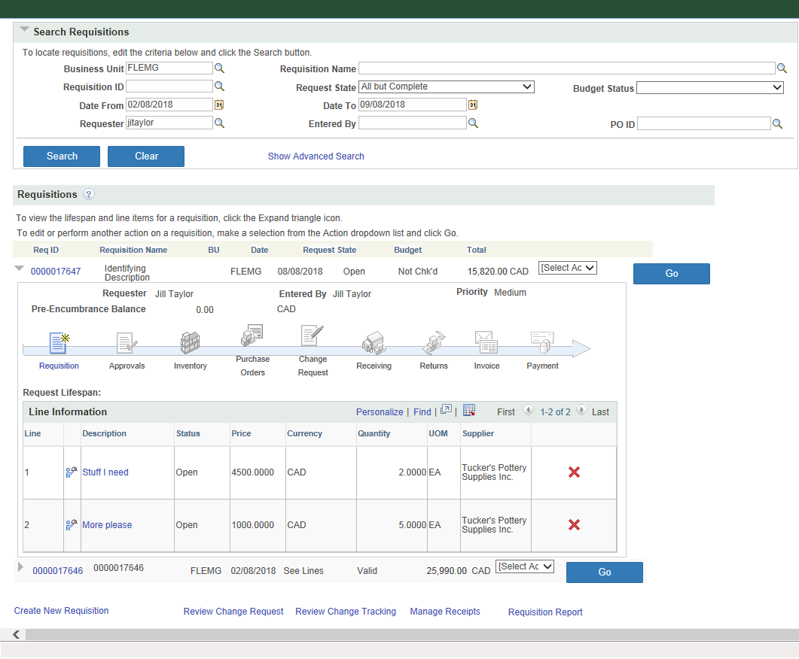
eProcurement>Manage requisitions is the navigation used to see all of the requisitions you have entered.

Change the Search parameters at the top of the page to control the requisitions listed.

Requisition Status In this example, Requisition 17647 has a status of Open. This requisition has been Saved for Later and has not been routed for approval. When routed for approval the status will be Pending.

Requisition Cycle: expand the arrow to the left of the requisition Id to show the linear requisition cycle. As a requisition proceeds through each step, approval, Purchase Order, Receiving etc the step is coloured. Each step when complete provides a link to the documents produced at that step.

With the line expanded, line details are also shown.

The icon beside each line allows you to delete the line. This option may not be available depending on the requisition status.

The Action Box opens to allow a number of processes.

Edit from the Action box allows for changes to be made to the requisition, ie. account/department, quantity. If previously approved, the changes may re-route the requisiton for re-approval.

In this example the requisition was finalized with Save and Submit. The approver routing is displayed upon Save and Submit.

Manage Requisitions - Approvals using the Action box, select Approvals and GO to view the name of the approver.

The status of the requisition is Pending.

