Evolve Manager Requisition Approvals

Table of Contents
- Notification of Approval Request…………………………………………………..1
- Approving a Requisition…………………………………………………………….2
- Denying a Requisition……………………………………………………………….6
- Adding Another Approver or Reviewer…………………………………………....8
- Manage Requisition Approvals and Worklist Finance…………………………..10
- Changing Manager Authority – setting up an alternate approver……………...12

- Notification of Approval Request

E-mail notifications are provided to approvers and requestors to advise of work required or status changes to a requisition. Upon saving and submitting a requisition, any approver attached to the departments charged will be notified by email that their approval is required. An example of an e-mail notification is shown below:

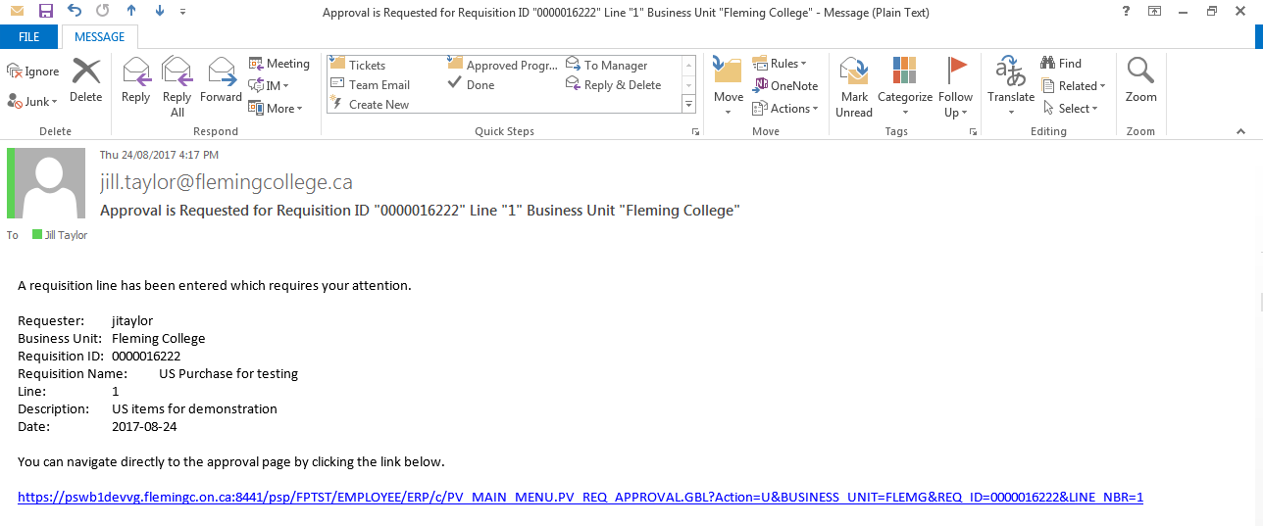

If you are signed into Evolve the link takes you directly to the requisition approval page where you can approve the requisition.

Alternatively you can sign into Evolve and go to Worklist – Finance>Worklist off the Evolve main menu to view and approve items.

- Approving a Requisition

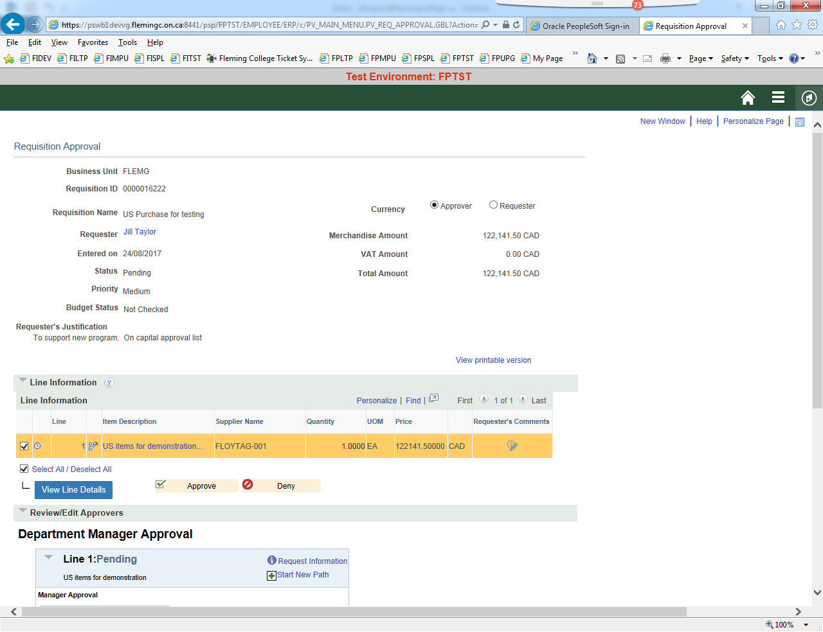

Requester Justification is a comment field that the requester may use to indicate why the purchase is required.

This icon on the line indicates that the requester has entered a comment on the line. Click the icon to open the page below.

In addition to the comment, note that a file has also been attached to the requisition.

Click the View button to open the attached file.

When the Currency buttons for Approver and Requester appear on the approval page items are being purchased with non-Canadian funds.

As a budget manager you want to know how much will be charged to your budget.

When the Approver button is clicked the cost in Canadian dollars is shown, approximately as it will be charged to your budget. Some variation may occur due to exchange and HST.

***As of the June 2021 Finance system upgrade, the unit price is not shown accurately in Canadian dollars. Toggle to the Requester view and then back to the Approver view and the unit price will be show correctly in CAD.***

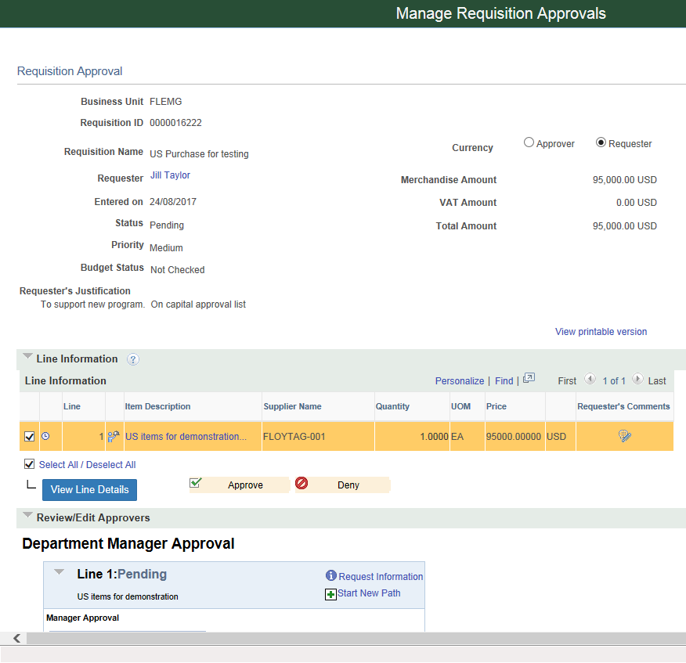

Click the Requester button and the dollar amount and the purchasing currency is displayed.

In this example, a $95,000 US purchase translates to $122,141.50 Canadian

**Most Important**

Click on the View Line Details button

A new window opens (shown on the next page)

Ensure that the correct account and department are being charged.

If there is more than one line on the requisition use the Select All check box

Details for all of the lines will appear in the new window, or view one line at a time, by selecting each line separately.

Note in the Header Comments
the capital approval # has been provided. This assists Finance to monitor capital spends

Verify the account and department used are correct.

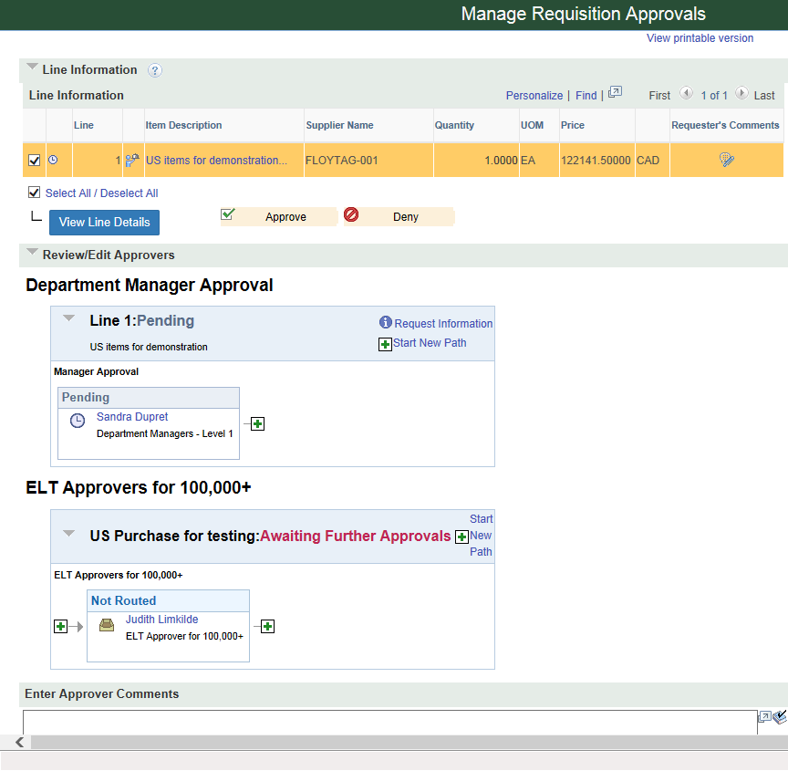

On the Approval page Scroll down the page to see the routing details

As this order is greater than $99,999. two approvers are required.

The first approver is the direct budget manager and the second approver is the ELT member for that manager

Click Approve if the order is acceptable and created correctly.

The requisition will then be routed to the ELT member for the second approval.

- Denying a Requisition

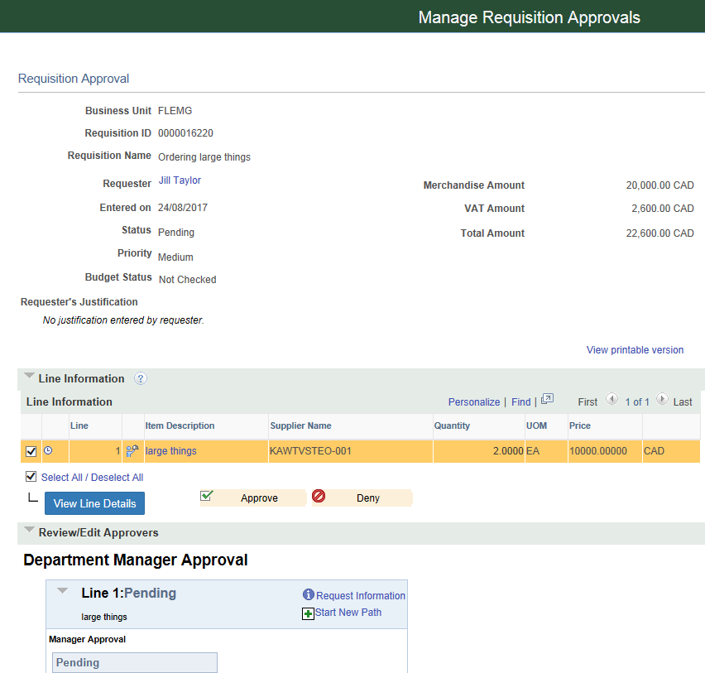
Click Deny

This message will pop up explaining that a comment is necessary when denying a requisition.

Add comments to explain why the requisition is being denied.

Click Deny again after entering comments.

An email notification will go to the requester advising of the denied requisition.

The requester can check their Worklist to see the comments.

This confirmation screen will pop up.

- Adding Another Approver or Reviewer

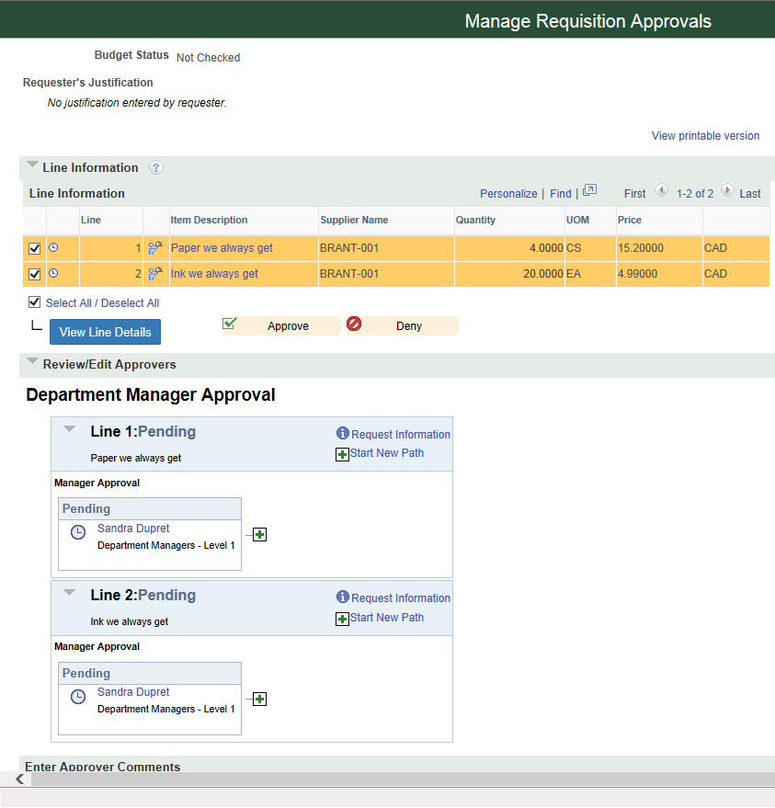

It is possible to add another manager to review or additionally approve this requisition using the Start New Path button

This button pops up the window below.

Use the magnifying glass to find the user id of the manager you wish to add.

Click Approver or Reviewer as required.

Note that Line 1 has been approved by the first manager, but the status of the line is still Pending as the second approver was added.

- Managing Requisition Approvals and Worklist Finance

If you know that you have requisitions awaiting your approval you can go directly to Managing Requisition Approvals or Worklist Finance. Both areas list items that require your approval.

At eProcurement>Manage Requisition Approvals the initial view lists all requsitions that are pending your approval.

Click the blue Req ID hyperlink to open the Requisition Approval page

Under Manage Requisition Approvals you have some search criteria that you can set to find a specific requisition or narrow the items listed.

By changing the search criteria in the status box you can also view requisitions that have already been
approved.

At Worklist Finance>Worklist items that have been routed to you for approval are also listed.

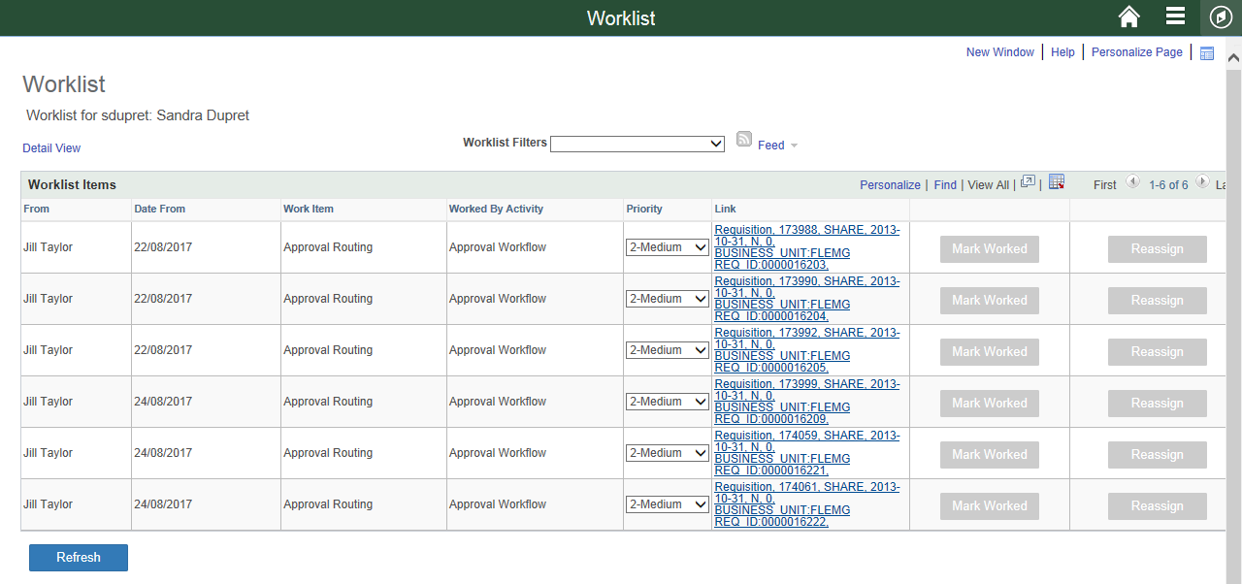
The above screen print shows the worklist with six requisitions to approve. Each item shows who initiated the workflow and the Link details the Req ID. Clicking each link brings up the requisition approval page for that item. As you approve each item it is removed from your worklist.

- Changing Manager Approval – Setting up an Alternate Approver

To set up a temporary approver while on vacation or away from the college, please fill in the Alternate User Section of the page below. This page can be found at eProcurement>My Profile. The alternate approver you assign must already be set up as an approver.

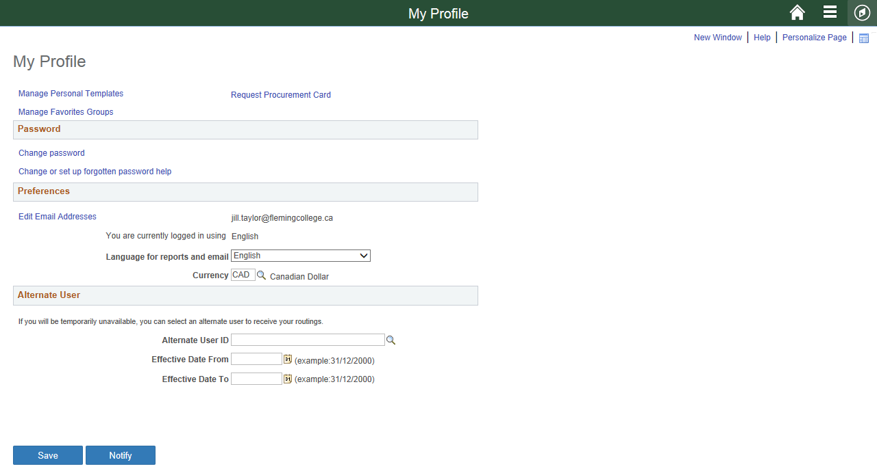

To set up a temporary approver while away from the college, please fill in the Alternate User section of this page. Assign the Alternate approver and the start and end dates of your absence.

