

**REQUIREMENTS:**

Choose an item. Choose an item. Choose an item.

# EMERGENCY CONTACTS:

Click or tap here to enter text.

Click or tap here to enter text.

Click or tap here to enter text.

# Call ext. 4444 for all emergencies

August 9, 2023

### Instructions for Creating your Sign

1. Copy and paste symbols appropriate for your lab from pages 3&4 into signage template on page 1.
2. If you are unsure of which pictograms need to be added to this sign please contact [safety@flemingcollege.ca](mailto:safety@flemingcollege.ca) or review the hazard and threshold chart on page 5.
3. In text box under symbol, you can type in specific hazards found in your lab. Beside the pictograms there are examples of hazard statements that may be copy and pasted into the text box.
4. If lab uses radiation, the Radiation symbol needs to be put on the sign.
5. If lab uses Biohazardous Materials, the Biohazard symbol has to be put on the sign and the appropriate Biosafety level i.e. BSL 1 or BSL 2 has to be typed into the textbox below the symbol.
6. If you have unused boxes (both picture and text) you can edit them so they are no longer visible by right clicking the blue box, click 'format shape,' and set Fill to No Fill, and close the dialogue box. For the text, simply click on the text box and delete the text.
7. Choose the appropriate Requirement messages from pull down menu. You can add your own by choosing “Edit” in the pull down menu and then typing in your specific message.
8. Fill in Emergency Contacts section with 24-hour emergency contacts for your lab.
9. Click on the date in the lower right corner and it will automatically update to today’s date.

Print on color printer if available. **Only print page 1.**

Post on H&S Information Boards found in all high hazard labs.

Gas under Pressure

Carcinogen Respiratory Sensitizer

Reproductive Toxin

Oxidizer

Environmental Hazard

Acute Aquatic

Acute Toxicity

Flammable Pyrophoric Self-Heating

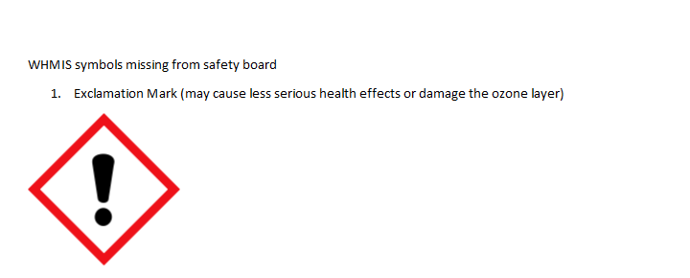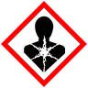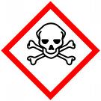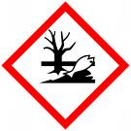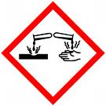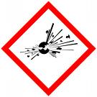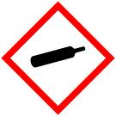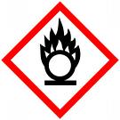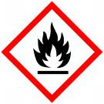

May cause less serious health effects or damage the ozone layer

Explosive Organic Peroxide

Corrosive

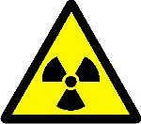

Radiation Hazard

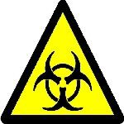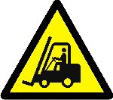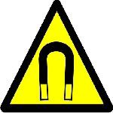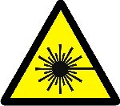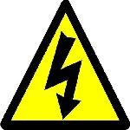

Biohazardous Hazard

Caution Fork-Lift Trucks Operating

Strong Magnetic Field

Laser Hazard

High Voltage Hazard

|  |  |  |  |
| --- | --- | --- | --- |
| **Hazard Class** | **Threshold (if exceeded add pictogram)** | | |
| Corrosive Liquids (pH < 3.5 or > 10.5). | | 4 liters |
| Flammable Liquids | | 4 liters |
| Flammable Solids | | any amount |
| Flammable Gases | | any amount |
| Oxidizers (liquid/solid) | | 4 liters/1 kilogram |
| Organic Peroxides | | 1 kilogram |
| Water-reactive chemicals | | any amount |
| Pyrophoric (air-reactive) materials | | any amount |
| Radioactive materials | | any amount |
| Biosafety Level 1 | | any |
| Biosafety Level 2 | | any |
| Self-Reactive (shock/heat sensitive)  Agents | | any amount |
| Carcinogenic, mutagenic Agents | | 100 grams |
| Highly Toxic materials  Gas Under Pressure (Compressed Gas Amount Cylinders) – excludes aerosol containers. | | 100 grams Any Amount |
| Laser(s) – excludes completely enclosed | | N/A |
| Lasers and consumer-type lasers – Any class lllb and IV) | |  |