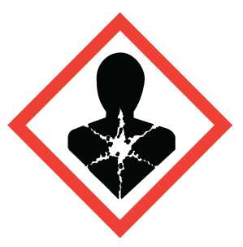
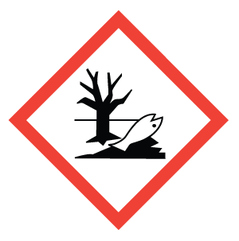
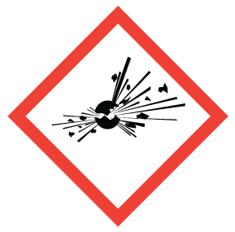
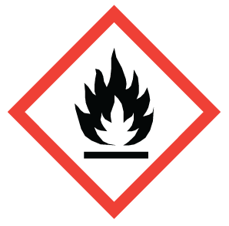

Biohazardous - Biohazardous Infectious Materials

Exploding Bomb - Explosive, Self-Reactive (severe), Organic Peroxide (severe)

Environment - Aquatic Toxicity

Flame - Flammable, Self-Reactive, Pyrophoric, Self-heating, In Contact With Water, Emits Flammable Gases, Organic Peroxide

Health Hazard - Carcinogenicity, Respiratory Sensitization, Reproductive Toxicity, Target Organ Toxicity, Germ Cell Mutagenicity, Aspiration Hazard

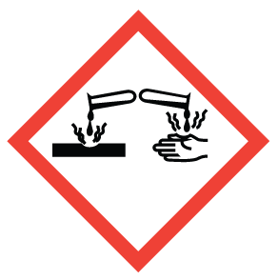
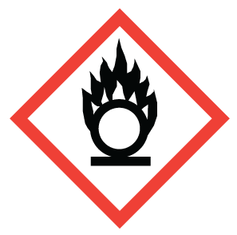
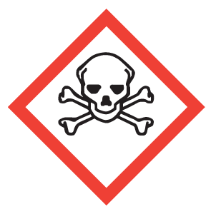
Gas Cylinder – Gas Under Pressure

Skull and Crossbones - Acute Toxicity (fatal or toxic)

Flame over Circle – Oxidizer

Exclamation Mark - Irritation (skin or eyes), Skin Sensitization, Acute Toxicity (harmful), Specific Target Organ Toxicity (drowsiness or dizziness, or respiratory irritation), Hazardous to the Ozone Layer

Corrosion - Serious Eye Damage, Skin Corrosion, Corrosive to Metals

