Department:
SOP Title:

 | NAME | TITLE | DATE
Author |  |  | Click or tap to enter a date.
Approved By |  |  | Click or tap to enter a date.

Revision History | NAME | TITLE | DATE
 |  |  | Click or tap to enter a date.

1.0 Scope

This SOP outlines the [Department/School] safety measures for [Equipment/Process] including required PPE, emergency information, operational procedures, and identified hazards and risks.
2.0 Purpose and Introduction

The purpose of this document is to provide a detailed guideline of health and safety measures for [Equipment/Process] including required PPE, emergency information, operational procedures, and identified hazards and risks.
Include any necessary background information, if required.
3.0 Emergency Information

3.1 Emergency Contacts
Outline emergency contacts, including applicable managers, supervisors, technologists, security, etc.
3.2 Emergency Procedures
Include any emergency information specific to the equipment/process, e.g., what to do in the event of a spill.
Detailed information regarding emergency procedures for Fleming College are located on the security website: https://department.flemingcollege.ca/security/emergency-procedures/emergency-procedures-3/
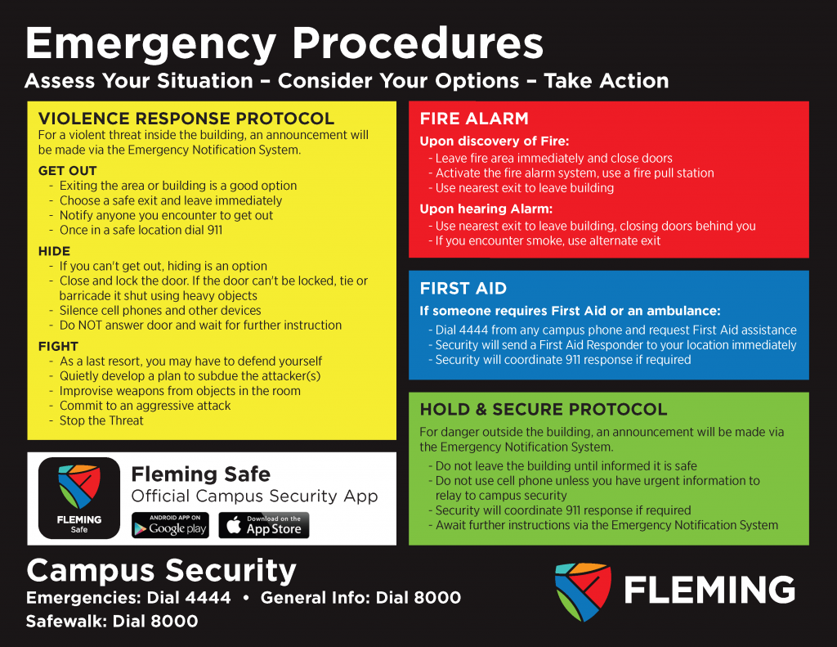

3.3 Safety Equipment
Outline location of safety equipment, such as telephones, fire exits, fire extinguishers, first aid kit, eyewash/shower, etc. as applicable.
3.4 Safety Data Sheets
Outline physical location or how to access if applicable. The Fleming College Online SDS Database can be found here or scan the QR code on a Health & Safety green board.
3.5 Gas Shutoffs
Outline location, if applicable.
3.6 Electrical Panels/Circuit Breakers
Outline location, if applicable.
3.7 Report an Incident/Accident or Near Miss
If you require First Aid or an ambulance while you are at the Frost and Sutherland campuses call:
- Immediately call 911 (if you do not require an ambulance please skip to #2)
- Dial 4444 from any campus phone and request First Aid assistance or Use the Fleming Safe App on your phone
- Security will send a First Aid Responder to your location immediately
Campus Security will help direct emergency crews to your location saving valuable response time.
Visit https://department.flemingcollege.ca/safety/report-an-incident/ to complete the appropriate reporting form.
4.0 Definitions/Acronyms

Outline any applicable definitions/acronyms.
5.0 Roles and Responsibilities

Specify who is responsible for performing the SOP and who is authorized to perform the procedure. Use position titles rather than specific names of individuals who will perform the procedure.
6.0 Operational Procedures

6.1 Required Training
Include any required certifications, licences, or training applicable to using the equipment/process.
6.2 Pre-Operational Safety Checks
What measures need to be taken before using equipment/process?
6.3 Procedure
Outline usage guidelines and a step-by-step procedure. Include any relevant images.
6.4 Location, Storage, and Maintenance

7.0 Identified Hazards and Risks

Symbol/Image | Hazard/Risk

Use symbols of hazards below (if applicable) and/or images. Include written detail or other symbols if needed.
Click here: WHMIS Symbols to copy and paste

8.0 Required PPE and Precautionary Measures

8.1 Hygiene
e.g., food/drink, sanitization, hand washing etc.
8.2 Housekeeping
8.3 Personal Protective Equipment and Dress
PPE | Instructions

List PPE and/or appropriate dress in relation to equipment/process. Include applicable images or instructions/details.
8.4 Other
9.0 Environmental Considerations

Outline any environmental considerations or conditions when the activity can/cannot be performed, e.g., weather, temperature etc.

10.0 References

Including any applicable standards and legislation.

