How-To Book a Conference Line using Outlook
Description | This document outlines the steps to book a Conference line

- Open Microsoft Outlook.
- At the bottom left hand corner of the screen, click the Calendar button.
- With your calendar selected (at the top it will show Calendar - firstname.lastname@flemingcollege.ca) select New Meeting on the left side of the ribbon.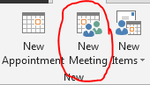
- In the Meeting window, left click the “To…” button.
- In the Search field in the Select Attendees and Resources window, type in conference.
- Double click on one of the available conference rooms (Conference Bridge M3 thru M6)
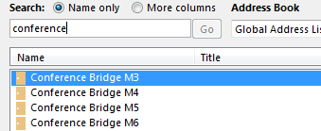
- Click OK
- Select the Time and Date for the conference call.
  - If you want to check to see if multiple conference lines are available at once, select all of the conference lines in your search, press OK and then select Scheduling Assistant at the top of the Meeting setup window. This will show which of the 4 lines are available at the time you’ve selected. Click Appointment to return back to the booking screen.
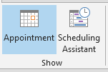
- Once you’ve confirmed the room you want is available, left click Send.
- If the line is available you’ll shortly receive an email with connection details. If the room is booked, you’ll receive an email with a rejection notice – the details to connect to the line are still sent, but please disregard them as the line will be in use.

