Fleming College

ACADEMIC ORIENTATION SCHEDULE
Tuesday, September 6, 2016

SCHOOL OF GENERAL ARTS AND SCIENCES
9:30 am Welcome Session for the School of General Arts and Sciences Lower Cafeteria
Break out into Orientation Session for each program after the Welcome Session:

Community Integration through Cooperative Education (CICE)  Program Coordinator: Joan Connolly | B2 106
General Arts and Science – College Health Science Option  Program Coordinator: Susan Hyndman | Lower Cafeteria
General Arts and Science – University Transfer  Program Coordinator: Dennis Vanderspek | B3 121
Preparatory Health Science  Program Coordinator: Erin Kirk | B3 167

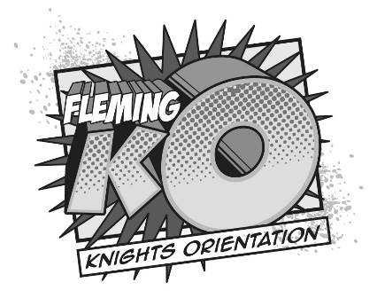
Don’t Miss the Party! Tuesday, September 6
Fleming Knights Orientation (Fleming KO) starts at 12:00 pm at the Sports Fields.
Check your Fleming KO schedule for full event listings!

