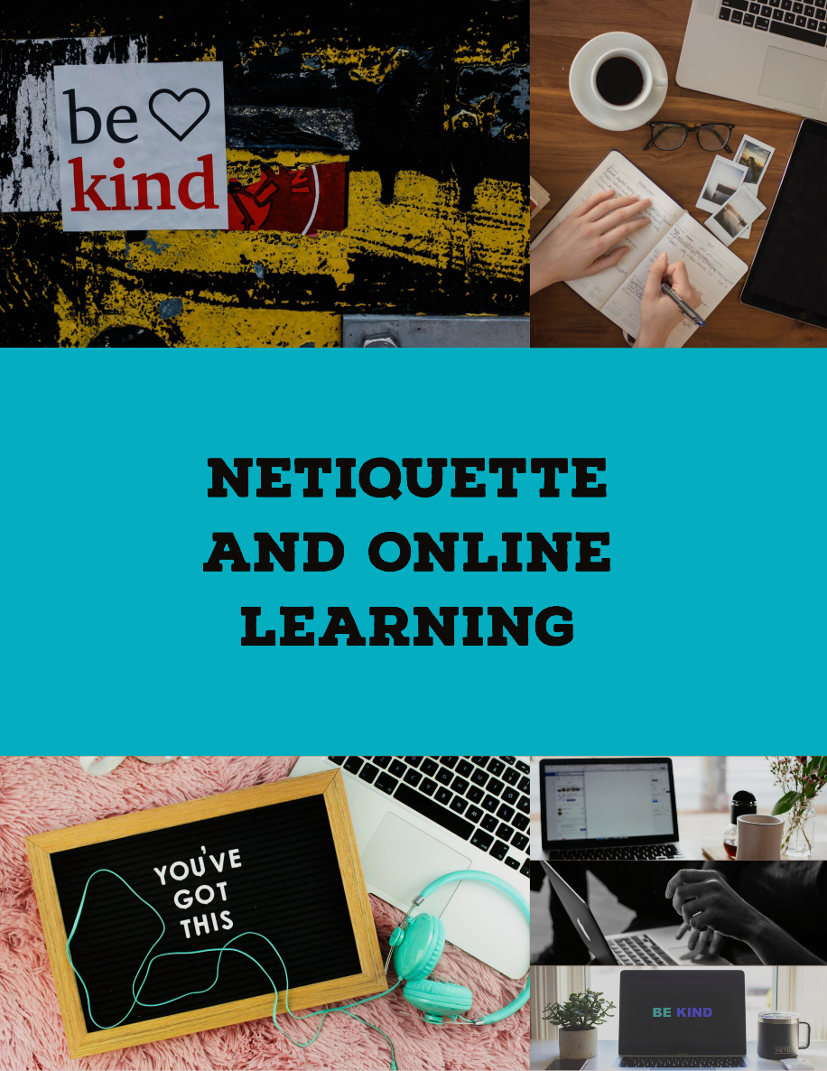
With classes and group work moving online, Fleming College and the Office of Student Rights and Responsibilities would like to remind everyone that College policies still apply to online spaces. This includes the Student Rights and Responsibilities Policy, the Sexual Violence Prevention Policy, the Harassment and Discrimination Policy, the Violence Prevention Policy, and the Academic Integrity Policy.

Ensuring communication online is positive, direct, and respectful is not only helpful for your learning, but your peers and faculty members are your future coworkers and will provide networking opportunities to you as emerging professionals. It is important to ensure that you are presenting yourself in a positive and respectful manner at all times, including in these online learning spaces.

Student Rights and Responsibilities Online

Livestream Classroom
Show up on video as you would to class. Dress appropriately. Check that your background does not include any pictures or art that can be viewed as inappropriate, obscene, sexual in nature, or offensive.
Mute your side of the conversation when not speaking. Paper shuffling, background music, dogs barking, or other people in your house can all create distractions for others.
Communicating in Online Spaces
Emotional & Relational Content
Ask yourself:
- Would I say this out loud to a person’s face? If the answer is no, don’t make the post.
- Could my tone or choice of words be misunderstood?
- Am I disagreeing or arguing in a way that may be considered rude or insensitive? If the topic is heated, be extra careful of the words and tone used. Consider getting a second opinion before you post to avoid misunderstandings.
- Am I upset and responding in anger? Stop and wait before responding immediately. Our first response is often not our best.
- Did I use all caps? This is often interpreted as anger or yelling. It is strongly advised to not use all caps in any communication, either academic or social.
- Did I use emoticons, humour or sarcasm? Emoticons and humour are not understood by everyone the same way. They are best left out of online academic learning.
Additional Guidelines
- Be brief, but still thoughtful; sometimes lengthy contributions are more likely to be misunderstood
- Be mindful of how much “space” you take up. In livestream classrooms, you cannot necessarily see if others are waiting to speak or have something they would like to contribute. Contribute freely, but allow others the space to do the same.
- Differences of opinion occur in academic learning. Be respectful. Stay away from insults and personal remarks. Keep the content about the issues, not the people.
- Ask for clarifications and accept that misunderstandings are common in the online world. Be professional and assertive, ask about intent, and give others the opportunity to explain.
- If something does bother or offend you, find respectful ways to articulate this. If you require support, please contact your faculty member or the Office of Student Rights and Responsibilities and we can help problem-solve with you.
Cyberbullying
Cyberbullying takes many forms. Personal insults, excluding others from academic discussions, posting pictures without someone’s permission, gossiping and discussing others online, cyberstalking, and trolling can all be considered cyberbullying. This is against Fleming College’s Student Rights and Responsibilities Policy.
If cyberbullying or online harassment are impacting you, please connect with the Office of Student Rights and Responsibilities.
Email Etiquette
- Check that your subject line accurately reflects the message in your email.
- Use a proper greeting such as “Hi” or “Hello”.
- Avoid slang, texting shorthand, and emoticons. School is a reflection of the workplace, so formal and proper language is expected.
- Is your email a long stream of text? If so, add paragraphs and whitespace so the receiver may catch all the important information.
- Sign your email with your full name and student number. Assume the reader does not recognize your email address.
- If you are sending an email when you are upset or angry, take a 24-hour cooling off period. You can also get a second reader to ensure your message is clear, factual and non-reactive. These actions will ensure the receiver hears the message you want them to hear and that you are proud of sending the email you have written.
For Support and More Information
For more information about Student Rights and Responsibilities, please see the WEBSITE
If you would like to make an online report about inappropriate behaviour, please click HERE
If you would like to speak to someone in the Office of Student Rights and Responsibilities, please contact:
Amie Kroes, Manager Student Rights and Responsibilities
amie.kroes@flemingcollege.ca
705-749-5530 x1137

*Created with appreciation of content provided by Saskatchewan Polytechnique

